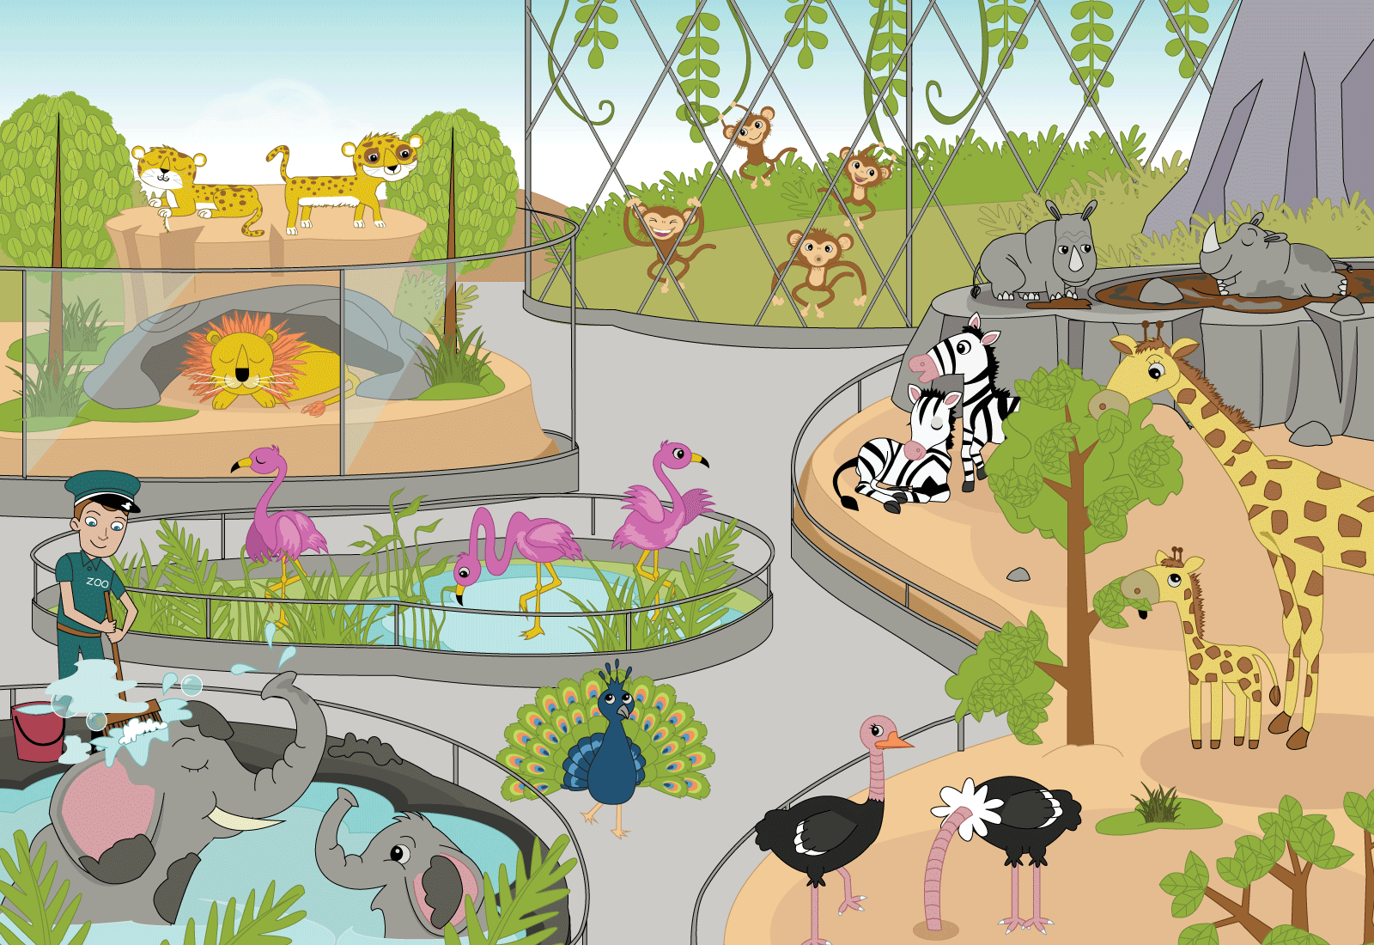
Class | Senior Infants | Theme | Animals
Unit | 12 | Subtheme | The zoo
Unit genre | Narrative
Vocabulary | Tier 1 examples: elephant, mud, giraffe, zebra, ostrich, rhinoceros,  lion, cheetah, flamingo, monkey, peacock, drinking, eating,  feeding, cleaning  Tier 2 examples: swamp, watering hole, peacock, flamingo, habitat  performing  Tier 3 examples: enclosure, escape, strutting
Lesson resources | Multimedia links

Fortnightly plan
Lesson 1 | Digital poster: (Story mode)  Digital poster: (Explore mode): Talk and discussion  Stop, stare and share  Mime and rhyme | Lesson 3 | Digital poster (Explore mode): Talk and discussion  Pair talking task: Can I/can’t I?  Digital poster (Activity mode): Sorting activity  A flamingo leg up  ‘Monkey See, Monkey Do’
Lesson 2 | Digital poster (Story mode): Recap  Digital poster (Question mode)  Storytime: Goodnight Gorilla  Pair talking task: Guess my animal | Lesson 4 | Digital poster (Label mode)  Digital poster (Poem mode): ‘Zoo Dream’  Zoo riddles

Lesson 1
Digital poster (Story mode)
Play either the Story mode 1 (starters) or Story mode 2 (flyers) for the class, depending on the ability level.

Digital poster (Explore mode): Talk and discussion
Start off discussion with the class with some verbal puzzles:
Today we are at the zoo. What a treat! Let’s play some zoo puzzles.
- Listen to the word ‘zoo’. What is the first sound do you hear? (z). Say the sound out loud. Feel inside your mouth as you are saying the sound. What are you using to make the ‘z’ sound? (tongue)
- Can you see any other pictures on the poster of ‘z’ things that we find in the zoo? (Zebra, zookeeper). The stripes on the zebra might make us feel dizzy!
- Let’s zoom in on the zebras in the poster. Try saying the tongue twister zebras zig and zebras zag (repeat, saying it faster each time).

Zoom out to reveal the rest of the poster. Explain that the zoo is divided into different zones. Different animals live in each zone.
- What other animals besides zebras can you see in the poster? (Lion; leopard; monkey; elephant; giraffe; ostrich; flamingo; peacock; rhino)
- There is only one lion and one peacock, but there are two leopards, four monkeys, two ostriches, three flamingos and two rhinos. Listen to the sound at the end of those words (‘z’). Repeat the words, emphasising the ‘z’ sound at the end. When we talk about more than one elephant/giraffe we say elephants and giraffes. The sound at the end of those words is a hissing sound like a snake.
- All these animals live in the zoo. But are they all the same? Can you think of ways that the animals are different? (e.g. colours, sizes, patterns, features, habits)
- Let’s talk about the differences: Colour (e.g. pink, grey, brown, black, white, brightly coloured, colourful); pattern (e.g. spots, stripes, plain); size (e.g. tall/short; Big/small; heavy/light; long/short; wide/narrow)
- Sing Heads, Shoulders, Knees and Toes performing appropriate actions OR read the poem Bird Talk by Aileen Fisher. Think about how animal features are similar to/different from humans, e.g. do animals have the same physical features as we have? What are they called? How are they different? (e.g. nose – trunk, snout, rhino horn; mouth – beak/bill; foot – paw(s), hoof(ves), claw(s), webbed; skin – hide, fur, feathers, fan, mane)
- Look at each of the animal zones (enclosures). Can you hear a small word in the middle of the word enclosure? (close) Are we in an enclosure? (No, because we can open the door and go out, but an animal in an enclosure is locked in – lock/unlock). Why are all the animals except the peacock in enclosures? How is each animal zone (habitat) different? (e.g. food, shelter, etc.)
- Look carefully at the poster again. We are at the Zoo. Can you find something in/on/under/around/above/between… in the poster? (e.g. the peacock is strutting around the zoo; the zookeeper is between the elephant enclosure and the flamingo enclosure)

Stop, stare and share
Organise children in pairs. Zoom in on one of the animal zones in the poster, e.g. the giraffes.
Encourage the children to stare at the giraffes and their enclosure for ten seconds.
Now tell them to turn away from the poster, face your partner and say everything you can remember about the giraffes and their zone in the poster. Children then swap roles and repeat the exercise. Repeat for other zoo zones.
Aim for three to five sentences from each child, incorporating descriptive language as appropriate.

Mime and rhyme
Teach children the rhymes below and encourage them to have fun chanting them, miming the actions as they chant.

‘The Elephant’s Nose’
An elephant goes like this and that (stomp feet)
He's terribly big (raise arms over head)
And he’s terribly fat (stretch arms to side)
He has no fingers (wiggle fingers)
And he has no toes (wiggle feet)
But, goodness gracious WHAT A NOSE! (use arm to make a trunk in front of nose)

‘The Yellow Giraffe’
The yellow giraffe is tall as can be.
His lunch is a bunch of leaves off a tree.
He has a long neck and his legs are long too,
And he can run faster than I can, woo-hoo!

‘A Rhinoceros’
A rhinoceros, a rhinoceros
Sometimes he makes a dreadful fuss.
He has a big horn on his nose.
He snorts and rumbles as he goes.
He's very long and very wide.
He has a very wrinkled hide.
He has big hooves on his four feet.
We feed him grass and hay to eat.
A rhinoceros, a rhinoceros,
Is surely not a pet for us.

‘The Itsy-Bitsy Monkey’
Itsy bitsy monkey climbed down the coconut tree
Down came a coconut and hit him on his knee – OWW
Out came a lion shaking his mighty mane
and the itsy-bitsy monkey climbed up the tree again.

(All taken from https://www.kidsparkz.com/preschool-sings-zoo.html)
Lesson 2
Digital poster (Story mode): Recap
Play either the Story mode 1 (starters) or Story mode 2 (flyers) for the children again. Make sure they understand all of the vocabulary.

Digital poster (Question mode)
Go to the Question mode of the poster. Listen to each question and discuss the answers with the children briefly.

Q1. | Where do these animals live?
Q2. | What are the giraffes doing?
Q3. | What are the pink birds called?
Q4. | Do you think the elephant likes being washed? Why do you think that?
Q5. | Which of the animals in the zoo do you think are the most playful?
Q6. | Why do you think rhinos like to relax in the mud?
Q7. | Lions are called ‘big cats’. Can you think of any other big cats you might find in a zoo?
Q8. | Would you like to be a zookeeper? Why?
Q9. | If you were an animal, would you like to live in a zoo? Why?
Q10. | Can you think of some good things and some bad things about zoos?

Storytime: Goodnight Gorilla
Play the story Goodnight Gorilla by Peggy Rathman for the class: https://vimeo.com/31572493
Ask the class the following questions:
- Where was the gorilla?
- How did he escape from his cage?
- How did the gorilla know which key to use to unlock each cage?
- Revise the descriptive language to identify each of the animals in the zoo.
- How did the zookeeper’s wife discover the animals?
- When do we say ‘Goodnight?’ How do we say ‘Goodnight’ in other languages?
- Who was first/second/last animal in the line?
- Who was the tallest/scariest/smallest/funniest animal in the line?
- Choose one image from the story. Encourage children to make a sentence about the image, telling what is happening.
- Retell the story in sequence as the gorilla/zookeeper/elephant, zookeeper’s wife, etc.
- What happened before the zookeeper came to check on the animals?
- What happened after the zookeeper’s wife put the animals back in the zoo?

Have children role-play a conversation between the gorilla and the mouse in pairs, e.g.
Mouse: What are you doing Gorilla?
Gorilla: I’m unlocking the cage.
Mouse: Why?
Gorilla: So that I can get out!
Mouse: Can I come with you?
Gorilla: Of course, but bring the banana.

Pair talking task: Guess my animal
Organise children in pairs. Have them pick an animal in the poster and describe it to their partner, e.g.:
Child A: My animal’s eyes are …/nose is …mouth is …ears are …body is covered with … my animal is different from other animals because …
Child B: I think your animal is a …
Children then swap roles and repeat.
Lesson 3
Digital poster (Explore mode): Talk and discussion
Go to the Explore mode with the children again. Focus on what is happening in the picture and ask children to describe what they see, e.g.:

I see a … peacock strutting; giraffe reaching; monkey swinging; rhino wallowing; ostrich burying his head in the sand; elephant swinging his trunk/lumbering; leopard watching out for danger; lion sleeping peacefully; flamingo wading; zebra prancing, etc.
Introduce the adjectives ‘proud’ (proud as a peacock) and ‘brave’ (brave as a lion).

Pair talking task: Can I/can’t I?
Child A: I’m a tall, graceful giraffe. Can I run?
Child B: Yes, you can/No, you can’t.
Child B: I’m a vibrant, striped zebra. Can I climb?
Child A: Yes, you can/No, you can’t.

Digital poster (Activity mode): Sorting activity
Go to the Activity mode of the poster. Play the sorting activity. Children must decide which animals are zoo animals and which are pets and sort them into the correct categories.

Zoo | Pet
tiger, rhino, bear, zebra, giraffe, elephant, penguin | dog, cat, guinea pig, goldfish, rabbit

A flamingo leg up
Read the story of Floyd the flamingo in San Diego Zoo to the class. If possible, show them the pictures to go along with it: http://kids.sandiegozoo.org/stories/flamingo-leg) The text is reproduced below:

A flamingo’s long legs are an important adaptation. They keep most of the bird’s body dry and warm while it wades in water, searching for food. Floyd is a flamingo at the San Diego Zoo that had a problem with his legs, but the zoo staff was able to help him.

Straightening out
As Floyd grew, keepers noticed that his legs were crooked. Veterinarians did three surgeries to help straighten Floyd’s legs. But after the surgery, Floyd needed to not stand on his legs to let them heal. Luckily, his keepers had a plan.

Have a seat, Floyd!
From the time he was just a fuzzy chick, his keepers noticed that Floyd was kind of a ‘lap flamingo’. He liked to sit in their laps or have them hold him, so that’s what they did while his legs healed!
‘For 2 weeks, someone was always holding him, 24-hours a day,’ says Kristina Nelson, a senior animal trainer at the Zoo. ‘He was very happy with that!’

Special care
As Floyd’s legs got stronger, the staff made a sling so he could practise standing. In between times, the keepers held him. The keepers even stayed with at night. “Sometimes we’d watch a movie on a tablet,” Kristina remembers. “Floyd watched ‘Finding Nemo’ and was very interested in it!”

Standing tall
Floyd is now one of the flamingos that guests meet during the Animals in Action Programme. “We check his legs daily,” says Kristina. “Sometimes his legs get tired, and he’ll sit down. But if we’re nearby, he still likes us to pick him up and hold him, so we do (even though he’s five feet tall!)

Use this story to introduce the children to the idioms, a leg up (to give someone help) and standing tall (brave and proud).

‘Monkey See, Monkey Do’
Have the whole class recite the rhyme with actions.

When I clap, clap, clap my hands,
The monkey claps, claps, claps his hands.
Monkey see, monkey do.
The monkey does the same as you!

Repeat the rhyme with a variety of actions and body parts: stomp, stomp, stomp my feet; nod my head; shrug my shoulders; wave my arms, etc. Children could recite the rhyme in pairs, with one child being the ‘monkey’.
(Rhyme taken from https://www.kidsparkz.com/preschool-sings-zoo.html)

Lesson 4
Digital poster (Label mode)
Go to the Label mode of the poster. Review the vocabulary. Have the children take turns dragging the labels onto the correct location in the poster.

Digital poster (Poem mode): ‘Zoo Dream’
Go to the Poem mode of the poster and play the poem ‘Zoo Dream’ by John Foster:

Zoo Dream
By John Foster

I dreamed I went
To the zoo one day.
All the animals came out to play.
There were
Ten whales whistling,
Nine hippos hopping,
Eight monkeys marching,
Seven lions laughing,
Six snakes skipping,
Five donkeys dancing,
Four crocodiles clapping,
Three rhinos roaring,
Two giraffes giggling
And one seal snoring!

Have children speak the poem with appropriate tone, pace and expression.
Encourage the children to perform the movements as they speak the poem.
Remind the children of the idioms proud as a peacock, brave as a lion, and standing tall, to support the children as they move.

Zoo riddles
Read these riddles out for the class. Encourage children to work through the possible answers out loud.

- What has a horn but does not honk? (A rhinoceros)
- What key can’t open any doors? (A monkey)
- I am a type of animal
You might see on a safari
I’m covered in black and white stripes
I’m part of the horse family (Zebra)

