Class | Junior Infants | Theme | 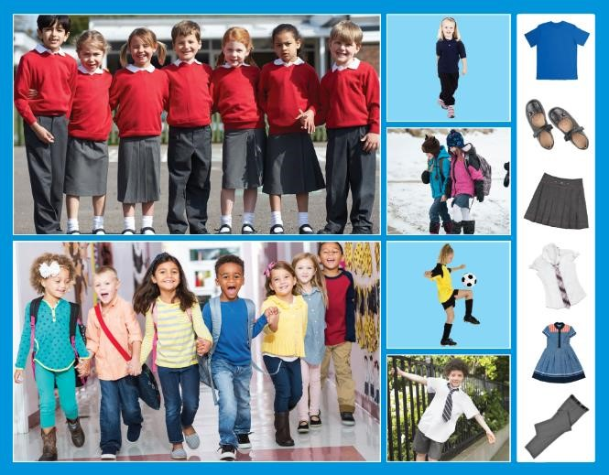  School
Unit | 9 | Subtheme | What I wear to school
Unit genre | Report
Vocabulary | Tier 1 examples: shirt, jumper, t-shirt, trousers, skirt, dress, tie,  socks, shoes, boots, trainers, coat, hat, gloves, tracksuit  Tier 2 examples: comfortable, uncomfortable, prefer, similar,  different
Lesson resources | Multimedia links

Fortnightly plan
Lesson 1 | Digital poster (Story mode)  Digital poster (Explore mode): Talk and discussion  Think and talk: I wonder … | Lesson 3 | Digital poster (Explore mode): Talk and discussion  Digital poster (Activity mode): Sorting into categories  Storytime: The Lost Button  Clothing songs and rhymes
Lesson 2 | Digital poster (Story mode): Recap  Digital poster (Question mode)  Pair talking task: What am I wearing today?  Barrier game: Listen and draw | Lesson 4 | Digital poster (Label mode)  Digital poster (Poem mode): ‘Getting Dressed for School’  Listen and say  Giggle and grin

Lesson 1

Digital poster (Story mode)

Play either the Story mode 1 (starters) or Story mode 2 (flyers) for the class, depending on the ability level.

Digital poster (Explore mode): Talk and discussion
Go to the Explore mode of the poster. Use the photographs of the two groups of children as a starting point to have a whole-class brainstorm focusing on the topic of clothes and clothes we wear to school. Introduce the word uniform (clothes we wear in school to show that we are all part of/members of our school). During the discussion, focus on characteristics such as colour, design, fabric, style, etc.
Now ask children to look at each item of clothing in turn, naming, describing and locating it in the big picture e.g. I see a shirt. It is white. It has a collar. It has short sleeves. There is a tie knotted around the collar. I can find it on the boy playing by the railings.

Nouns: jumper/sweater; t-shirt; sleeves; collar; pants/trousers; skirts; shoes; buckles; straps; laces; Velcro; crest; label; leggings; jeans; track bottoms; hoodies; sweatshirts; cardigan; shirt; runners; ankle boots; buttons.
Verbs: take off, put on, button, tie, pull up, close, knot, zip, take off; dress; undress.
Prepositions: over my head, through the sleeves, around my neck, under my pants, on my feet, in my shoes
Adjectives: long, short, red, grey, black, white, leather, shiny, soft, comfortable, pleated, smooth, knee socks, ankle socks, white socks, grey socks, woollen/cotton

Think and talk: I wonder …
Ask children the following questions:
- Looking at the pictures on the right, which clothes might you wear to school? Which clothes would you not wear to school? Why?
- What items of clothing are the children wearing that we can’t see in the picture? (Vest, underpants, belt, jacket, coat, anorak)
- Can you name another type of shoe? (Slippers, runners/trainers, boots, wellingtons, flip-flops, football boots, dancing shoes, ballet shoes, roller-skates, sandals, pumps)
- Which clothes do you like?
- I like … although … e.g. I like the red jumpers although (even though) I think our navy jumper is nicer; I like the boys’ trousers although shorts would be cooler in the hot sun; I like the girl’s hairband in the bottom picture although it is a bit too far down her forehead; I like the boy’s jeans although they are a bit too long, etc.

Lesson 2

Digital poster (Story mode): Recap
Play either the Story mode 1 (starters) or Story mode 2 (flyers) for the children again. Make sure they understand all of the vocabulary.

Digital poster (Question mode)
Go to the Question mode of the poster. Listen to each question and discuss the answers with the children briefly.

Q1. | Look at the picture of the children wearing a uniform. What colour are the school jumpers?
Q2. | Look at the picture of the children wearing a uniform. What colour are the skirts and trousers?
Q3. | What is the girl with the football wearing?
Q4. | What kind of clothes do you wear for PE?
Q5. | In the picture with the snow, what are the children wearing? Why are they wearing these clothes?
Q6. | What kind of clothes do you wear during the summer?
Q7. | What kind of clothes do you find most comfortable?
Q8. | Why do you think many schools have uniforms?
Q9. | Do you think wearing school uniforms is a good idea or a bad idea?
Q10. | What is your favourite item of clothing? Why?

Pair talking task: What am I wearing today?
Organise children in pairs. Each child turns to his or her partner and names and describes what he/she is wearing. Encourage children to use as many descriptive words (adjectives) as possible.

Barrier game: Listen and draw
Draw a large, blank outline of a child on a flipchart or on the whiteboard. Ask the class to instruct you on how to dress the child in their school uniform, eliciting the most detailed descriptions possible, e.g. He is wearing a bright blue jumper with long sleeves; She is wearing old white school socks with a hole above the right knee, etc.
Now organise children in pairs. Distribute a blank child template to each child or have them draw their own. Ensure pairs cannot see each other’s paper. Child A draws a uniform and describes what they are drawing to Child B, who tries to draw the same. Children then compare their drawings, switch roles and repeat.

Lesson 3

Digital poster: Talk and discussion
Go to the Explore mode with children again. Start by focusing on opposites. Ask children, what opposites can you see in the pictures? (Same/different; long/short; bright/dark; black/white; open/closed; plain/patterned; striped/spotted; one colour/multi-coloured; pleated/smooth; baggy/tight) How are the pictures similar or different?

Instead of pointing to the differences and similarities, encourage the children to use words to compare and contrast, e.g. The girls in the top picture are wearing skirts and the girls in the bottom picture are wearing pants; in the top picture, all the children are wearing a similar/the same coloured uniform but the girls are wearing skirts and the boys are wearing trousers; in the bottom picture all the children are similar because they are all wearing pants but some of them are wearing jeans and some are wearing track bottoms and some of them are wearing leggings, etc.

Use the highlight function to encourage children to name individual items, then categorise the various items after they have been named – e.g. spotlight all the items on the poster which are red; all the tops/bottoms; those that have buttons/zips/buckles; those that are made of wool/cotton/leather; something you wear on your feet, etc. Encourage children to describe the various items using increasingly complex syntax, e.g. The children in the top picture are wearing a uniform which is red and grey with a white shirt and black shoes; the boys’ and girls’ uniforms are similar although the girls are wearing skirts and the boys are wearing trousers; the girls’ uniform is the same colour as the boys’ but the girls are wearing grey skirts instead of pants/trousers and they are wearing white socks which are ankle/knee socks; My favourite child is wearing … I like these clothes because … ; If I could change the school uniform I would … because …

Digital poster: (Activity mode): Sorting into categories
Go to the Activity mode of the poster. Play the sorting activity for the children and see if they can correctly categorise summer and winter clothes.

Summer | shorts, vest, sunglasses, t-shirt, sandals, sun hat
Winter | coat, woolly hat, jumper, boots, scarf, woolly gloves

Storytime: The Lost Button
Play the story of The Lost Button from Frog and Toad are Friends by Arnold Lobel for the class: https://www.youtube.com/watch?v=ICWySmmJE-8
Ask children to find out what kind of button Toad lost. Distribute buttons among the children – one button for each child – in a range of colours, shapes, size, thickness and number of holes. As the story is read aloud for a second time, ask the children to raise their buttons in the air if they match any of the characteristics identified in the story – e.g. when a white button is named, raise your button if it is white; if a round button is named, raise your button if it is round, etc.
Ask the children these follow-up questions:
- How many opposites can you remember from the story? (Black/white; two holes/four holes; small/big; square/round; thin/thick)
- How is your button the same as/different from Toad’s button/your partner’s button?
- Where did Frog and Toad walk (Across a large meadow; in the woods; along the river)
- Where did they walk first, next, in the end?
- When they were going home, where did Frog and Toad walk? (Along the river, in the woods, across a large meadow)

Clothing songs and rhymes
Encourage children to join in with these clothing songs and rhymes, doing appropriate actions and gestures and pointing to the items of clothing mentioned.

The Clothing Pokie
(sung to the tune of ‘The Hokie Pokie’)

You put your socks in
You take your socks out
You put your socks in
And you shake them all about

You do the clothing pokie
And you turn yourself about
That's what it's all about

You put your hat in … etc.
You put your gloves in … etc.
You put your jumper in … etc.

Hat, Jumper, Trousers, Shoes
(to the tune of ‘Head, Shoulders, Knees and Toes’)

Hat, jumper, trousers, shoes
Trousers, shoes.
Hat, jumper, trousers, shoes
Trousers, shoes.
And shirt and scarf and underwear,
Hat, jumper, trousers, shoes
Trousers, shoes.

Lesson 4

Digital poster (Label mode)
Go to the Label mode of the poster. Review the vocabulary. Have children take turns dragging the labels onto the correct location in the poster.

Digital poster (Poem mode): Getting Dressed for School

Go to the Poem mode of the poster and play the poem ‘Getting Dressed for School’ by Kenn Nesbitt:

Getting Dressed for School
By Kenn Nesbitt

I must have been too sleepy
getting dressed for school today.
I tried to tuck my shirt in
but I couldn’t make it stay.
I also couldn’t tie my shoes.
I fumbled with the laces.
I snagged my scarf, and now some yarn
is dangling from my braces.
My socks are different colours,
and my pants are inside out.
My sweater from the hamper left me
smelling like a trout.
I thought I put a hat on
to control my crazy hair.
The hat turned out to be a pair
of purple underwear.
I spilled my breakfast on my clothes
and headed into school.
My friends, of course, were all impressed.
I'd never looked so cool.

Encourage children to join in speaking the poem. Encourage appropriate intonation, pacing and facial expression.

Listen and say
Have children name and describe the items of clothing featured in the poem (shirt, shoes, laces, pants, torn scarf, different-coloured socks, smelly sweater, purple underwear) and the actions the speaker uses when he gets dressed (tuck in, tie, fumbled with, put on, dress, undress, snagged).

Giggle and grin
Ask children to listen to the poem and name any silly things the poet did when getting dressed that made them giggle or grin. The child in the poem says his pants are inside out. Is that a silly thing to do? Why? How do we know if we are wearing something inside out? (Label). Ask children what they think is the silliest thing the boy in the poem did, e.g. I think … I agree/disagree … because …

