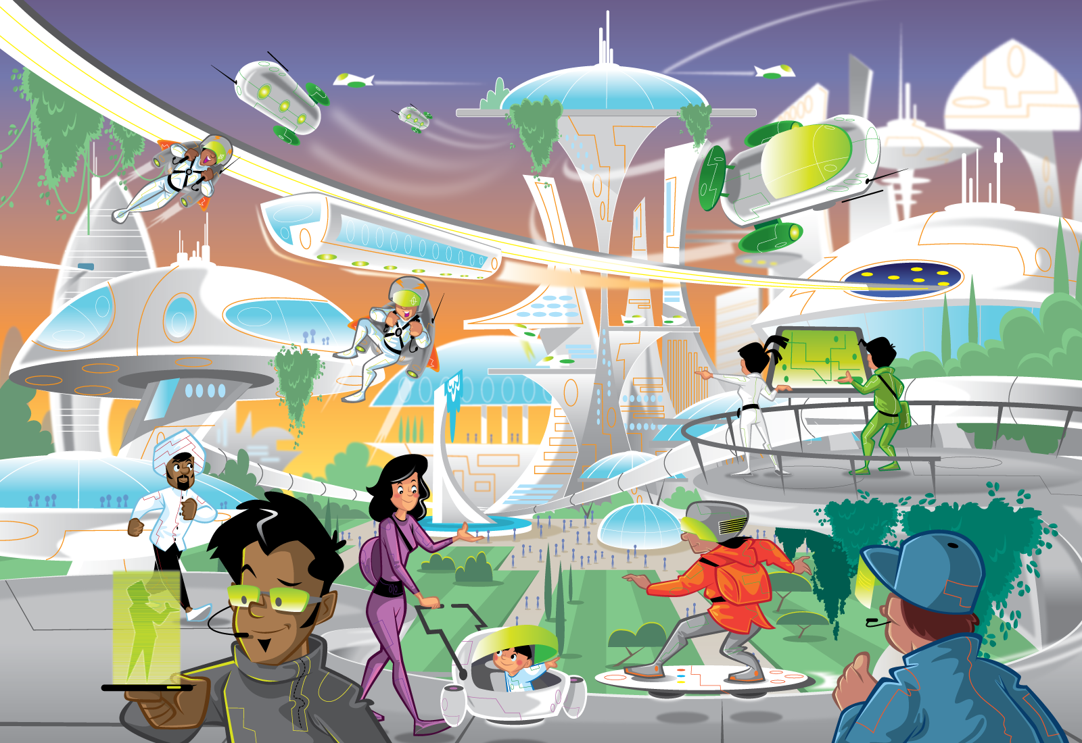  Class | 6th | Theme | Space and technology
Unit | 6 | Subtheme | Living in the future
Unit genre | Persuasive | Oral text type | Argument and debate
Vocabulary | Tier 1 examples: pollution, bustling, transport, minimal, professionals, environment, traditional, comfort, residents, luxurious  Tier 2 examples: solar energy, visor, pedestrianised, commuting, efficient, synthetic, metropolis, tranquil, amenities, elevate, mass-destruction  Tier 3 examples: hoverboard, monorail, aerodynamic, carbon dioxide
Lesson resources | N/A

Fortnightly plan
Lesson 1 | Digital poster (Story mode)  Digital poster: Talk and discussion  Pair talking task: Tell me why  Pair talking task: Who, what, when, where, why? | Lesson 3 | Digital poster (Explore mode): Talk and discussion  Pair talking task (Argument and debate): Past and present  Group talking task: Persuasive presentation
Lesson 2 | Digital poster (Story mode): Recap  Digital poster (Question mode)  Group talking task: Create a slogan | Lesson 4 | Digital poster (Let’s Talk! mode): Why the future will be better  Whole-class talking task (Argument and debate): Why the future could be worse

Lesson 1

Digital poster (Story mode)
Play either the Story mode 1 (starters) or Story mode 2 (flyers) for the class, depending on the ability level.

Digital poster (Explore mode): Talk and discussion
Go to the Explore mode of the poster. Ask students the following questions:
- What do we call an idea about the future that may or may not come true? (Speculation, conjecture, theory, hypothetical, guess, guesstimate, belief, hunch)
- The things shown in the poster are not currently a reality for us. How much of what you see in the poster do you expect might become a reality in the next ten years? In the next 20? In the next 50? In the next 100?
- Do you think these things are guaranteed to happen? What might prevent them from happening? What might make them happen sooner?
- What forms of energy are mentioned in the poster? What other forms of energy can you name? (Fossil fuels: oil, petrol, diesel, natural gas, coal, peat; Clean energy: solar, wind, water-powered; Other: nuclear, wood, etc.)
- Is there anything in the poster that you think may never happen/become a reality? Why?
Explain to students that this is a persuasive text – this means it is trying to persuade the viewer of something. What is this poster trying to persuade us of? (That the future will be good for everyone) When we listen to a persuasive text, what do we need to be mindful of? (Mix of fact and opinion – not everything in the text will be true/factual)
Ask students to list as many persuasive phrases from the poster story as they can, and to identify the type of persuasive language that each phrase is an example of (e.g. ‘Would you like to live in the city of the future?’ – question to draw the listener in; ‘Everyone in the future travels in true style!’ – Exclamation/emotive language, etc.)

Pair talking task: Tell me why
Organise students into pairs. Have pairs ask each other the following questions and explain why, justifying their answers. Remind students that as the future shown in the poster is hypothetical, they should speculate on the answers to the question and work together to determine what the most likely answer to these questions is.
Encourage students to use a range of conjunctions when explaining, e.g. because, if, unless, although, but, instead of, while, etc.
Can you explain why …
- it might be necessary to grow plants on buildings in the future?
- the future could be fully pedestrianised, when the world today is not?
- a happy society might lead to a lower crime rate?
- being able to get around without using much fuel might be necessary?
- the future might be better than the present?

Pair talking task: Who, what, where, when, why?
Organise students into pairs. Ask pairs to come up with five questions based on the poster.
Each question must begin with a different ‘Wh’ word – who, what, where, when, why. For an extra challenge, ask students how many questions they can think of that begin with ‘which’.
Have students take turns to ask their partners these questions.

Lesson 2

Digital poster (Story mode): Recap
Play either the Story mode 1 (starters) or Story mode 2 (flyers) again. Make sure students understand all of the vocabulary.

Digital poster (Question mode)
Go to the Question mode of the poster. Play each question and discuss the answers with the students briefly.
Q1. | How many people live in the city of the future?
Q2. | Name three different ways people travel in the city of the future.
Q3. | List two ways in which a hover buggy is better than a traditional buggy.
Q4. | Why do the people in this image look so happy?
Q5. | How do people in the city of the future stay healthy?
Q6. | Why is the crime rate in the city of the future so low?
Q7. | What makes hoverboards an eco-friendly way to travel?
Q8. | What do you think you would like most and least about life in the city of the future?
Q9. | Discuss your own ideas for how people could be happy, healthy and in harmony with the planet.
Q10. | Think of a vision statement of your own for a city of the future.

Group talking task: Create a slogan
Organise students in groups. Each group must choose one of the innovations/inventions/futuristic technologies shown in the poster and create a slogan or jingle that could be used to sell that thing. Remind students of the different forms of persuasive language and how they can be used (e.g. rhetorical questions to draw the listener in, emotive language to encourage them to agree with your opinion, catchy phrases, etc.)
You could assign roles to each group, e.g. illustrator, word wizard, instruction giver, presenter, etc. or have students collaborate on each element of the task. Give each group an A3 piece of paper. Each group should create a diagram or illustration of the thing they are trying to sell and give it a catchy name (e.g. the amazing aerodynamic astro-suit). Encourage students to use alliteration or rhyme in naming their item. Groups must then come up with a one-sentence slogan, or a two- or three-sentence jingle (e.g. slogan: guaranteed to up your speed! jingle: our amazing astro-suits will let you glide through the air without a care! Guaranteed to up your speed, buy yours today!)
Have each group present their slogan or jingle to the rest of the class. Groups can then rate each presentation on how persuasive they found it and how likely they would be to buy the item.

Lesson 3

Digital poster (Explore mode): Talk and discussion
Go to the Explore mode of the poster. Ask students to name as many nouns as they can under the category ‘Modes of transport’. Students should draw on the things listed in the poster as well as their own prior knowledge. List the modes of transport on the white board as they are named.
Modes of transport (Futuristic: monorail, hoverboard, jetpack, hovercar, electric car; On land, with wheels: car, bicycle, tricycle, unicycle, scooter; On land, without wheels: commuter train, bullet train, tram; On water: ship, boat, ferry, jet ski, motorboat, submarine, kayak, canoe, etc.)
Organise students into pairs or small groups. Give each pair or group three forms of transport. Ask students to list three verbs against each of their modes of transport (e.g. hoverboard – hover, float, drift; monorail – glide, speed, hurtle; jetpack – zip, zoom, fly, etc.)
Now ask pairs or groups to list one adverb to go with each verb and adverb pairing (e.g. monorail – glide swiftly, speed amazingly, hurtle instantly, etc.) Finally, ask students to build sentences about each mode of transport using at least one verb, one adverb and one adjective, e.g. The incredible monorail speeds swiftly across the sky.
Have groups or pairs share their sentence with another group or pair.

Pair talking task: Present and future
Organise students in pairs. Ask pairs to work together to make comparisons between life in the poster (future) and life today (present day). Encourage students to use long, complex sentences with as many adjectives and adverbs as possible, and to use conjunctions and comparative adjectives in their comparisons. They should also identify the particular character, object or location in the poster to which they are referring and indicate its position. They can include additional facts about the present and future in their comparisons, e.g.:
Student A: In modern times/the present/today, many people commute to work and school by car. Cars today/modern-day cars consume large amounts of fossil fuels and cause pollution and traffic congestion. The most environmentally friendly ways to travel in the present are by bike and by foot.
Student B: In the future, there are many eco-friendly ways to get around. Jet packs use very little fuel and are fun and convenient to use. This is shown by the two young workers on the left-hand side of the poster … etc.

Group talking task: Persuasive presentation
Organise students into groups of three to four. Give each group one sheet of A3 paper.
Have the students design either:
- An ideal city of the near future, which is focused on technological and social improvements that could be made in the next 20 years,
or
- An ideal city of the present, which shows how we could make the most of the technologies and systems we have in place now to improve on the way we currently live.

Students must try to convince the class why their ideal city of the near future or present would be the perfect place to live. You could assign roles for this activity, e.g. coordinator, scribe, illustrator, presentation manager, encourager, word wizard, etc. Ensure each member of each group has the opportunity to speak during the presentation.
Remind students of the key features of strong persuasive language:
- Catchy phrasing
- Play on words
- Interesting adjectives
- Communicating directly through questions
- Exaggeration
- Strong finish, etc.

Lesson 4

Digital poster (Let’s Talk! mode): Why the future will be better
Go to the Let’s Talk! mode of the poster. Play the podcast ‘Why the future will be better’ for the class.
Ask students the following questions:
- Why might people worry about the future?
- What possible benefits of the future does Ella mention?
- Which of these benefits would be most important to you? Which is the least important? Give reasons for your answer.
- Ella asks, ‘Would you like to live past 100?’ Would you like to live past 100? Can you see any downsides of living so long?
- Why might people have four-day weekends in the future?
- What does the phrase ‘history is on my side’ mean?

Encourage students to respond with their own opinions on the content of the podcast. Do they agree that the future will be better? Why or why not?

Whole-class talking task (Argument and debate): Why the future could be worse
In response to the podcast, have a whole-class debate with the topic ‘Why the future could be worse’. Write the debate topic on the white board. Start with a brainstorm. You could kick-start the discussion by using the topics in the podcast and asking the class for counter-points, e.g.
- Artificial Intelligence means people won’t have to do boring, repetitive jobs – Artificial Intelligence means jobs will be eliminated and many people will be unemployed
- Medical advances means people will live past 100 – Having so many frail elderly people will put a strain on health and government services
Once you have brainstormed some of the key points, encourage students to put forward their opinions using the language of argument and debate, e.g.:
- I strongly/thoroughly/firmly believe that …
- I agree/disagree that …
- It is believed that …
- On one hand … on the other hand…
- Furthermore/Alternatively/Significantly/In particular …
- To illustrate my point/For example …
- Firstly/Secondly/Next/Also …
- Overall/In conclusion/In summary/To summarise …
Remind students to be respectful of the opinions of others, to raise their hands before giving an opinion and to allow others to finish speaking.
Note the key points made on the white board as the debate is carried out. You could then record a response podcast from the perspective of the whole class, with an introduction and conclusion, and play this back for the class.

