Class | 5th Class | Theme | 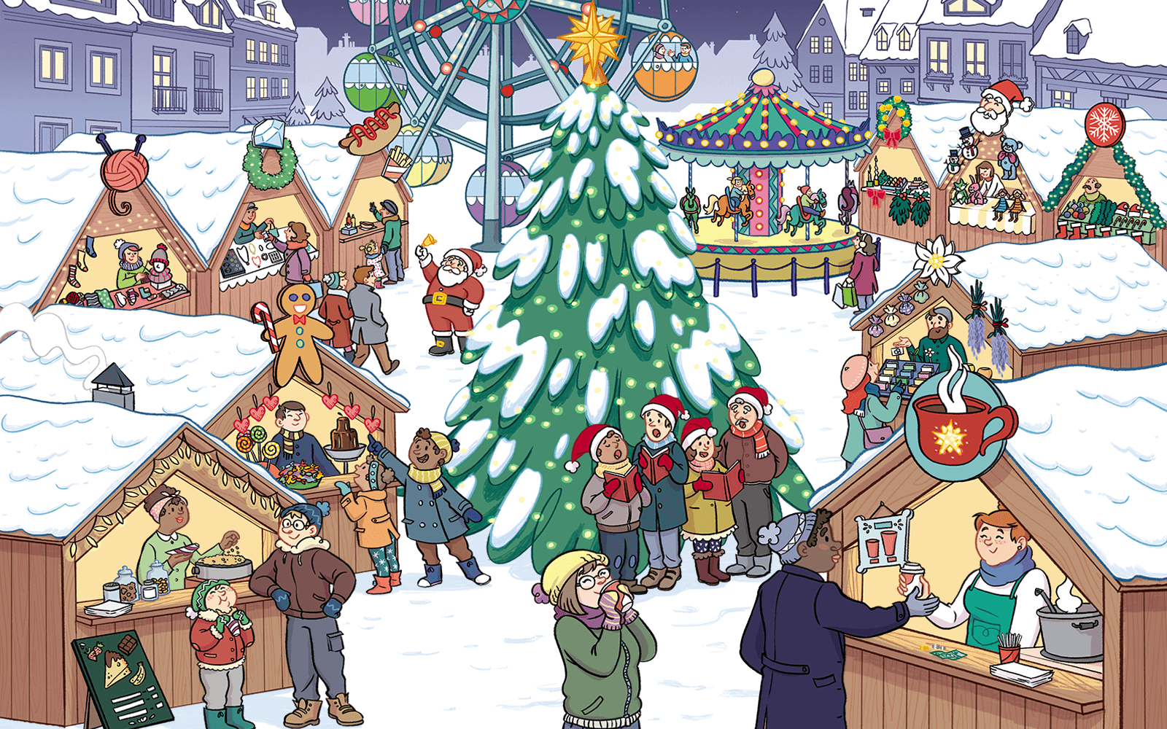  Fun and fantasy
Unit | 7 | Subtheme | Christmas
Unit genre | Narrative | Oral Text Type | Oral storytelling
Vocabulary | Tier 1: festive season, contributing, atmosphere, savouring, carousel,  squeals, carousel, Merry-Go-Round, cinnamon, carol singers  Tier 2: rousing, rendition, debating, oblige, insulated, commence, vigorously  Tier 3: literal, figurative
Lesson resources | Multimedia links

Fortnightly plan
Lesson 1 | Digital poster (Story mode)  Digital poster (Explore mode) – talk and discussion  Under the Weather; Winter Word Game; Tongue Twister | Lesson 3 | Digital poster (Explore mode) – talk and discussion  Tantalise your Taste Buds; Compare and Contrast; The Spirit of Christmas;
Lesson 2 | Digital poster (Story mode) – recap  Digital poster (Question mode)  Synonyms; Word Study; Don’t Mention it | Lesson 4 | Digital poster (Label mode)  Digital poster (Poem mode) – ‘Little Tree’  Poetry Exploration

Lesson 1

Digital poster (story mode)
Play either the Story mode 1 (starters) or Story mode 2 (flyers) for the class, depending on the ability level.

Digital poster: Talk and discussion
Go to the Explore mode of the poster. Ask students the following questions:
- When is the festive season?
- How often does it happen? (annually) What do we say if something happens every day/week? (daily/weekly)
- What symbols of Christmas can you see in this poster? (Christmas tree, star, twinkling lights, ornaments, decorations, garland, candles, Christmas stockings, boughs of holly, Christmas wreath, red ribbons, gingerbread cookies, candy cane, Santa Claus, carol singers …)
- What weather words did you hear in the story/see in the poster? (crisp air, icy temperatures, snow-covered rooftops, snow, snow flake)
- Use ONE word to Name this type of weather – icy/frosty/snowy/wintry. What other types of weather can you name? (e.g. sunny, rainy, cloudy, hailstones, foggy, misty, windy, thunder and lightening, stormy). Describe the weather: Which weather is hot (sunny), cold (frosty, snowy, stormy, foggy). wet (rain, hail, fog, mist, snow), dry (sun, wind, thunder, lightening); noisy (rain, hail, wind, thunder); quiet (sun, cloud, fog, mist, snow, lightening, frost); hard (hail, wind, thunder, frost), soft (sunny, cloudy, foggy, misty, snow); bright (sunny, snowy, frosty, lightening), dark (cloudy, rainy, foggy, misty, stormy, thunder); pleasant (sunny, snowy, frosty, windy), unpleasant (rainy, cloudy, foggy, misty); scary/frightening (stormy, thunder, lightening).
- Ask students to look out the window and give a clear description of the weather outside, using some of the vocabulary explored. Encourage students to use complex sentences appropriate to their level, e.g. While yesterday was a dull, dreary day, today is a dry, bitterly cold, frosty and wintry day but it is calm and quiet with a pleasant bright blue sky since the sun is beaming down)

Pair Talking Tasks: Under the Weather
Introduce and explain to the class some winter weather idioms. Scaffold students to understand the difference between the literal (actual) and figurative meanings (words and phrases with more imaginative meaning to give special effect).
Idioms you could explore include: Raining cats and dogs; breaking the ice; skating on thin ice; weather the storm; don’t keep me out in the cold; snowed under; blanket of snow; tip of the iceberg; put something on ice; the snowball effect; leave someone out in the cold; as snug as a bug in a rug; every cloud has a silver lining.
Organise students in pairs. Each pair must choose ONE of the idioms. On one sheet of A4 paper, each pair of students draws an image representing the literal meaning of the idiom on the left-hand side and an image representing the figurative meaning on the right-hand side. Gather up the drawings and redistribute them randomly among the class. Now give each pair of students a sheet with one idiom written on it. Students walk around the room with the sheet containing the written idiom trying to find the pair with the drawing which represents that idiom. When all the idioms and drawings have been successfully matched, each pair of students explains/puts the idiom into a sentence orally.

Lesson 2

Digital poster: Recap
Play either the Story mode 1 (starters) or Story mode 2 (flyers) for the students again. Listen and see if you can hear what words (synonyms) are used in the story that mean the same as:
Story Mode 1 (Starters)
Booth/stand (stall); delectable/mouth-watering (delicious); mementos (souvenirs); relishing/enjoying (savouring); eager (keen); favoured/crowd-pleasing (popular); aroma (scent/smell); remains/stays around (lingers); proclaims/makes known publicly (announces); energetically (vigorously); overview/panoramic view (bird’s eye view); move smoothly (glide).
Story Mode 2 (Flyers)
Goods/merchandise (wares); asked (requested); merchant (trader); considering (debating); drink (gulp); bites (morsels); choices (options); interpretation/version of a piece of music (rendition); enjoying/delighting (revelling); wrapped (insulated); begin (commence); energetically (vigorously); shrieks (squeals); favoured/crowd-pleasing (popular); aroma (scent/smell); steed/horse (mount); decorated/adorned/draped (festooned)
Word Study: Ware
Ware: Noun (goods, merchandise, commodity, stock); Related forms (glassware, silverware, hardware, software, earthenware); Verb: (beware – to guard against); Adjective (wary – to be cautious of); sounds like Wear (homonym)
Can you use it in a sentence as a noun/verb/adjective (e.g. the peddler was selling his wares at the market; the guards warned citzens to beware of the escaped prisoner on the run; people are often wary of strangers).

Digital poster (Question mode)
Go to the Question mode of the poster. Listen to each question and discuss the answers with the students briefly.

Q1. | What is taking place in the town square?
Q2. | What are the people beneath the Christmas tree doing?
Q3. | What is the lady at the bottom of the poster drinking?
Q4. | What kind of gifts can you buy at the market?
Q5. | Which stall would you go to to buy a present for your little brother or sister?
Q6. | What can be seen from the top of the Big Wheel?
Q7. | How do you know what is for sale in each stall?
Q8. | Which of the stalls could you go to if you were feeling a little cold?
Q9. | Why do lots of stalls at Christmas markets sell food?
Q10. | Why do you think Christmas markets are so popular?

Small Group Talking Task: Don’t Mention it!
Organise students in groups of three or four. Each student thinks of one word or phrase associated with the poster and gives three clues about the word or phrase to the rest of the group, without saying the word or phrase itself (e.g. Word: hot chocolate. Clues: warm; in a cup; brown; a popular winter drink) Whoever guesses the word or phrase correctly goes next.

Lesson 3

Digital poster: Talk and discussion
Go to the Explore mode with students again. Focus on sensory words describing the Christmas Market.
- Smells: aroma, scent, cinnamon, ginger, orange, chocolate, almond/marzipan pine, coffee, spicy, etc.
- Sounds: bells, singing, chatting, laughing, carousel music, traders calling out, chiming, crackling, crunching, jangling, rustling, tinkling, etc
- Tastes: aromatic, buttery, doughy, spicy, sweet, smooth, satisfying, rich, etc.
- Touch: soft, crunchy snow underfoot, warm cup, cosy scarf, biting wind, etc.
- Sight: twinkling lights, brightly coloured ornaments/garland/decorations, warmly dressed carol singers, etc.

Whole Class Talking Task: Christmas History
Watch this clip about how the Christmas Markets came into existence
History of Xmas Market https://www.youtube.com/watch?v=Wu1Eyh0WOqY. Answer the following questions:
- What is the meaning of ‘Striezelmarkt’? (named after the Stollen cake which was originally made in Dresden)
- How long has this market been in existence? (local tradition for 580 years)
- How did this market start? (meat market for people who had been fasting from meat before Christmas)
- Why is the market so popular? (atmosphere, variety of stalls, decorations, crafts, carousel, bakery/food, woodcraft)

Pair Talking Task (Oral Presentation): Tantalise your taste buds!
Organise students in pairs. Play this clip to tantalise the taste buds (Note: though the intro is in English, the people interviewed are speaking German, so you will need to read the food names aloud to the class): https://www.youtube.com/watch?v=a4ZgBUEHP-I
Now ask students the following questions:
- What food and drink are mentioned in the clip? (mulled wine, eggnog, roasted almonds/chestnuts, grilled sausage, chocolate covered banana, nutella, potato pancakes with apple sauce, gingerbread cookies)
- Can you remember any of the German words used for the food and drink? (e.g. bratwurst – sausage; kuchen – cookie; maronen – chestnuts; lebkuchenherz – gingerbread cookie).
- Have you ever seen any of those words used in Irish supermarkets?
Ask pairs to prepare a presentation of their favourite food and drink for Christmas. They should then present this to the class using mouth-watering descriptors/adjectives (e.g. steaming, delicious, scrumptious, mouth-watering, creamy, crispy, tasty, sweet, savoury, crumbly, chewy, buttery, fluffy, succulent, seasonal, rich, aromatic, chocolatey, finger-licking, lip-smacking, heavenly, piping) The rest of the class could then rate the presentations based on how appetising the foods sound.

Small Group Talking Task (Oral Report): Compare and contrast
Choose ONE of these clips of a Christmas market in Ireland.
https://www.youtube.com/watch?v=OcqjPY-hGIQ - Dublin
https://www.youtube.com/watch?v=hsuIxftdiqE - Galway
Organise students in small groups. Ask students, can you find things that are similar/different between the Dresden Christmas market and the Christmas market in Ireland? Each group reports back to the class.
Encourage the students to express contrasts using full sentences and to use a range of connectives, e.g. however, in contrast to, on the other hand, as well as, although, besides, at the same time, etc.

Lesson 4

Digital poster (poem mode): ‘Little Tree’
Go to the Poem mode of the poster and play the poem ‘Little Tree’ by E.E Cummings.
Little Tree
little tree
little silent Christmas tree
you are so little
you are more like a flower
who found you in the green forest
and were you very sorry to come away?
see I will comfort you
because you smell so sweetly

I will kiss your cool bark
and hug you safe and tight
just as your mother would,
only don't be afraid

look the spangles
that sleep all the year in a dark box
dreaming of being taken out and allowed to shine,
the balls the chains red and gold the fluffy threads,

put up your little arms
and I’ll give them all to you to hold
every finger shall have its ring
and there won't be a single place dark or unhappy

then when you're quite dressed
you'll stand in the window for everyone to see
and how they'll stare!
oh but you'll be very proud

and my little sister and I will take hands
and looking up at our beautiful tree
we'll dance and sing
Noel Noel

E.E Cummings

Encourage the students to consider how best to present this poem as a group and to speak it aloud with appropriate expression and intonation.
Ask students the following questions:
- What do you think this poem is about?
- Who do you think is speaking in the poem?
- How does the poet feel? Why?
- How is the poet displaying kindness and compassion in this poem?
- What feelings are expressed in this poem?
- How can we convey these feelings when we speak the poem aloud? (focus here on pace, volume, emphasis)
- What does the poet mean when he says ‘every finger shall have its ring’?

Support the students to see examples of the poet’s use of literary devices (personification, e.g. put up your little arms; alliteration, e.g. smell so sweetly); figurative language in the poem (e.g. like a flower)

Small Group Talking Task
Organise students in groups. Encourage each group to create a short verse describing a contemporary Christmas tree. You could combine these verses to create a longer whole-class poem. Students could then recite the poem together.

