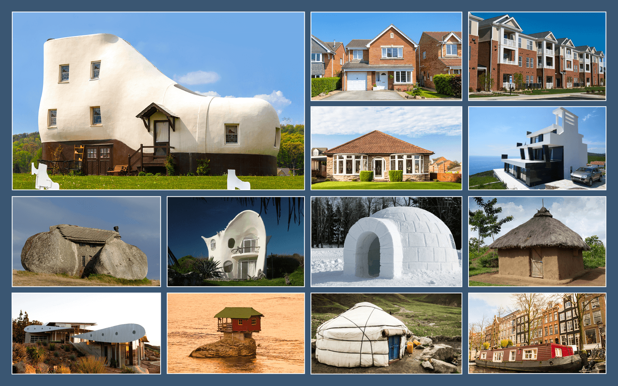  Class | 5th | Theme | Family and community
Unit | 2 | Subtheme | Homes and houses
Unit genre | Report | Oral text type | Oral report
Vocabulary | Tier 1 examples: apartments, balconies, materials, aeroplane, bungalow, architect, engineer, houseboat, unwise  Tier 2 examples: communal, submerged, techniques, premium, optical illusion, detached, semi-detached, terraced
Lesson resources | Multimedia links

Fortnightly plan
Lesson 1 | The Burrow  Digital poster (Story mode)  Digital poster (Talk and discussion)  The minister’s cat | Lesson 3 | Digital poster (Explore mode): Talk and discussion  Pair-talking task (Oral report): Where I live
Lesson 2 | Digital poster (Story mode): Recap  Digital poster (Question mode)  Class talking task: Why we need homes  Design a dream dwelling | Lesson 4 | Digital poster (Poem mode): ‘Empty House’

Lesson 1

The Burrow
Begin the theme of homes and houses by showing the students this clip of life in number 4 Privet Drive where Harry Potter lived – https://www.youtube.com/watch?v=GHXSvCMpCGM.
Ask students, what did the house look like? In what ways would you say it was a typical house? (Location, design, finish, interior, furniture, etc.)
Now show students this clip of ‘The Burrow’, the house the Weasleys lived in – https://www.youtube.com/watch?v=ZUl4amon00E.
Alternatively, read aloud this extract from Chapter 3 of Harry Potter and the Chamber of Secrets:
It looked as though it had once been a large stone pigpen, but extra rooms had been added here and there until it was several stories high and so crooked it looked as though it were held up by magic (which, Harry reminded himself, it probably was).
Four or five chimneys were perched on top of the red roof.
A lopsided sign stuck in the ground near the entrance read, THE BURROW.
Around the front door lay a jumble of rubber boots and a very rusty cauldron.
Several fat brown chickens were pecking their way around the yard.
“It’s not much,” said Ron.
“It’s wonderful,” said Harry happily, thinking of Privet Drive.

Ask students the following questions:
- Would you say this could be described as a typical house? Why not?
- How did Harry feel about this house? Why?
- Would you say he felt more ‘at home’ here? Why? (Comfortable, relaxed, welcoming, warm, loving, caring, protected, accepted, belonging, respected …)

Digital poster (Story mode)
Play either the Story mode 1 (starters) or Story mode 2 (flyers) for the class, depending on the ability level.

Digital poster (Talk and discussion)
- What word is used to depict what we see in all the images on the poster? (House)
- Sometimes, we use another word – can you think what that word is? (Home)
- Think-pair-share: Turn to your partner and think about these two words, which are often used inter-changeably. Do you think there a difference between what these two words mean? If not, why not? If you think there is a difference, how would you characterise the difference? (e.g. a house refers to a building/physical structure where people live; a home is a place where you live with members of your family/household)

Using the poster as a stimulus, introduce or prompt for further vocabulary on the theme, e.g.

- Synonyms for house (abode, dwelling, pad, residence);
- House’ in other languages – including languages spoken by students in the class (e.g. teach – Irish, maison – French, casa – Italian, Spanish, Portuguese, haus – German, huis – Dutch, hys – Swedish, etc.)
- Types of house (e.g. apartment, boarding house, bungalow, cabin, caravan, castle, cave, chalet, chateau, cottage, detached house, domicile, eco-friendly house, farmhouse, flat, guesthouse, houseboat, hotel, hut, igloo, inn, loft, log cabin, mansion, mobile home, motel, motor home, mud hut, palace, penthouse, semi-detached, shanty, suite, studio, shelter, tepee, tenement, tent, terraced house, townhouse, tree house, two-storey house, yurt, villa, wigwam)
- Features of a house (e.g. rooms, furniture, windows (skylight windows); internal doors, front door, exterior, basement, chimneys, attic, etc.)
- Materials used to construct houses (e.g. concrete, cement, chipboard, cladding, laminate flooring, slates, timber, tile, plaster, plasterboard, putty, insulation, masonry – bricks/stones, etc.)
- People who build/design houses (e.g. architect, carpenter, mason, builder, plumber, plasterer, tiler, electrician, engineer, etc.)
- Tools/equipment used in house construction (e.g. bolt, chisel, concrete mixer, drill, glue gun, hacksaw, hammer, ladder, nail, nut, ratchet, safety glasses, sander, sandpaper, screwdriver, shovel, saw, tile cutter, etc)

Small group talking task: The minister’s cat
Organise students in groups of three or four, seated in a circle.

Each child in turn completes the sentence - The minister’s cat lives in a (name a type of house, e.g. bungalow, apartment, mansion, hut, etc). The group clap three times before the next child speaks. The group which continues successfully for the longest time wins.

This game can be made easier by confining the responses to the images on the poster OR more challenging if played in alphabetical order/including an adjective to describe the house.

Lesson 2

Digital poster (Story mode): Recap
Play either the Story mode 1 (starters) or Story mode 2 (flyers) again. Make sure students understand all of the vocabulary.

Digital poster (Question mode)
Go to the Question mode of the poster. Play each question and discuss the answers with the students briefly.
Q1. | Name three styles of home that are commonly found in Ireland.
Q2. | What material is used to build the roof of a mud hut?
Q3. | For what reason did the 747 Wing House get its name?
Q4. | Can you think of another name for the Stone House?
Q5. | Why is the Stone House painted in two different colours?
Q6. | What disadvantages might there be to living in the house of the rock?
Q7. | In what ways are the igloo and the mud hut similar?
Q8. | Use two examples to say how houses can be adapted to their owners’ lifestyles.
Q9. | Most of the unusual houses shown are stand alone or one-off builds – why do you think that is so?
Q10. | Which of the houses would you most like to live in? Give your reasons.

Whole class talking task: Why we need houses
Even though the houses on the poster are mainly one-off builds, they all share some common features. Discuss the common features of houses with the class.
- Why do we need houses? (Shelter, warmth, protection from the weather, facilities)
- What facilities do we need in a house? (Cooking, eating, sleeping, hygiene)
- What are the different parts of a house that fulfil those requirements?
When an architect is designing a house all of these requirements need to be taken into consideration. Ask students to imagine they are architects. What other considerations might they have when designing a house? (Accessibility, location, what the house faces, attractive/interesting/modern design, etc.)

Small group talking task: Design a dream dwelling!
Organise students in groups of three.
Give each group the following list: swimming pool, garden shed, bathroom, basement, windows, internal doors, garden, library, fireplace, patio, staircase, welcome mat, doorbell, games room, under floor heating system, cat flap, garage, home cinema room, fitted kitchen, smart technology controls
Design your dream dwelling but your design can only include 12 items from this list. Which items will you choose? Why? Which items will you exclude? Why? Give each group ONE A3 sheet. Instruct each group to draw their design, give it a name, and justify everything that is included.

Lesson 3

Digital poster (Explore mode): Talk and discussion
Go to the Explore mode of the poster. Ask students, which house is/has/looks like … e.g:
Which house has bay windows? The house with the red roof tiles in the image underneath the two-storey red house with the garage.
Encourage the students to ask and answer questions using language that is clear and includes appropriate information.

Pair talking task (Oral report): Where I live
Organise students in pairs. Each child must pick one of the houses from the poster and pretend that they live there. They must then give a report about that house.
Encourage students to start their reports with an introduction (e.g. Today I will be reporting on my home/house/apartment/the place I live in) and clearly explain the different features of their homes in a factual manner (e.g. I live in an apartment/house with two/three/four bedrooms. It has a living room/kitchen/dining room/bathroom/kitchen-dining area/communal living space/attic.) Ask students to include at least one unusual or interesting feature or fact about the place where they live, and to end their report with a conclusion or summary (e.g. To conclude/to summarise/let me sum up by saying, etc.)
Encourage individual students to share their reports with the whole class, or with another class or teacher.

Lesson 4

Digital poster (Poem mode)
Go to the Poem mode of the poster. Play the poem, ‘Empty House’ by Gareth Owen.
Empty House
By Gareth Owen

I hate our house when there’s no one in
I miss my family and I miss the din.
The rooms and the hallway seem cold and bare
And the silence hangs like dust in the air.
What’s that sound upstairs that makes me start
Driving Fear like an icicle through my heart?
I’m imagining things, there’s nobody there –
But I have to make sure so I creep up the stair.
I stand holding my breath by the bedroom door
And hear something rustling across the floor.
Then a scratching sound, a tiny cry!
I can’t seem to breathe, my throat is dry.
In the silence I hear my own heart beating
And the rumble of water in the central heating.
I should go in but I just don’t dare
So I call aloud, ‘Is anyone there?’
Nobody answers. I push open the door
A fluttering shadow crosses the floor.
And now I see him, now understand
And I gather him gently in my hands.
‘I won’t hurt you, my friend. Don’t flutter, don’t start.’
But his body beats wild like a feathered heart.
Out through the window, watch him wheel and fly
Carrying my fear across the sky.

Ask the students to:
- Prepare a group presentation of the poem with appropriate expression to capture the mood of the poem.
- Tell the story of the poem in their own words.
- Identify all words in the poem that make it clear it takes place in a house.
- List the interesting references to our senses that the poet uses. Explore the sounds (I miss the din, rustling, scratching, cry, heart beating, rumble of water in the central heating); and images (fluttering shadow, body beats wildly, watch him wheel and fly) that the poet explores.
- Explain how the poet creates tension in the poem.

For further discussion, ask students the following questions:
- If ‘there’s nobody there’ why does the poet ‘creep up the stair’?
- What would you say are the feelings expressed in this poem?
- This poem makes great use of similes to create images. What similes can you hear? How effective do you think they are?
- How does the poet communicate the feeling of ‘fear’ in the poem?
- Have you ever been alone in your home? How did you feel? Can you think of a simile/metaphor to express your feeling?

