Class | 4th | Theme | 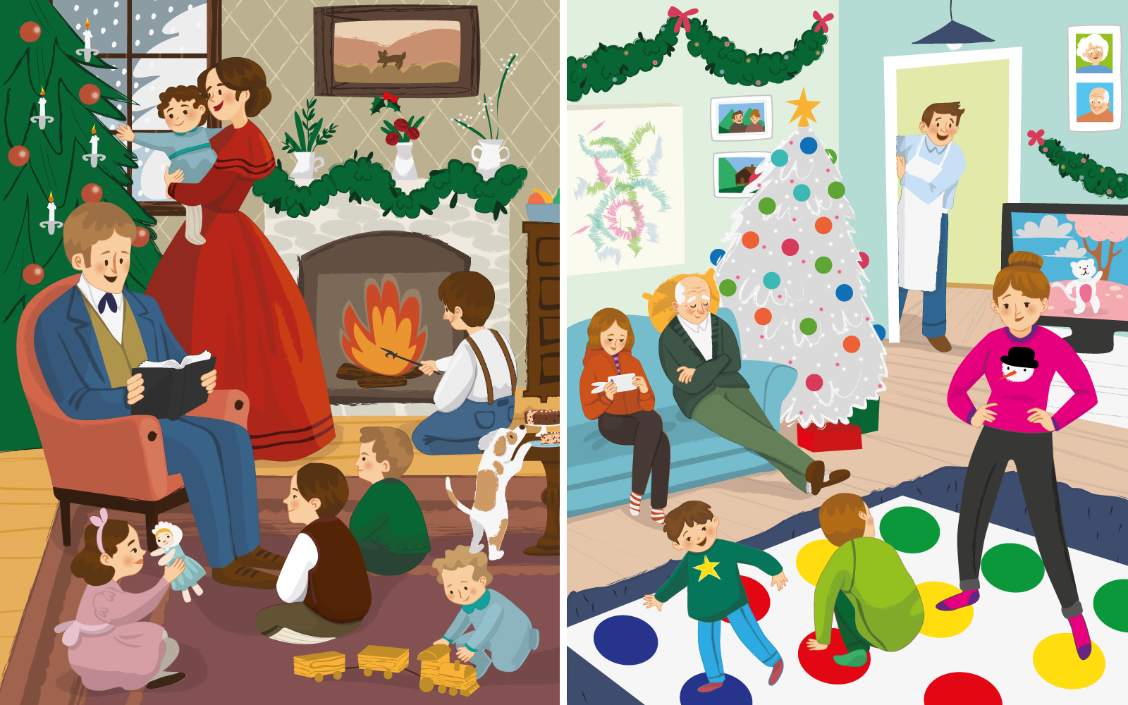  Ireland
Unit | 7 | Subtheme | Christmas
Unit genre | Narrative | Oral text type | Oral storytelling
Vocabulary | Tier 1 examples: mischief, wealthy, delicious, festive  Tier 2 examples: resemblance, shortage, energetic, engrossed, regaling,  absorbed, intended, glimmering, artificial, sourced  Tier 3 examples: garlands, boughs (of holly)
Lesson resources | Multimedia links

Fortnightly plan
Lesson 1 | Introduction: Fun Christmas facts  Digital poster (Story mode)  Digital poster (Explore mode): Talk and discussion  Pair talking task: Who does what?  Whole-class talking task: Christmas alphabet | Lesson 3 | Digital poster (Explore mode): Talk and discussion  Small group talking task: Appealing apparel  Digital poster (Let’s Talk! mode): Christmas flashcards
Lesson 2 | Digital poster (Story mode): Recap  Digital poster (Question mode)  Whole-class activity: The Christmas Miracle of Jonathon Toomey  Whole-class/pair talking task: Yuletide tongue twisters  Whole-class activity: Christmas greetings | Lesson 4 | Digital poster (Poem mode): ‘Dear Santa, Did You Get My Tweet?’  Small group talking task: Dear Santa

Lesson 1

Introduction: Fun Christmas facts
Read students the following fun Christmas facts. As you read, Ask students to listen out for ONE fact they already know, ONE fact they found surprising and ONE fact they would like to tell someone. Ask students to explain why for each fact.
- Christmas Day is celebrated on December 25^{th.}
- Two billion people worldwide celebrate Christmas.
- Many years ago, in England, traditional Christmas dinner consisted of a pig’s head served with a dressing of mustard.
- Tinsel was once made from solid silver – it was a custom that started in Germany in 1610.
- The tradition of giving naughty children a lump of coal in their Christmas stocking started in Italy.
- The tallest Christmas tree ever was 67 metres high.
- There are three towns in the United States named Santa Claus – one in Georgia, one in Arizona and one in Indiana.
- There are two islands named Christmas - Christmas Island in the Pacific Ocean and Christmas Island in the Indian Ocean
- Santa Claus is also known as Saint Nicholas, Kris Kringle and Father Christmas.

Digital poster (Story mode)
Play either the Story mode 1 (starters) or Story mode 2 (flyers) for the class, depending on the ability level.

Digital poster (Explore mode): Talk and discussion
Go to the Explore mode of the poster. Ask students the following questions:
- What do you think is the main point this poster is making about Christmas?
- What differences can you see between how we celebrate Christmas nowadays and how it was celebrated in the past?
- Do you think Cracker is a good name for a dog? Why?
- Identify the character: Without pointing, can you identify all the characters who feature on the poster? (Mum, Dad, Cormac, Feargal, Caoimhe, Father, Mother, Bridget, Stephen, Thomas, John, Patrick, Baby Mary), e.g. Caoimhe is the girl in the picture on the right, playing a game on her mobile phone while sitting on the couch beside Grandad who is sleeping. Encourage the students to identify each character using complex sentences.
- Can you explain these phrases used in the story: Pride of place; fire hazard; up to his elbows.
- How are the children in each family being entertained? Which kind of entertainment would you like best? What do you do on Christmas day for entertainment?

Pair talking task: Who does what?
Organise students into pairs. Have students consider the following questions in their pairs:
- What age do you think each character is in each family?
- Who looks to be in charge in each family? Think about the role played by the 1860s father as compared to the modern-day dad.
- Is there a difference in how the children behave in each family? Give examples.
Encourage pairs to share their answers with the class and to justify their thoughts.

Whole-class talking task: Christmas alphabet
This game can be played in groups or with the whole class.
With the poster as a stimulus, each child contributes ONE word associated with Christmas to build a full ‘Christmas alphabet’. The words must be in alphabetical order, e.g.:
A: angel, advent, artificial; B: bells, box; C: candle, candy cane, celebrate, chimney, cookie, chilly, cosy; D: decorate, dashing; E: elf; F: fir tree, family, festive, frosty; G: greetings, glowing, goodwill, gifts, garland; H: ham, happy, holly, hearth; I: icicle; J: jingle, jolly, lights; M: merry; N: Noël, North Pole, nostalgic; O: ornaments; P: package, parcel, party, plum pudding, presents; R: reindeer, receive; S: Scrooge, shepherds, spirit, snow, scarf, stocking, spices, season; T: tinsel, tradition, toboggan, twinkling, tidings, trimmings; U: unwrap; V: visit, Vixen; W: Wenceslaus, wrapping, wish, wise men, wreath; X: Xmas; Y: Yule log/tide
You could record the Christmas alphabet on an A3 sheet or on the whiteboard.

Lesson 2

Digital poster (Story mode): Recap
Play either the Story mode 1 (starters) or Story mode 2 (flyers) for the students again. Make sure they understand all of the vocabulary.

Digital poster (Question mode)
Go to the Question mode of the poster. Listen to each question and discuss the answers with the students briefly.

Q1. | What is the weather like outside in the 1860s scene?
Q2. | What is Caoimhe doing in the modern scene?
Q3. | Why is Dad wearing an apron in the modern scene?
Q4. | How is the 1860s house heated?
Q5. | What do you think will happen when the 1860s family notice what the dog is doing?
Q6. | Name three things from the modern scene that wouldn’t have happened in 1860.
Q7. | Name two things that both the modern and the 1860s Christmas have in common.
Q8. | Why do you think most people don't decorate their Christmas tree with lighted candles these days?
Q9. | What differences do you notice between the 1860s clothes and modern clothes? Which would you rather wear and why?
Q10. | What might be the good things about an 1860s Christmas, compared with a modern Christmas?

Whole-class activity: The Christmas Miracle of Jonathon Toomey
Listen to or read aloud for the class the story of The Christmas Miracle of Jonathon Toomey, by Susan Wojciechowski. (See read aloud version on YouTube: https://www.youtube.com/watch?v=wTaBQPRF76E. Begin at 0.30 – approx. 15 minutes)
As you listen, encourage students to find the signs of Christmas that feature in the story. Afterwards, Ask students the following questions:
- Is this a contemporary story? How do you know? (e.g. clothes, food, no hospitals, travelled in a wagon, etc.)
- How were the Widow McDowell and Jonathon Toomey similar? (Widowed – each of them had lost a spouse)
- Would you say that the Widow McDowell was nostalgic? Why? (She was anxious to get the crib in time for Christmas Day because she had lost the one her grandfather had carved for her)
- What did the characters in the story do for entertainment? How was it different from what we do for entertainment?
- What sounds could be heard in the story? (e.g. church bells chiming, carving knife scraping, knitting needles clicking)
- Describe the food in the story. (Sticky raisin buns, warm corn bread, delicious sweet molasses cookies)
- Thomas was very anxious that the carved figures had the same feelings as those of the crib that was lost. Can you remember the feelings represented on each of the figures? (e.g. happy sheep, proud cow, important angel, etc.)
- Why do you think this story is about a miracle? What was the miracle in the story?

Whole-class/pair talking task: Yuletide tongue twisters
Invite students to try get their tongues around these Yuletide tongue twisters!
- Seven Santas sang silly songs
- Tiny Tim trims the tall tree with tinsel
- Comet cuddles cute Christmas kittens carefully
- Hollie hangs holly here hoping happy holidays hurry
To introduce a further challenge, Organise students into pairs and have each pair create their own Yuletide tongue twister. Encourage the pairs to share their tongue twisters with the class and try it out on friends.

Whole-class activity: Christmas greetings
Teach students how to sing a Christmas Carol using Lámh: https://www.youtube.com/watch?v=0Ss_yNZyA0I

Lesson 3

Digital poster (Explore mode): Talk and discussion
Go to the Explore mode with students again. Focus on the mother in each image. Use the images of the two mothers as a starting point to have a whole-class discussion on the topic of CLOTHES.
The discussion takes the form of a comparison of clothes from long ago with clothes nowadays, including characteristics such as colour, design, fabric, style, naming items, range of clothing.
Zoom out to explore how clothing is similar and different and why. Encourage students to name the different items they see, e.g. suits, trousers, dresses, long skirts, boots, stockings, puffed sleeves, high/lace collar, kerchief, waistcoat, petticoat, buttons vs jeans, runners, hoodies, babygro, sweatshirt, belt, zip, socks, etc.
Ask students, do you think Caoimhe/Cormac would like to wear the clothes worn by children in 1860? Would you like to wear these clothes? Why or why not?
Ask students to name items of clothing worn by: different age groups; male and female clothing; clothes for different seasons; weather; occupations (uniforms); clothing for different activities (e.g. games, dancing, bed, swimming, etc.); dress-up clothes (superheroes, fairies, witches, etc.) and different general categories of clothing (e.g. shoes, coats, hats, etc.)

Small group talking task: Appealing apparel
Have a whole-class discussion about the clothes of characters in various Christmas movies.
Contrast traditional and contemporary clothing by playing the trailers of contrasting Christmas movies, e.g.:
Old-fashioned
A Christmas Carol: https://www.youtube.com/watch?v=AEyKKt9EfeI
It’s a Wonderful Life: https://www.youtube.com/watch?v=6jB4Vsi1UUM
Miracle on 34th Street: https://www.youtube.com/watch?v=lo5OmGDjZEQ
Contemporary
Elf: https://www.youtube.com/watch?v=gW9wRNqQ_P8
Home Alone: https://www.youtube.com/watch?v=jEDaVHmw7r4
The Polar Express: https://www.youtube.com/watch?v=TQhRqtt-Fpo
Ask students, what do you notice about the clothes the characters are wearing? (e.g. colour, fabric, design, pattern, etc.) Can you see any difference between the clothes worn long ago and today? (e.g. breeches vs trousers; jackets vs jumpers; cloaks vs coats; top hats vs beanies, etc.)

Digital poster (Let’s Talk! mode): Christmas flashcards
Go to the Let’s Talk! mode of the poster. Click on each flashcard showing an item from the past and from today. Ask the students to discuss whether the items from today have improved our lives or made it worse.

Lesson 4

Digital poster (Poem mode): ‘Dear Santa, Did You Get My Tweet?’
Go to the Poem mode of the poster and play the poem, ‘Dear Santa, Did You Get My Tweet?’ by Kenn Nesbitt.
Dear Santa, Did You Get My Tweet?
By Kenn Nesbitt

Dear Santa, did you get my tweet
of presents I would think are sweet?
And what about my Facebook post
of toys and stuff I want the most?

Dear Santa, did you read my blog?
That’s where I keep a running log
of all the times that I’ve been good
and doing things I know I should.
I hope you saw my Instagram,
my email wasn’t flagged as spam,
you’ve seen my YouTube channel too
and all my texts have made it through.

Wait, does the North Pole even get
computers and the Internet?
I hope it does. I mean, it better,
or I might have to write a letter.

Encourage students to join in and speak the poem with expression. Ask students the following questions:
- What contemporary forms of communication are mentioned in the poem?
- How are each of these similar/different?
- How are they different from communication long ago?
- What are the advantages and disadvantages of each?

Small group talking task: Dear Santa
Organise students in small groups. Each group must compose a letter to Santa as one of the children in the 1860s picture. Have each group present their letter to the class. You could then have students add illustrations to their letters and display them as a whole-class display.

