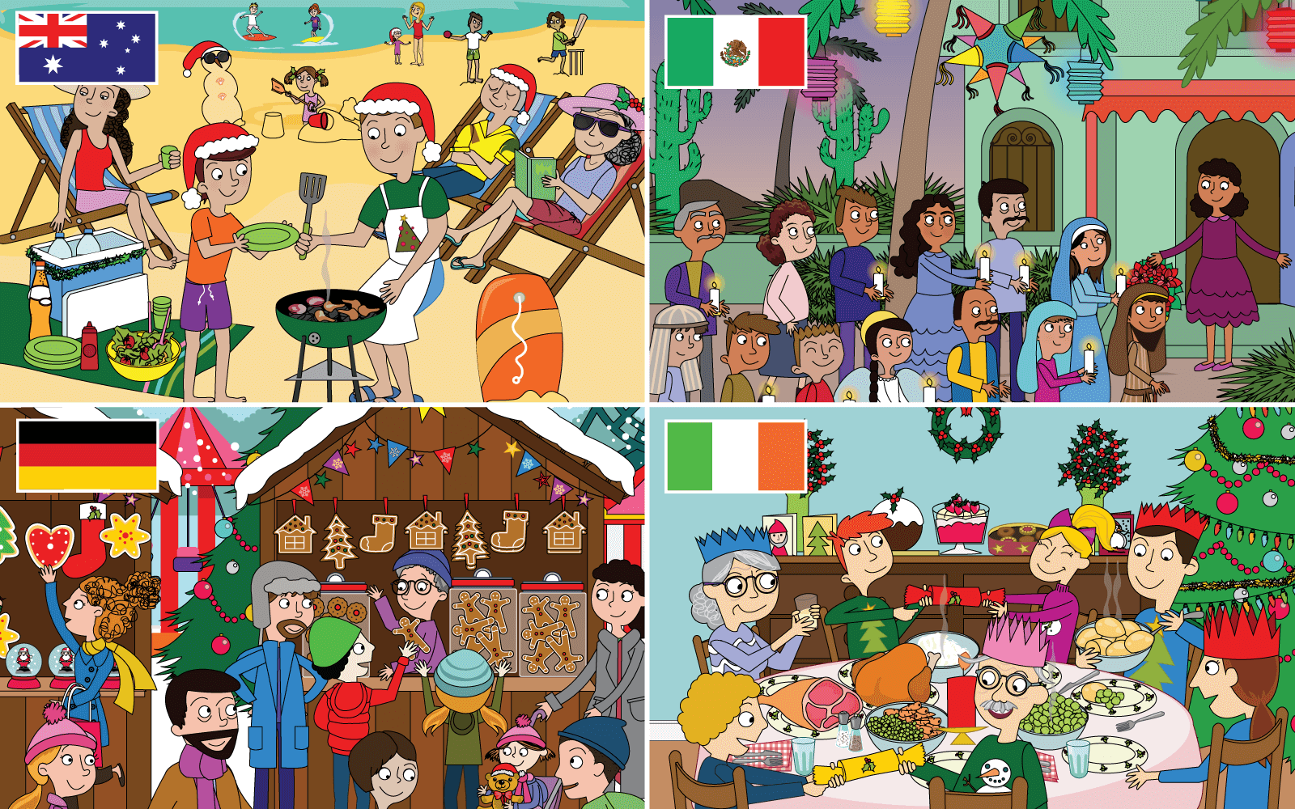  Class | 3rd Class | Theme | People and places
Unit | 7 | Subtheme | Christmas
Unit genre | Narrative | Oral text type | Oral storytelling
Vocabulary | Tier 1 examples: countries, barbeque, cool box, stall,  Christmas market, Christmas carol, decorations  Tier 2 examples: customs, cultures, traditions, festive, scorching, essential,  illuminated, browse, procession, re-enact
Lesson resources | Gingerbread Man

Fortnightly plan
Lesson 1 | Digital poster (Story mode)  Digital poster (Explore mode): Talk and discussion  Children around the world  Pair talking task: Same and different | Lesson 3 | Digital poster (Explore mode): Talk and discussion  Pair-talking task (storytelling): A Christmas tale  Small group talking task: Festive Christmas table quiz
Lesson 2 | Digital poster (Story mode): Recap  Digital poster (Question mode)  Pair talking task: Word tennis | Lesson 4 | Digital poster (Poem mode): This year I will stay awake  Barrier game (Giving instructions): Decorate a gingerbread man

Lesson 1

Digital poster
Play either the Story mode 1 (starters) or Story mode 2 (flyers) for the class, depending on the ability level.

Digital poster: Talk and discussion
Go to the Explore mode of the poster. Ask students the following questions:
- What festival are we talking about in this poster?
- When do we celebrate Christmas?
- What does it mean when we say we ‘celebrate’? (e.g. to do something special to enjoy an important occasion). Lots and lots of people all around the world celebrate Christmas. Let’s see HOW people celebrate!
- A very important thing we do to celebrate Christmas is to wish others a Happy Christmas. Can you think of what we say? (e.g. Merry Christmas, Christmas Greetings, Happy Holidays, Have a Happy Christmas, Seasons Greetings etc). How do we say this in Gaeilge? (Nollaig Shona Duit!)
- What kinds of special things do we do when we celebrate? (e.g. Family, friends, food, decorations, greetings, games, clothes, gifts …).
Explain that when we do the same kinds of things for a festival every time we celebrate the festival we call them customs, and if the things we do are similar to what generations of people who lived before us did, we call these activities ‘tradition’ (consider here also the term ‘traditional’)
Zoom in on the image of the Irish Christmas celebration on the bottom right hand side of the poster. Perhaps replay the story mode for this image. Explore the poster for examples of Christmas customs which are traditional at Christmas in Ireland, E.g.

- Dinner: meat – turkey, ham, vegetables – peas, carrots, brussel sprouts, potatoes (boiled, mashed, roast), plum pudding, sherry trifle, biscuits; Increase the language challenge by adding:
- categorical terms for food containers (e.g. bowl of trifle, tin of biscuits, cutlery, crockery, glassware, table linen etc.)
- adjectives to describe the food (e.g. steaming, delicious, scrumptious, mouth-watering, creamy, crispy, tasty, sweet, savoury, crumbly, chewy, buttery, fluffy, succulent, seasonal, rich etc)
- verbs (e.g. slice the turkey, pour the gravy, scoop the mashed potatoes, choose a biscuit, enjoy
the trifle)
- Christmas Symbols: e.g. Christmas carols, candles, star, bells, angels, candy canes, gingerbread men, yule log, elves, tree, holly, mistletoe …)
- Decorations: ornaments, tree (pine, fir, needles, tinsel, lights, baubles, shiny, glowing, glittering, twinkling); holly/wreath (prickly, red berry, red/green), candle
- Clothes: Christmas jumper (signs of Christmas – robin, snowman, tree, star …), Party Hats – made of coloured paper, serrated edge, looks like a crown

Christmas around the world
Encourage students from other countries to share their Christmas greetings with the class (E.g. https://www.youtube.com/watch?v=fAF0o9ls598)
Have students listen and sing-a-long to the song Felize Navidad (E.g. https://www.youtube.com/watch?v=uDm4XgqTtDg.) Afterwards, ask them if they can say the word ‘Happy’/’Christmas’/’Year’/’Prosperous’ in Spanish.

Pair talking task: Same and different
Divide students into pairs. Have them take turns to describe how they celebrate Christmas. Afterwards have one student from each pair describe what is the same/different about how they both celebrate Christmas?

Lesson 2

Digital poster (Story mode): Recap
Play either the Story mode 1 (starters) or Story mode 2 (flyers) for the students again. Make sure they understand all of the vocabulary.

Digital poster (Question mode)
Go to the Question mode of the poster. Listen to each question and discuss the answers with the
students briefly.
Q1. | In which country is the market in the bottom-left picture?
Q2. | Look at the top-left picture. What game can you see children playing?
Q3. | Look at the bottom-right picture. What can you see hanging on the wall?
Q4. | Why are children dressed as Mary and Joseph in the top-right picture?
Q5. | Do you think the people in the bottom-right picture are enjoying themselves? How do you know?
Q6. | How do the pictures tell us which country is which?
Q7. | Why might you feel hungry when you visit a German Christmas market?
Q8. | What might you need to take with you if you visit Australia for Christmas Day?
Q9. | Can you describe another Irish Christmas tradition?
Q10. | What is different about Christmas in the four countries? What is similar?

Zoom in on the image of the Christmas celebration in Australia on the top left-hand side of the poster. Perhaps replay the story mode for this image. Discuss examples of Christmas customs which are traditional at Christmas in Australia. Ask students the following:
- What can you tell about how Christmas is similar in Australia? (e.g. celebration, family, food, games, fun …)
- Do you notice any differences in the traditional celebrations in Australia? (e.g. Food, Clothes, Decorations – fake holly, games, location, weather …)

Pair talking task: Word tennis
Divide students into pairs. Tell them to focus on the images of Christmas in Ireland and in Australia. Students then take it in turns to name contrasting customs/opposites in each poster, e.g.
Student A: I see a Snowman in the picture on the bottom right of the poster
Student B: However, I see a Sandman in the picture on the top left of the poster
Other possible examples: inside/outside, beach/house, cold weather/warm weather, deckchairs/dining chairs, sunhat/party hat, china plates/paper plates, steel cutlery/plastic cutlery, salad/vegetables, burgers/turkey and ham, hot drinks/cool drinks, real holly/fake holly
Encourage the students to express contrasts using full sentences and to use a range of connectives, e.g. however, in contrast to, on the other hand, as well as, although, besides …

Lesson 3

Digital poster: Talk and discussion
Go to the Explore mode with students again. Zoom in on the image of the Christmas market in Germany on the bottom left hand side of the poster. Perhaps replay the story mode for this image. Ask students the following:
- Can you hear a word that means cheerful/joyful/jolly/celebratory (festive), fair (market), stand (stall), lit up (illuminated), made skilfully by hand (hand-crafted), scent (aroma), glittering (twinkling), biscuits (cookies)
- What traditional Christmas symbols can you see/hear in this image? (e.g. bells ringing, people buying gifts, twinkling lights, decorations, delicious treats, Christmas tree, star, Christmas stocking, gingerbread …)
Zoom in on the image of the Christmas in Mexico on the top right-hand side of the poster. Perhaps replay the story mode for this image. Ask students the following:
- What is the word used to describe the religious procession in Mexico? (Posada)
- Does the story re-enacted by the people in Mexico remind you of another story? (If students of other religions are in the classroom, encourage them to share their religious customs at Christmas)
Spotlight the Piñata. Ask students the following:
- Do you know what this is? (Papier maché, brightly coloured container filled with sweet treats)
- Do you notice anything in particular about this one? (Shape of a seven-point star). Why do you think this is? What do you think is inside it? Why?

Pair talking task (storytelling): A Christmas tale
Divide students into pairs. Have them pick one of the scenes from the poster and create a story based on the poster scene. Tell them to start by identifying the character(s) (person), the setting (place) and the problem (plot) and write these words on the board. Remind them that a story has a beginning, middle and end.
Students brainstorm their story and then retell the class or another pair.

Small group talking task: Festive Christmas table quiz
Divide students into small groups. Give one student in each group a pen and some paper. Ask a variety of questions associated with Christmas. Students may confer with one another and agree on the correct answer – this may have a time limit. (This task may be made easier by providing a multiple-choice option/more time. It may be made more challenging by encouraging each group to contribute one question to the quiz).
Sample Quiz questions:
- What date is Christmas Day?
- What do we call the leaves of a Christmas Pine Tree? (needles)
- What decorations are round and glittering? (baubles)
- What decoration rhymes with ‘jolly’ (holly)
- Name two winter sports that we can play on snow (snowball fight, sledding)
- What Christmas cookie is shaped like a human? (gingerbread man)
- Complete the phrase: sleigh bells (ring); under the (tree); (Christmas) cracker/stocking/card/carol; (Candy) cane; (hot) chocolate

Lesson 4

Digital poster (poem mode): This year I will stay awake
Go to the Poem mode of the poster and play the poem, This year I will stay awake.

This year I will stay awake
by Paul Cookson
This year I will stay awake
all night long make no mistake.
On this Christmas Eve I'll keep
my eyes open, try to peep.
This year I won't drowse or dream
but be alert till Santa's been,
see just what he leaves and how
he fits down our chimney now,
how the presents all appear
hear the sleigh bells and reindeer.
This year I will not count sheep
but pretend to be asleep.
No catnaps or snoozing but I
won't drop off and get some shut-eye.
This year there will be no slumber
I won't let myself go under.

No forty winks or throwing zeds.
No blinking, kipping, heavy headszz.
This year I won't nod or doze
Or let my heavy eyelids close.
This year I won't nod or doze
or let my heavy eyelids close.
or let my heavy eyelids close.
or let my he..avy eye..li..ds clo..se.
or let my he..avy eye..liiids clo..zzzzzzzzzzzzzzzzzz.

Students speak the poem with expression, slowing down the pace, reducing volume as they reach the end of the poem. Ask them the following questions:
- What words to describe sleep can you hear in the poem (drowse, dream, count sheep, catnap, snoozing, drop off, shut-eye, slumber, forty winks, doze)
- Do you know any other words for sleep – asleep, sound asleep, fast asleep, sleepy, sleep in, sleep over, beauty sleep, kip, sleepwalk, take a nap, land of Nod, sleep like a log, sleep tight, don’t let the bedbugs bite
- What words in the poem express the opposite meaning (stay awake, eyes open, alert)
- Why does the child want to stay awake?
- What do you think happened?
- Storytelling: Have you ever tried to stay awake? Tell us when, why, what happened

Barrier game (Giving instructions): Decorate a gingerbread man
Divide students into pairs. Each pair has an outline of a gingerbread man and an identical set of colouring pencils/crayons (See Resource 1). One student gives instructions on how to decorate the picture, while decorating. The other student follows the instructions. E.g.
- Draw … eyes that …
- First, next, after that, when, if, unless …
- Above, below, beside, on, in the centre …
At the end they compare the pictures to see how clearly the instructions were given/how well the instructions were received

Lesson Resource 1

