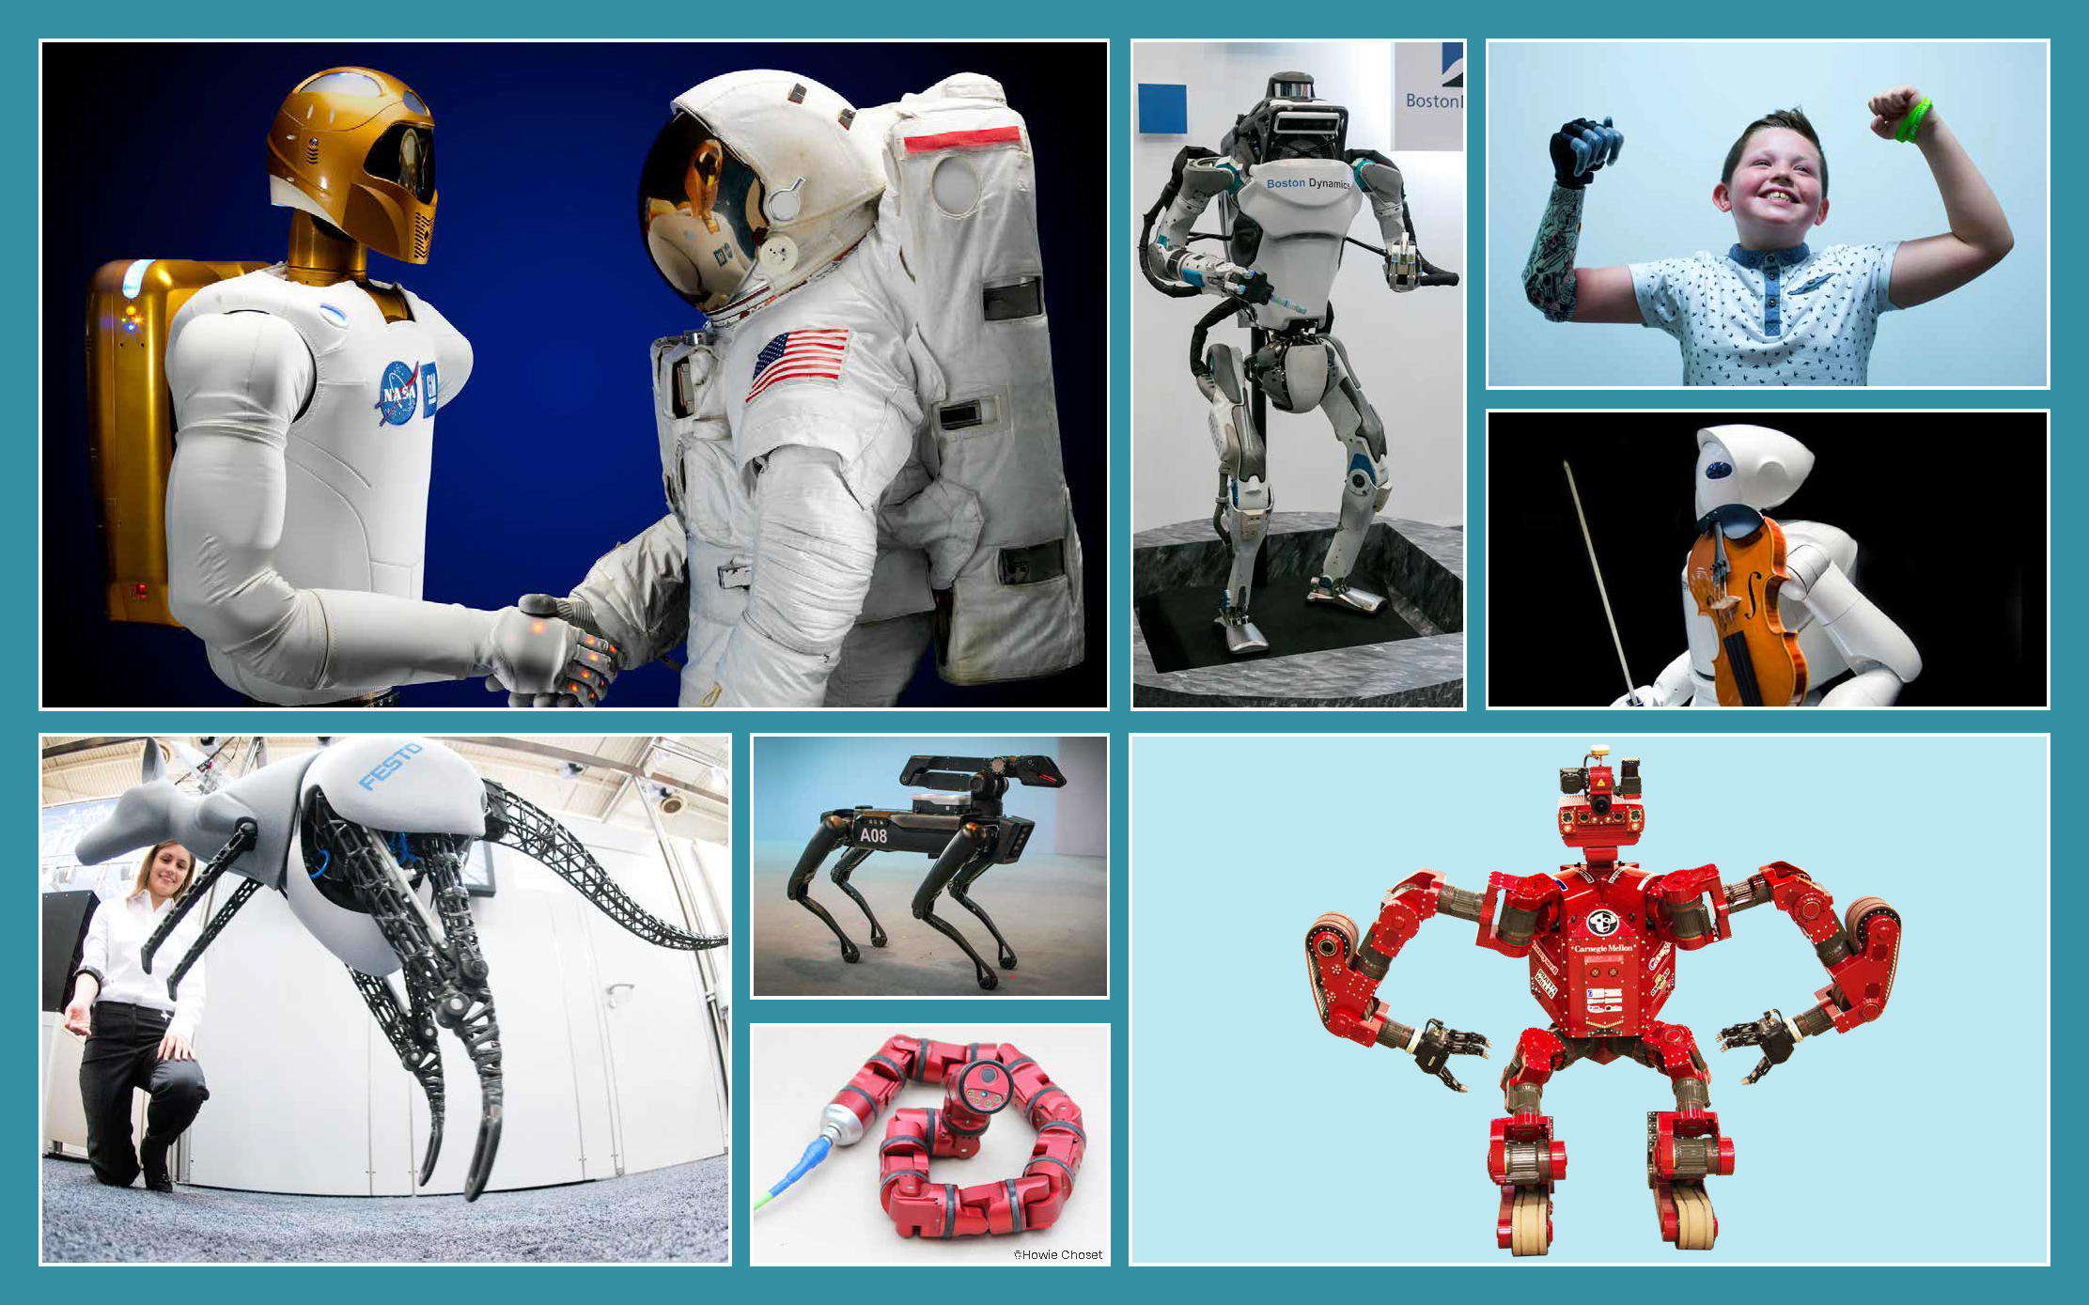
Class | 3rd Class | Theme | Space and technology
Unit | 6 | Subtheme | Robots
Unit Genre | Persuasive | Oral text type | Argument and Debate,  Giving Instructions
Vocabulary | Tier 1 examples: computer, remote control, head set, command, factories  Tier 2 examples: design, artificial, technology, terrain, mechanical, perform, complicated, manipulate, accurately, rigid, flexible, dynamic, innovation, dexterity  Tier 3 Examples: humanoid, bionic, sensors, prototype
Lesson resources | Multimedia link

Fortnightly plan
Lesson 1 | Digital poster (Story mode)  Digital poster (Explore mode): Talk and discussion  Word Study  Pair talking task: Robotalk | Lesson 3 | Pair talking task: Which one am I?  Digital poster (Let’s Talk! mode): Podcast  Oral presentation (Argument and Debate): Robot or Notrobot!
Lesson 2 | Digital poster (Story mode): Recap  Digital poster (Question mode)  Pair talking task (Giving instructions): On My Command | Lesson 4 | Oral presentation (Argument and Debate): Buy our Robot

Lesson 1
Digital poster (Story mode)
Play either the Story mode 1 (starters) or Story mode 2 (flyers) for the class, depending on the ability level.

Digital poster (Explore mode): Talk and discussion
Go to the Explore mode of the poster. Using the image as a stimulus, elicit/introduce and explain as appropriate the characteristic features of robots. Ask students the following questions:
- Look at the first picture on the top row. One of these is a robot. Which one do you think?
- What words to do with robots did you hear in the story/do you know? (E.g. technology, scientists, design, create, remote control, computer, command, sensors, metal, grabber, tasks, perform, manipulate, dangerous, space)
- Do you know why robots were invented? (E.g. to perform complicated tasks better than humans can – more easily/safely/accurately)
- What do robots do? We can understand the answer to this question if we know that the word ‘robot’ originally came from Robota - a Czech word which means drudgery/hard work. Robots do tasks which are repetitive, dangerous or difficult for humans
- What are the parts of a robot? (E.g. sensors that allow it collect information from its environment, a computer which processes the information and make decisions; mechanical parts, such as motors, pistons, wheels, grabbers/grippers to carry out tasks.)
- Can we generate a definition of what a robot is using robot words that we know? Encourage the students to think of an over-arching/superordinate term (E.g. machine/device designed/created/manufactured/programmed by humans); descriptive words (E.g. smart, android, mechanical, metal, plastic, stiff/rigid, flexible); information on what robots do (E.g. carries out commands/instructions, collects information from the environment through sensors, controlled by computer, performs actions using mechanical parts, dexterity, developed by scientists/engineers, designed to help people)
- Zoom out to reveal all the images on the poster. Can you remember the names of the robots we can see on the poster? (Robonaut, Atlas, Bionic Kangaroo, Spot Mini the Dynamic Dog, Snakebot, Chimp the Robot).

Word Study
Think about the names of the robots in the poster. What can we tell about each robot from the name? (E.g. Robonaut – Robot and Astronaut; Atlas is a Humanoid robot – something which resembles a human but isn’t a human; Bionic – having artificial body parts; Spot Mini – miniature version of something; Boston dynamic – constantly changing; Snakebot – Snake shaped Robot). Consider here also forms of the word ‘robot’, e.g. robotic – having the characteristics of a robot.

Pair Talking Task: Robotalk
Ask students how they think a robot sounds when it talks (no intonation, slow, steady pace, no variation in pitch). In pairs, tell them to choose any one of the humanoid robots featured in the poster (Robonaut, Atlas, Violin player). Each pair must prepare a short introduction (2-3 sentences)to the robot (e.g. its name, a description of it, its capabilities). They must then turn to another pair of students and introduce their robot to them using a robotic speaking voice. The other pair must guess which robot they are.

Lesson 2
Digital poster (Story mode): Recap
Play either the Story mode 1 (starters) or Story mode 2 (flyers) for the students again. Make sure they understand all of the vocabulary.

Digital poster (Question mode)
Go to the Question mode of the poster. Listen to each question and discuss the answers with the children briefly.

Q1. | What does a humanoid robot look like?
Q2. | Look at the picture of the kangaroo robot. How is the woman controlling the robot?
Q3. | Which three robots help rescue people?
Q4. | Look at the picture of Chimp. Why is it important that Chimp can grip things in its hands?
Q5. | Look at the picture of Spot Mini. Explain in your own words how it can reach out and carry things.
Q6. | Why is it useful for Snakebot to be able to slither through small, narrow spaces?
Q7. | Why do you think it is important that Robonaut will eventually work outside in space?
Q8. | Which robot do you think is most useful? Why?
Q9. | List three tasks you would like a robot to do for you. Explain why you would like a robot to do these tasks.
Q10. | What is your opinion of robots? Are you worried they will take over our lives or do you look forward to having more robots around? Explain your reasons.

Pair Talking Task (Giving Instructions): On My Command
Child A: Takes on the form of a robot and stands stiff and still without making eye-contact
Child B: Gives the robot instructions to carry out (E.g. turn, stop, move, crouch, bend, stretch, extend, lift, drop, grab, squeeze, open/shut, write etc.)
The children then switch roles.

This talking task could be made more challenging by adding adverbs to the instructions (E.g. quickly/hastily, slowly, carefully/cautiously, gently, noisily, quietly etc.)

Lesson 3
Pair Talking Task: Which one am I?
Go to the Explore Mode of the poster. Tell each child to choose one of the robots on the poster. Their partner must describe which robot it is and where it is located on the poster.
Child A: Which robot is… (e.g. Snakebot)
Child B: It is the robot which… (e.g. is in the picture beside (near/adjacent to), above, below, between, on the top/bottom/right/left); looks like/resembles/has - human/animal features; hinges, grabbers, equipment)
The children then switch roles.

Digital poster (Let’s Talk! mode): Podcast
Go to the Let’s Talk mode of the poster. Play the Let’s Talk podcast for the class.

Discuss: Robots will replace humans in millions of jobs by the year 2030. Ask students if they think this is this a good thing? (Think Pair Share)

Have students watch a video of ‘Pepper the Robot’ the latest recruit to work in Pizza Hut: https://www.youtube.com/watch?v=bjsC50IL454
Ask students if they think Pepper is doing the job better/worse than a human.

Oral Presentation (Argument and Debate): Robot or Not Robot!
Begin with a whole-class brainstorming of how robots are different from humans? (E.g. made of …; made by …; can only perform the actions that they are programmed to make; cannot think; cannot feel; limited to what they are built to do…)

Divide students into groups. Each group must generate a list of:
- What can robots do that humans can’t / don’t want to do (E.g. lift heavy objects, do tasks without taking a break, repeat the same task without getting tired or bored, extreme sensing capabilities – can see through walls, hear faint sounds etc.)
- What humans can do that robots can’t do (E.g. robots don’t eat, sleep, dress themselves, understand comedy, feel pain, sadness, unhappiness, understand someone else’s feelings, trust someone, think for themselves, create, e.g. a piece of art)

Ask students to think about this statement from the Let’s Talk Podcast: Can robot workers really be good for mankind?
Tell students to discuss within their group which they think is a better worker, a robot or a human and why? Encourage them to start their discussion with In my opinion having robot workers is good for mankind because… OR I disagree because…
Encourage students to use the language of argument and debate (E.g. I believe…; My personal opinion is…; This is a good idea because…; If you think about…) to persuade the other members of the group that their opinion is the correct one.

Lesson 4
Oral Presentation (Argument and Debate): Buy our Robot!
Divide students into groups. Tell them they must design a brand new robot and then try to persuade their classmates that they should buy their robot.

Write the following on the board to help students create their robot:
- Our robot is called…
- Our robot looks like…
- Our robot can…
- You would really like our robot because …

Groups must take turns to convince the rest of the class to buy their robot using language of persuasion (E.g. We all know that/We all agree that…) One student in the group should play the robot. Other members of the group can demonstrate the robot to the rest of the class by giving the robot instructions and asking it questions.

When making their pitch encourage students to use short sentences, strong, positive adjectives, interesting verbs and adverbs and catchy slogans.

