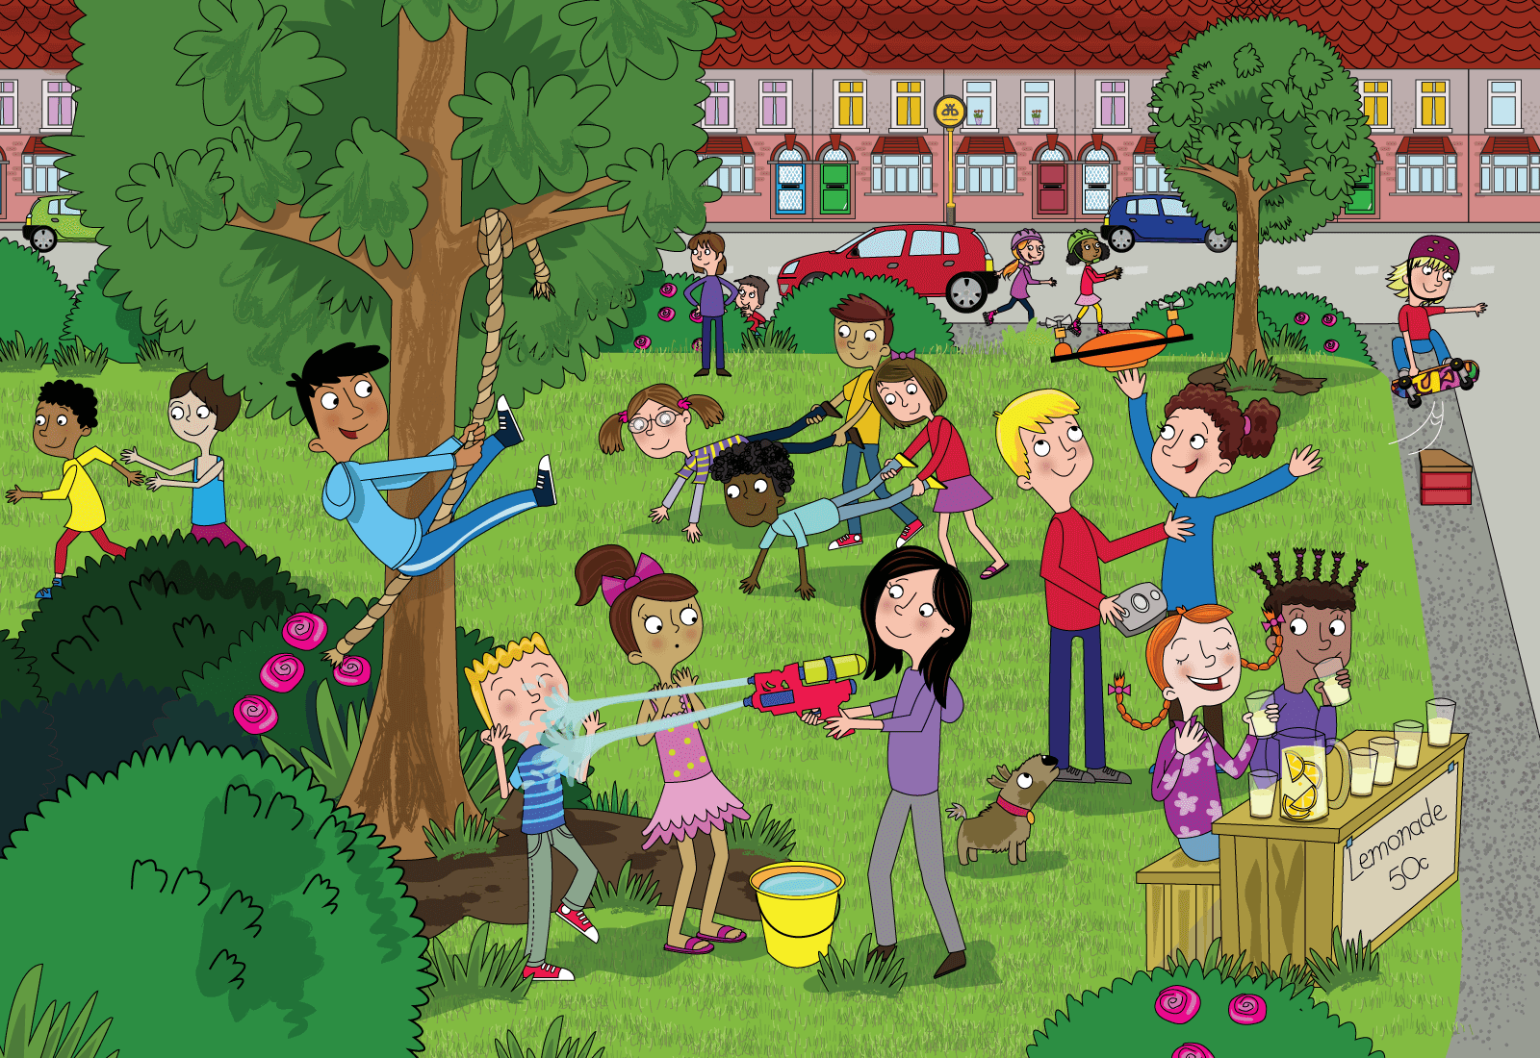
Class | 1st | Theme | Holidays
Unit | 16 | Subtheme | Summer at home
Unit genre | Narrative
Vocabulary | Tier 1 examples: summer, holidays, wheelbarrow race, climb  treehouse, rope, rollerblading, skateboarding, ramp, lemonade  Tier 2 examples: drone, conditions, soaked, entertaining, protective, refreshing
Lesson resources | N/A

Element | Learning outcome | The child should be able to …
Communicating | LO 1 | Listen to new information about summer at home.
 | LO 2, 3 | Converse on the thoughts and feelings of others.  Work in pairs/groups and build upon a group discussion.
Understanding | LO 4 | Use tenses correctly in more complex sentences.  Use comparatives, plurals, suffixes and compound words correctly.
 | LO 5, 6 | Use prepositions, e.g. beside; under; near; above; across.  Understand and use similes, e.g. as green as grass.  Acquire new vocabulary and phrases from an oral language text about summer holidays at home.
 | LO 7 | Respond to a wide range of questions about camping and holidays.
 | LO 8, 9 | Use language to refer to their own thoughts and those of others.
Exploring and using | LO 11 | Retell a story and build a narrative.
 | LO 12 | Demonstrate creative language use when interacting with poetry.
 | LO13 | Explain and justify their response to a question.

Fortnightly plan
Lesson 1 | Digital poster (Story mode)  Digital poster (Explore mode): Talk and discussion  Activity: Super similes | Lesson 3 | Digital poster (Explore mode): Talk and discussion  Digital poster (Activity mode): Multiple choice questions  Bailey the dog’s story
Lesson 2 | Digital poster (Story mode): Recap  Digital poster (Question mode)  Activity: Guess the game | Lesson 4 | Digital poster (Label mode)  Digital poster (Poem mode): Sunflakes  Sunflake drawing

Lesson 1
Digital poster (Story mode) LO 1
Play either the Story mode 1 (starters) or Story mode 2 (flyers) for the class, depending on the ability level.

Digital poster (Explore mode): Talk and discussion LO 4, 5, 6, 7
Go to the Explore mode of the poster. Ask children the following questions:

- What time of year is it?
- What kind of day is it? What do you need to wear on your skin on a sunny day? (Suncream) Why do we wear suncream? (To protect our skin from the sun)
- Why aren’t the children in school? (They are on holidays) How do you feel when you are on holidays? (Happy, delighted, excited, thrilled, overjoyed, ecstatic, jumping for joy!)
- What are the children having a water fight using to hold the water? (A bucket) What kind of bucket is it? (A yellow, plastic bucket)
- Describe what you do when you are having a water fight.
- What is another way to say ‘soaked’? (Wet through, drenched, sopping)
- How many children are having a wheelbarrow race? Why is it called a wheelbarrow race?
- What are the children using to fly the drone? (A remote control) What does the word remote mean? (Far off, distant)
- Can you name the different types of clothes the people in the poster are wearing?
- What other games can you play outside at home? (Kick the can, hide and seek, tag, football, soccer, hurling, bulldog, rounders, sly fox, etc.)

Nouns: Use the spotlight tool to focus on different items as they are named. Use the pen tool to categorise the various items after they have been named, e.g. circle … games/activities involving wheels, games you need equipment for, games/activities you can play in a group/on your own
Verbs: e.g. running, sprinting, chasing, swinging, skating, squirting, spraying, flying, zooming, gliding, hiding, concealing, drinking, gulping
Prepositions: e.g. beside; under; near; above; across from; next to; in front of; between

Activity: Super similes LO 5, 6
Draw a table on the board with the headings ‘Colour’ and ‘Animals’. Draw attention to the grass in the poster. Ask what colour it is. Ask children if they have heard of the expression ‘as green as grass’. What about as brave as a lion? Explain that sometimes we compare one thing to another to show similarities.

Colour | Animals
As green as grass | As brave as a lion

See if children can come up with other similes themselves and write them on the board.

Colour: as black as coal; as white as snow; as red as a rose/beetroot; as yellow as gold
Animals: as slow as a snail; as blind as a bat; as busy as a bee; as smart as a fox

Lesson 2
Digital poster (Story mode): Recap LO1
Play either the Story mode 1 (starters) or Story mode 2 (flyers) for the children again. Make sure they understand all of the vocabulary.
Digital poster (Question mode) LO 8, 9, 13, 14
Go to the Question mode of the poster. Listen to each question and discuss the answers with the children briefly. Encourage them to justify and expand upon their answers.

Q1. | Where are the children?
Q2. | What is the weather like?
Q3. | What games are being played?
Q4. | Look at the boy being sprayed with the water pistol. How do you think he feels?
Q5. | Why do you think the dog is looking up at the drone?
Q6. | Do you think setting up a lemonade stand in the park is a good idea? Why?
Q7. | Can you think of other good places to go on a sunny day?
Q8. | How do you know that the girl on the skateboard is experienced at skateboarding?
Q9. | Imagine that you were playing outdoors on a lovely, hot day. Which activity would you be doing?
Q10. | What do you think is the best thing and the worst thing about summer holidays?

Activity: Guess the game LO 2, 7, 14
First model the game for the children. Say you are going to describe a game or activity you can play outside and that the children must guess what it is, e.g. ‘You need other people to play this game. One person closes their eyes and counts to 20 and everyone else must hide,’ etc.
Divide children into pairs. They take it in turns to describe a game or activity and their partner must guess what it is.

Lesson 3
Digital poster (Explore mode): Talk and discussion LO 4, 5, 6
Go to the Explore mode with children again. Focus on:

Plurals – e.g. children/children;
Opposites – e.g. sunny/dull or cloudy; fun/boring; daring; careful; protect; hurt
Comparative and superlative – e.g. hot, hotter, hottest, wet, wetter, wettest
Rhyming words – e.g. grass/pass/mass; tree/free/see; skate/hate/crate
Suffixes – e.g. swing/swinging; skate/skating; chase/chasing, drink/drinking, play/playing
Compound words – e.g. rollerblade, skateboard, pigtails, wheelbarrow

Digital poster (Activity mode): Multiple choice questions LO 13
Go to the Activity mode of the poster and click on the multiple choice questions. Children must choose the activity which best suits each of the weather conditions described. Discuss the possible answers and encourage children to justify their choices before moving on to the next question.

The audio questions will be:

Q1. | Choose an activity for a warm, sunny day.
Q2. | Choose an activity for a rainy day.
Q3. | Choose an activity for a dry, windy day.
Q4. | Choose an activity for a snowy day.

Bailey the dog’s story LO 4, 8, 11
Spotlight the dog looking up at the drone. Ask children:
- Why do you think he is looking up at the drone?
- What do you think he is thinking?
- What do you think might happen next?

Scaffold children to tell a simple story of how Bailey the dog got lost. He ran after the drone, got lost but was eventually found again.
Ella and Tom were having great fun playing with their new drone. Suddenly there was a strong gust of wind and the drone blew off down the street. Bailey the dog ran after it. But he ran too far and got lost. Ella and Tom were very upset. They told all the other children playing outside what had happened. The children all split up into groups. The groups went looking for Bailey in the nearby streets. Eventually Ella and Tom found Bailey in someone’s front garden. He was playing with a small girl and having lots of fun. Ella and Tom were very relieved and took Bailey home.

Encourage the children in pairs/groups to retell the story AND/OR to create another story based on the poster, e.g. when the girl skateboarding fell off the ramp, when the branch on the swinging tree broke, when the sun disappeared behind the cloud and it began to rain, etc. Aim for five to eight sentences in the past tense, sequencing the events correctly, including a climax and a resolution.

Lesson 4
Digital poster (Label mode) LO 6, 7
Go to the Label mode of the poster. Review the vocabulary. Have children take turns dragging the labels onto the correct location in the poster.

Digital poster (Poem mode): Sunflakes LO 12
Go to the Poem mode of the poster and play the poem, Sunflakes by Frank Asch:

Sunflakes
By Frank Asch

If sunlight fell like snowflakes,
gleaming yellow and so bright,
we could build a sunman,
we could have a sunball fight,
we could watch the sunflakes
drifting in the sky.
We could go sleighing
in the middle of July
through sundrifts and sunbanks,
we could ride a sunmobile,
and we could touch sunflakes –
I wonder how they’d feel.

Encourage children to speak the poem with appropriate intonation, facial expression and gesture.

Sunflake drawing LO X
Ask children to draw a picture of a sunflake/sunman/sunball fight. Have them write adjectives around the picture to describe it (e.g. hot, warm, bright, orange, delicate, etc.)

