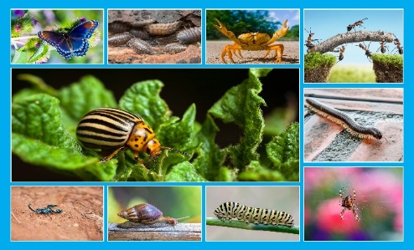

|  |  |  |  |
| --- | --- | --- | --- |
| **Class** | 1st | **Theme** | The world around us |
| **Unit** | 11 | **Subtheme** | Minibeasts |
| **Unit genre** | Report | | |
| **Vocabulary** | Tier 1 examples: minibeast, poisonous, pests, fascinating, crawl,  protected, stems, colony, continent, vegetable  Tier 2 examples: arachnid, paralyse, transformation | | |
| **Lesson resources** | Multimedia links, minibeast cards | | |
|  |  | | |
| **Element** | **Learning outcome** | **The child should be able to …** | |
| Communicating | LO 1 | Actively listen and show an interest in acquiring new information. | |
| LO 2, LO 3 | Initiate and take turns in conversations. Work in pairs/groups using gestures, expressions and signs showing an awareness of audience. Use text-specific language to work collaboratively with others on a range of activities. | |
| Understanding | LO 4 | Use tenses correctly in more complex sentences. Use plurals correctly in a sentence. Understand and use topic-specific language in interactions with others. | |
| LO 5, LO 6 | Acquire and understand new vocabulary and phrases from an oral text on minibeasts. Understand and use newly acquired nouns, adjectives, verbs and adverbs correctly.  Describe individual minibeasts using topic-appropriate vocabulary. Understand and use other words to indicate plurals. Identify the rhyming words in a poem. | |
| LO 7 | Ask and respond to a range of questions about minibeasts. Engage in group and class activities by responding appropriately to a series of instructions. Use an oral presentation to coherently explain a day in the life of a minibeast. | |
| Exploring and using | LO 8, LO 9 | Use open and closed questions and elaborate on his/her answers.  Give appropriate justifications for their responses to questions. | |
| LO 10 | Name and categorise different words associated with minibeasts.  Name and categorise words according to their properties, e.g. nouns, verbs, adjectives, rhyming words. | |
| LO 11 | Re-tell and sequence the life cycle of a butterfly. Re-tell and organise facts on minibeasts. | |
| LO 12 | Listen and respond to a poem and explore the creative aspects of language used by the author. Create and perform an oral scenario on a day in the life of a minibeast using creative language. | |
| LO 13 | Give a detailed description of a picture using appropriate language and descriptions. Justify their response to a question.  Relay newly acquired information in a coherent, cohesive manner. | |
| LO 14 | Describe and explain actions and events. Give reasons for a predicted outcome. | |

# Fortnightly plan

|  |  |  |  |
| --- | --- | --- | --- |
| **Lesson 1** | Digital poster (Story mode)  Digital poster (Explore mode): Talk and discussion  Singular and plural  Pair talking task: Minibeast adventure! | **Lesson 3** | Digital poster (Explore mode): Talk and discussion  Digital poster (Activity mode): Which minibeast?  Minibeast headbands |
| **Lesson 2** | Digital poster: Recap  Digital poster (Question mode)  Sequencing activity | **Lesson 4** | Digital poster (Label mode)  Digital poster (Poem mode): *Upside Down*  Minibeast poetry |

# Lesson 1

**Digital poster (Story mode) *LO 1***

Play either the Story mode 1 (starters) or Story mode 2 (flyers) for the class, depending on the ability level.

**Digital poster (Explore mode): Talk and discussion *LO 4, 5, 6, 7, 10, 13, 14***

Go to the Explore mode of the poster. Ask children the following questions, using the pen, zoom, spotlight and conceal tools to aid you:

* Describe the butterfly. *(encourage children to describe as fully as possible using colour, size, number, texture and doing words)*
* Look at the ants. What are they doing and why?
* Look at the picture of the spider. Where does he live? Why does he live there?
* Which of the minibeasts in this picture can fly? How do you know?
* I want to find a crab. Where would I go to look for one?
* Which minibeasts do you think I would find in my own garden?
* Which minibeast carries its home around with them? Why does it do this?
* Which minibeasts do you think feed on animals? Why do you think this?
* Which minibeasts do you think feed on plants? Why do you think this?

**Singular and plural *LO 1, 4, 5, 6***

Look at the minibeasts in the picture and model the correct language when using **singulars** and **plurals**, e.g.:

* I can see *one butterfly*. I cannot see *three butterflies*.
* I can see *a colony of ants*.
* Some *minibeasts have* lots of legs. The *crab has* ten legs.

Discuss the different plural words which are formed by adding s onto the end of the word, e.g. ant/ants, snail/snails, beetle/beetles, etc.

Discuss and model other words which can be used to show that there is one or more than one, e.g.

* I can see *one* ant.
* I can see *many* ants.
* I can see *several* snails.
* Here are *a few* woodlice, etc.

**Pair talking task:** **Minibeast adventure!** ***LO 5, 6, 7, 12, 14***

Organise children in pairs. Describe the following scenario to the children:

You have been shrunk by a shrinking machine and are now part of the tiny minibeast world! How do you feel? Where will you sleep? What will you eat?

In their pairs, encourage children to discuss about where they would sleep, eat, how they would obtain food, how they would transport themselves, what they would do all day and what the world would look like. Children should listen carefully to what their partner says and then introduce their partner to the rest of the class by saying: Hello, this is … and he/she is the size of a … *(spider, snail, ant)* He/she eats … and sleeps in a … All day, he/she … etc.

# Lesson 2

**Digital poster: Recap**

Play either the Story mode 1 (starters) or Story mode 2 (flyers) for the children again. Make sure they understand all of the vocabulary.

**Digital poster (Question mode) *LO 8, 9, 13, 14***

Go to the Question mode of the poster. Listen to each question and discuss the answers with the children briefly.

|  |  |
| --- | --- |
| Q1. | What colour is the butterfly? |
| Q2. | What colour is the Colorado potato beetle? |
| Q3. | What kind of insect is in the third photo on the bottom of the poster? |
| Q4. | What is the Colorado potato beetle’s favourite food? |
| Q5. | Where is a scorpion’s sting? |
| Q6. | Ants live together in large groups. What are these groups called? |
| Q7. | Why are snails called garden pests? |
| Q8. | Which of these animals do you like best? Why? |
| Q9. | Which of these animals would you least like to meet? Why? |
| Q10. | Can you think of any animals, besides butterflies, that transform? |

**Group task: Sequencing activity *LO 2, 3, 5, 6, 7, 11***

Watch the following video with the children to identify the different stages of the life cycle of a butterfly. <https://www.youtube.com/watch?v=V5RSpMQQOpw>

Discuss with the children what they found out. Encourage the use of terms such as larva, pupa, chrysalis, eggs, etc.

Organise children in groups and give each group the pictures of the life cycle of a butterfly included in Lesson Resource 1. In their groups, children must sequence the pictures in order, then orally re-tell the sequence. Encourage the use of sequencing terms such as first, then, next, later, after that, finally. The groups can practise together before orally re-telling the sequence to the rest of the class.

# Lesson 3

**Digital poster (Explore mode): Talk and discussion *LO 4, 5, 6***

Go to the Explore mode with children again. Focus on descriptive terms. On the board, draw up a chart, enabling the children to use appropriate vocabulary to describe each minibeast. Encourage the children to use adjectives to describe what they look and feel like, and verbs and adverbs to describe how they move, e.g.:

|  |  |  |  |
| --- | --- | --- | --- |
| **Name of minibeast** | **How does it look?** | **How does it feel?** | **How does it move?** |
| snail | brown  small | slimy  soft | slowly  sliding |

Encourage the children to each say one or two sentences describing each minibeast using the vocabulary gathered, e.g. *The soft slimy snail slides slowly across the leaf.*

**Digital poster (Activity mode): Which minibeast? *LO 2, 13***

Go to the Activity mode of the poster. Ask children to look at the images displayed and to guess which minibeast is speaking. Encourage children to justify their decisions and discuss them briefly before moving on to the next picture.

|  |  |
| --- | --- |
| Snail | I like to take my time – I’m never in a hurry! I always leave a slimy trail behind me. Who am I? |
| Beetle | Can you guess who I am? I'll give you two clues. I have black stripes on my body and my favourite vegetable is the potato! |
| Crab | I wear my skeleton on the outside of my body. Do you know who I am? |
| Butterfly | I am a beautiful insect with delicate wings. I transformed from a caterpillar! Guess who! |
| Scorpion | I have eight legs and I hide my sting in the tip of my curly tail. Who am I? |
| Ant | I may look small – but I can carry things up to 50 times heavier than me! I’d love to stay and chat, but I have lots of work to do. |

**Group activity: Minibeast headbands *LO 5, 6, 8, 9***

Print the minibeast cards included in Lesson Resource 2. Model the activity first by inviting one child to the front of the room to select a card. Have the child wear a headband around their forehead and slot the card into it so it is clearly visible to the class, but the child can’t see it. The child then has to ask the class a series of yes or no questions in order to determine what minibeast is on the selected card. Once the children are familiar with the task they can be divided into smaller groups to play the game together.

# Lesson 4

**Digital poster (Label mode)** ***LO 6, 7***

Go to the Label mode of the poster. Review the vocabulary. Have children take turns dragging the labels onto the correct location in the poster.

**Digital poster (Poem mode):** ***Upside Down LO 12***

Go to the Poem mode of the poster and play the poem *Upside Down* by Aileen Fisher:

***Upside Down***

By Aileen Fisher

It’s funny how beetles

and creatures like that

can walk upside down

as well as walk flat.

They crawl on a ceiling

and climb on a wall

without any practice

or trouble at all.

While I have been trying

for a year (maybe more)

and still I can’t stand

with my head on the floor.

Encourage children to recite the poem with appropriate gestures, intonation and actions.

Ask children to:

* Identify other animals that can walk upside down.
* Find and locate rhyming words in the poem.

**Minibeast poetry *LO 5, 6, 12***

Organise children in groups. Discuss snails with the class: what they look like, how they move, their slimy trails, etc. Ask the children to give you some words used to describe snails … *shell, spiral, slow, slime, shiny, slippery* etc. Write them as a list on a large sheet of paper, headed ‘Snails’, as the children say them. When the list is complete, read it back to the children. If a lot of the words began with ‘s’/are colours/are movement words, etc., you could point this out to them. Now ask each group to create a poem using some of these words. Explain that it doesn’t have to rhyme – it could be a cinquain, kennings, or any other form of poetry the class has previously explored. Finally, have each group perform their poem for the class.

**Lesson Resource 1**

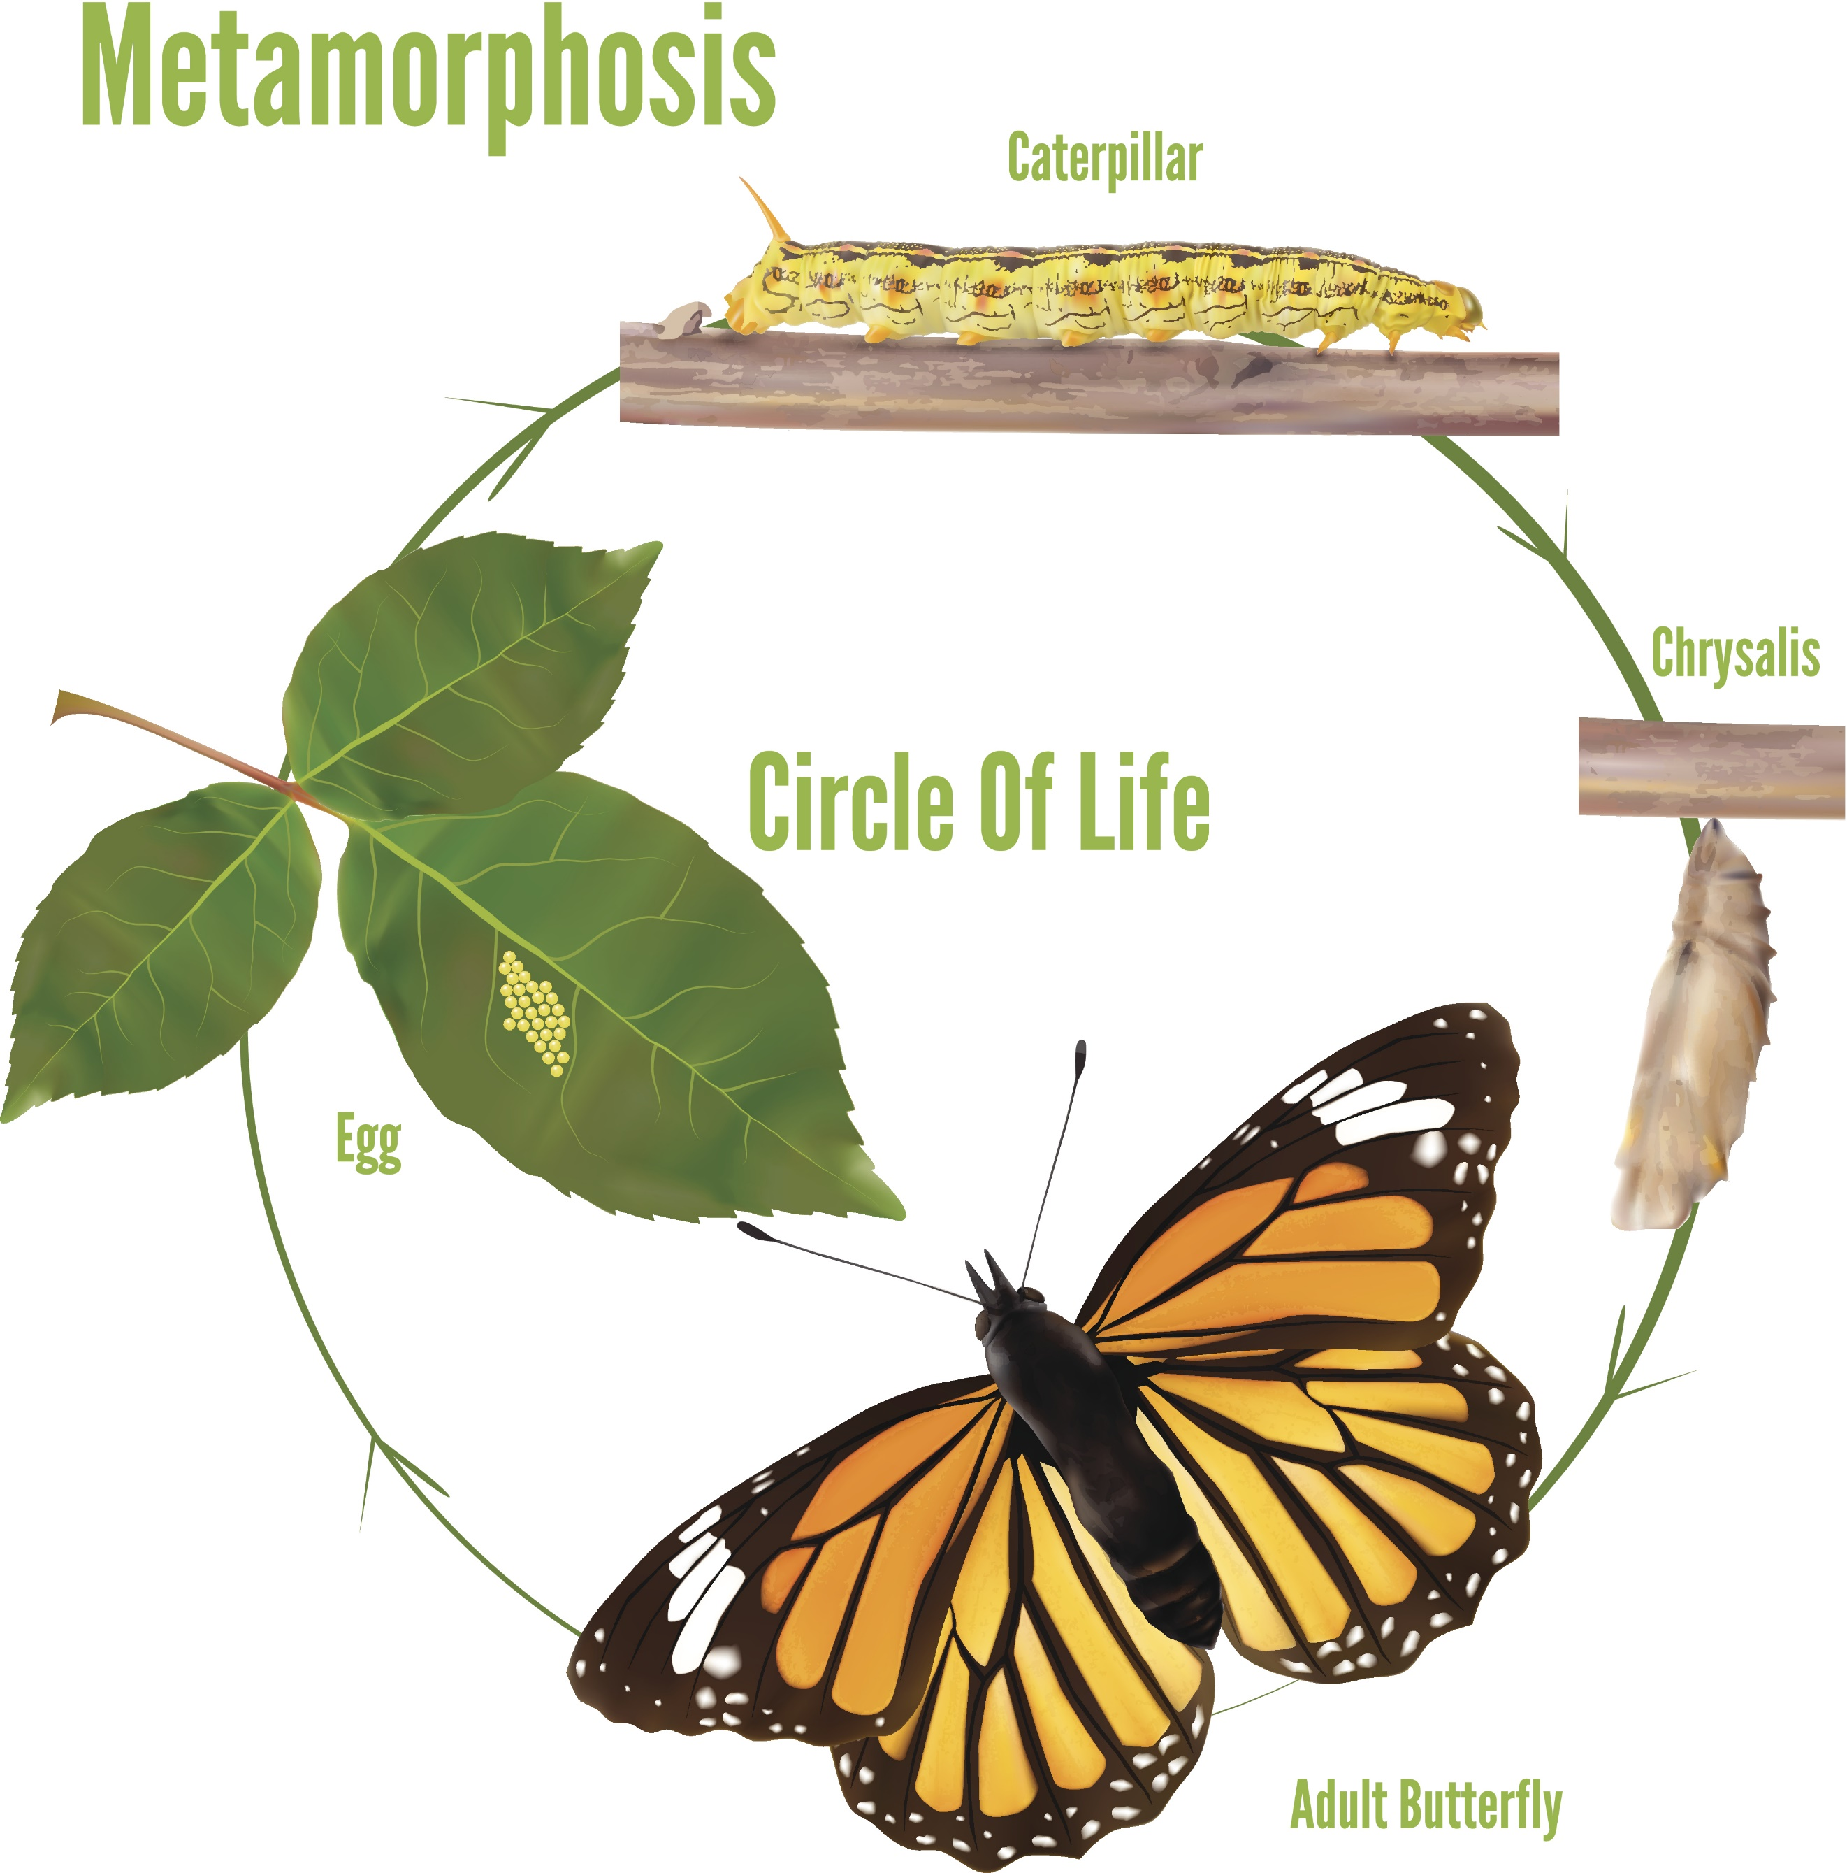

**Lesson Resource 2**

