Number: Sets and Operations
17. Addition

This unit explores the building blocks of addition as children learn how to combine sets up to 10. They represent these pictorially (using ten frames) and then abstractly (using number sentences). They will also be introduced to the + and = symbols. The learning in this unit forms the basis for understanding addition (including the commutative property) which can then be applied to larger numbers.

Unit Information
Learning Outcome(s) | Sets and Operations: recognise and understand what happens when quantities (sets) are partitioned and combined.
Maths Concept(s) | - Quantities (or sets) can be partitioned and combined.  - Adding a natural number to a natural number makes the number (quantity) bigger.
Maths Language | Add, Combine, Put together, How many altogether?, Plus, Equals, Makes, Same as, How many more?
Prior Knowledge | - number names  - ability to count sets  - knowledge of conservation of number  - strong foundations in number sequence, number sequel, number perceptual
Potential Misconceptions | - When combining, children may start at 1 and count the two sets together, which leads to the possibility of missing objects when they count. Encourage children to count on from a known amount.  - Children might struggle to understand that equals means ‘the same as’ and not just ‘the answer’.  - Children might use ‘+’ and ‘=’ signs incorrectly.  - Children might use the starting number as starting place, and therefore end with an answer that is one short. Encouraging children to count forwards/jump away from starting number when using number tracks can be effective here.  - Children might start their addition with the smaller number and then add the bigger one. Encourage children to look for the bigger number as a starting point and add on the smaller number.

Overview
 | Lesson 1 | Lesson 2 | Lesson 3 | Lesson 4 | Lesson 5
Focus of New Learning | Combine sets to 10 using a 10 frame | Use different strategies to solve addition stories | Write addition stories to 10 with ‘+’ and ‘=’ signs | Solve addition word problems to 10 | Weekly review
Slides | 17.1 | 17.2 | 17.3 | 17.4 | 17.5
Book |  |  | p.44 |  | p.45
Concrete Resources | Ten frames, counters | Ten frames, counters, number tracks | Number tracks, dice, coat hanger, coloured pegs |  | Ten frames, counters, number tracks
Digital Resources | Bear’s adventures poster, Addition story quiz

Lesson 1: Combine sets to 10 using a ten frame

Resources
ten frames, different colour counters

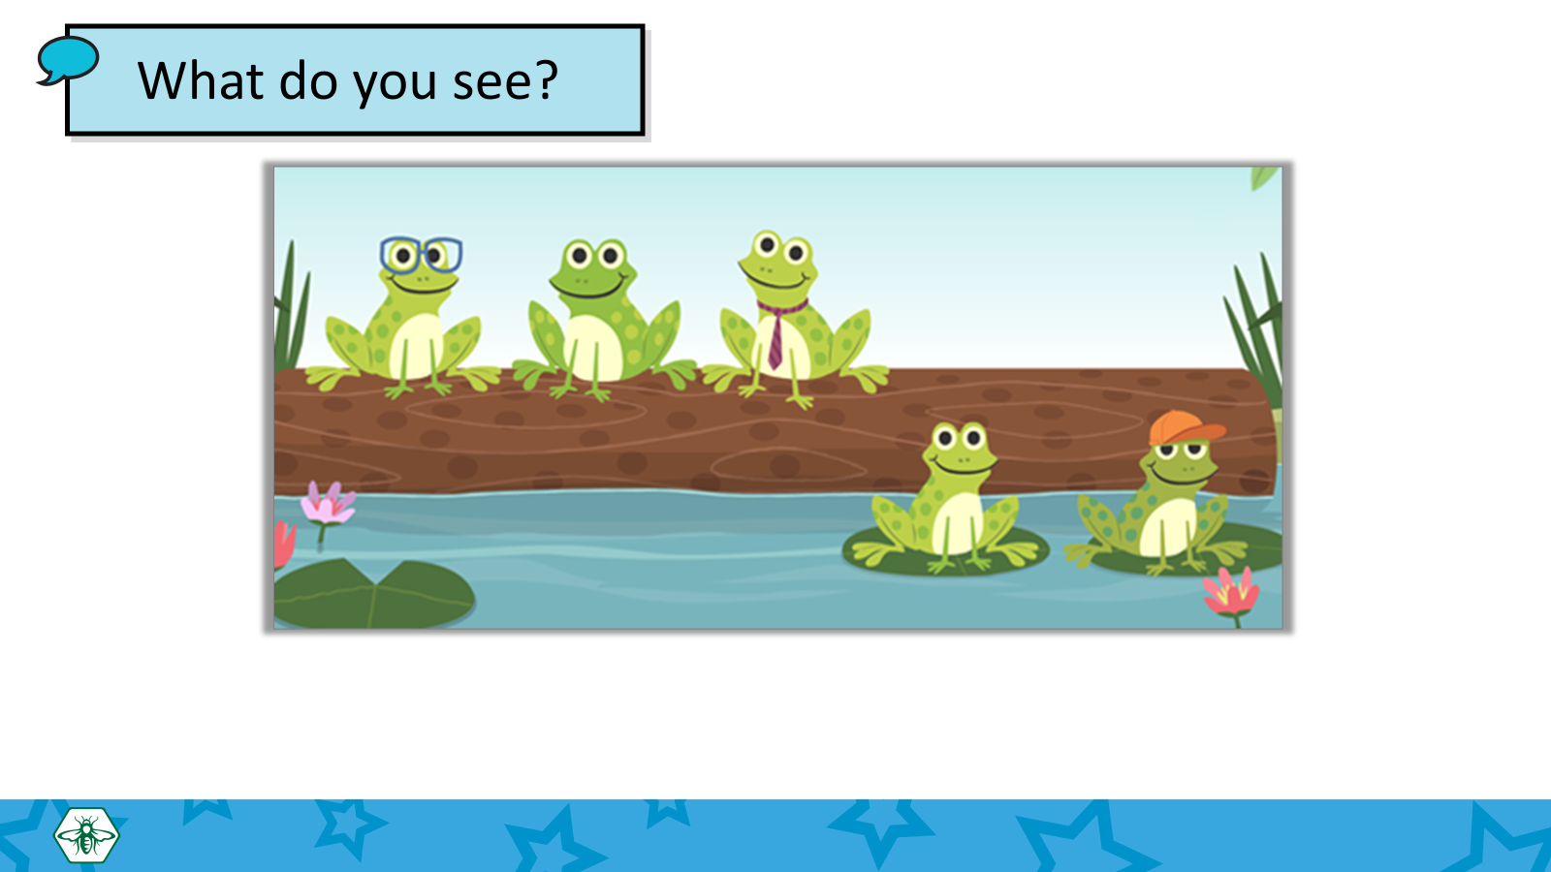
Learning experiences
In this lesson, children combine sets to 10 using a ten frame. The key learning point is that combining sets makes a new bigger set. Modelling combining on a ten frame (pictorial) is a building block for children to represent addition stories using number sentences (abstract).

Using the pictorial prompt of the frogs, establish that there are
3 frogs on the log and 2 frogs in the pond. Ask the children ‘How many frogs are there altogether?’
Then have children model combining sets (3 frogs + 2 frogs) using ten frames and counters to find the number of frogs altogether. Remind children to count on from the larger addend. Then, using the ‘Your turn’ slides, have children model combining other sets to 10 using their own ten frames.

Key questions/Maths talk
- How many are there in each set?
- How many are there altogether?
- How can you show this on a ten frame?
- Are there other ways to show 3 and 2 on a ten frame?
- Can you tell me how you got that answer?
- Will your way/idea always work?
- What do you notice?

Differentiation
- Support struggling learners by providing concrete material where needed.
- Challenge advanced learners by encouraging them to combine sets beyond 10. They can also write number sentences, increasing number values where appropriate.

Hands-on activities/Games
- Using counters: Choose two sets of 1–5 counters (or cubes) and place them under a cloth or a sheet of paper. Show one set at a time. Then ask children ‘How many are there altogether?’
If your class is ready, progress to numbers 6–10, keeping the second set in the range 0–5.
This game could also be played with number cards, making sure the card for the second number is a different colour. Encourage children to use their whiteboards to record their answers.
- Small world resources: Prompt children to explore different ways to make addition stories to 10 with small world resources. For example, how many ways can you place 10 cars in two car parks?
- The disappearing act: Show a set of objects. Ask children to count how many there are, then cover the set with a napkin or a piece of paper. Show the set again and check if they were right. Now show a second set. Ask ‘How many are there?’ (Answer: There were x objects before, and there are y objects here now.). ‘How many do we have altogether?’
Lesson 2: Use different strategies to solve addition stories

Resources
Bear’s Adventures (digital), ten frames, different colour counters, number tracks

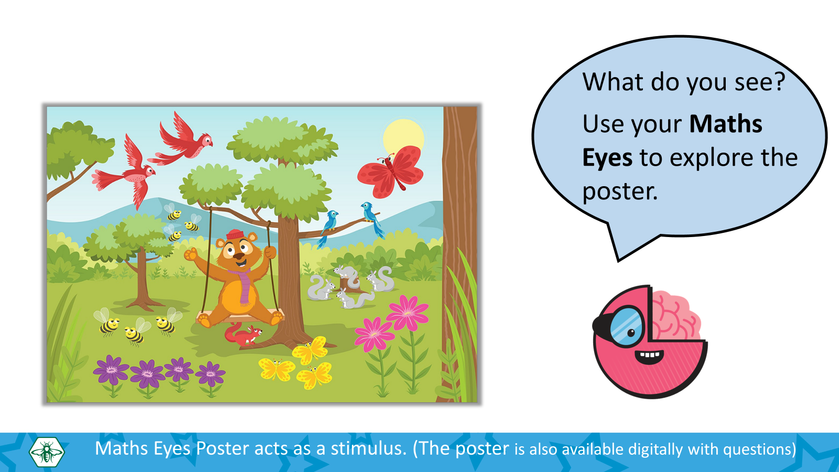
Learning experiences
This lesson introduces addition stories to represent the combining of two sets within 10. Students start by exploring a maths eyes poster (Bear’s Adventures). Using the poster picture as a prompt, they revise combining two sets using ten frames (see Lesson 1). They then learn how to use counting on as an addition strategy using a number track.

Once they are familiar with the concept of an addition story, they can use the Bear’s Adventures poster to find other addition stories. (E.g. 2 (red birds) and 2 (blue birds) make 4 (birds)). They can play with a partner, independently, in groups, or as a class. Ask them how to show their addition stories on a ten frame, on a number track, and to write them on a white board.

Key questions/Maths talk
- What do you see?
- How can you show the addition story on a ten frame?
- How can you show the addition story on a number track?
- Can you write the addition story on your whiteboard?
- Can you write other addition stories to six? What do you notice?
- Are there any other ways you can write your addition story? What do you notice?

Differentiation
- Support struggling learners by providing concrete materials (e.g. cubes) if needed. Ask them how they can use the cubes to show sets of objects in the picture. You can also give out the word cards ‘and’ and ‘make’ if needed. Note: some children may find it difficult to count on from a given amount. Try to identify children who need to count from 1 to find how many: these children may need to work on counting on from a given number. Support struggling learners by teaching them to use their two hands (if using number tracks). Model placing one finger on the starting number and using the other hand to jump on. Start with jumping on just 1, then increase to 2 when ready before progressing to larger numbers.
- Challenge advanced learners by encouraging them to add 3 addends. Ask them if they can represent their answer in another way, such as symbols, drawings, etc.

Hands-on activities/Games
- Practice time: Children work in pairs. One child gives out a number story, e.g. ‘2 and 1’. The other one uses a number track to complete the addition story, e.g. ‘2 and 1 make 3’. Encourage children to come up with as many addition stories as can they think of and share them with the class.
- Game time: Children play in pairs. They each pick a domino piece, then add the numbers from the domino. The child with the biggest number is the winner and keeps their own and their partners’ dominoes. The player with the most pieces at the end is the winner.
Lesson 3: Write addition stories to 10 with ‘+’ and ‘=’ signs

Resources
Number tracks, dice, coat hanger, coloured pegs

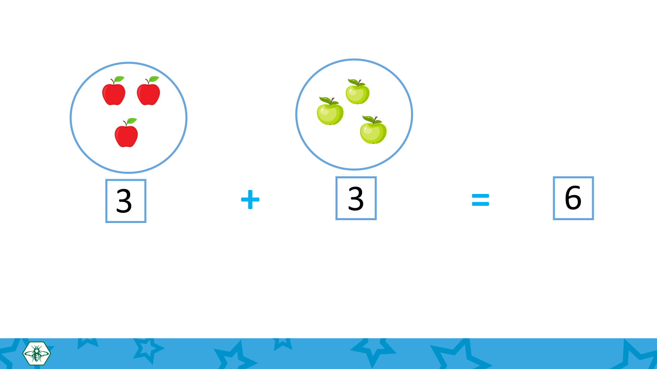
Learning experiences
This lesson introduces the plus (+) and equals (=) signs. Children learn that the addition story 3 and 3 makes 6 can also be written as the number sentence 3 + 3 = 6. When introducing the equals sign, make sure to point out that ‘equals’ means ‘the same as’. In other words, that both sides are the same. When introducing the plus sign, discuss with the children what this symbol means. Ask them if they can think of any other words that have the same meaning, e.g. and, add, plus, put together, combine. (You may wish to make a list of words under this symbol and display on a notice board.)

In the Your Turn slides, children are presented with several addition stories and must write the number sentence for each one. Encourage them to solve the addition stories by using a number track to count on. They can also explore using ten frames as an alternative addition strategy.

As an additional activity, children can use the Bear’s Adventures poster from Lesson 2 to create and write different addition stories using the ‘plus’ and ‘equals’ symbols.

This also lesson serves as a gentle introduction to the commutative property of addition, which states that the order in which two numbers are added does not change the sum. In other words (a + b = b + a).
In the teaching slides, children are presented with two addition stories (5 + 1 = 6 and 1 + 5 = 6) and a maths talk prompt encourages them to observe that the sum is the same for each. Children then have the opportunity to explore this further with concrete material as an extension activity. At this point, they do not need to be introduced to specific terminology.

Key questions/Maths talk
- How many ____ are there altogether? How do we know?
- What does ‘plus’ mean? Can you think of other words that have the same meaning?
- What does ‘equals’ mean? Can you think of other words that have the same meaning?
- Start at ____ and count on ___ places.
- How did you do this?
- Why do we need to jump away from our starting number when counting on?
- What do you notice about these number sentences? What is the same? What is different?
- Is there another way to show this addition story?
- How did you do this?

Differentiation
- Support struggling learners by providing them with number cards (1 – 10) and ‘+’ and ‘=’ sign cards and asking them use these to create number sentences. You can also hand out concrete material such as cubes and counters. Use simple language when exploring the commutative property. For example, you could say ‘flip the numbers’, ‘swap the numbers around’, or ‘3 and 2 is the same as 2 and 3’. Does it change the answer? Use concrete materials to help represent this concept, switching the objects around to show that the total number of items stays the same.
- Challenge advanced learners by increasing number values where appropriate, and by asking them to create their own addition stories showing the commutative property of addition.

Hands-on activities/Games
- Practice time: Children work in pairs. One child gives out a number story, e.g. ‘2 plus 1’. The other one uses a number track or ten frame to complete the addition story, e.g. ‘2 plus 1 equals 3’.
Encourage children to come up with as many addition stories as can they think of and share them with the class.
- Tower of 10: Children use cubes to build a tower. Use number cards 1, 2 and 3, shuffled. Children pick a card, then stack that many cubes. All children pick a card, then go around again and pick a second card. They need to stack that many cubes on top of their tower and add to find the total. The first to get to a
tower of 10 cubes wins. If children get a number that is more than 10, they go bust and must start over. As children work, discuss how many more they need to make 10. This activity can also be extended by choosing a higher target number (e.g. 15) and asking children to use their operation and counting skills.
- Use a coat hanger and pegs to show an addition story. Flip the hanger around to show that the order of the numbers added doesn’t affect the sum.

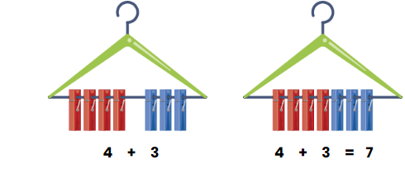
- Ask children to make their own addition stories and show them on their ten frames. Encourage them to also write the addition story on their whiteboard. They then give their number and flip the numbers around. Then, partners check their work.

Lesson 4: Solve addition word problems to 10

Resources
Counters, 10 frames, number tracks

Learning experiences
This lesson focuses on using addition to solve word problems. Start the lesson by introducing a word problem based on concrete material available in the classroom, e.g. ‘Tom has 4 pencils. Ava has 2 pencils. How many pencils do they have altogether?’ You can choose to display the material, or even to hand out sets to pupils so they can model solving the problem alongside you. Establish a strategy to understanding word problems by asking children what information is given in the problem, and what information they need to find out. Prompt them to come up with different ways they could solve the problem and discuss these as a class.

In the teaching slides, pupils are introduced to different methods for solving the word problem, based on previous learning within this unit. At first, they merge the sets and count the total (this can be done either with concrete material, or by prompting pupils to draw the sets). Then, they represent the problem using counters and 10 frames. They finally solve the problem by counting on a number track. The purpose is to encourage children to find a method they feel most comfortable with, and to emphasise the correlation between concrete strategies and abstract equation.

Children then have the opportunity to tackle some new word problems, using a strategy of their choosing to work out the answer. When working on the word problems, ask children to explain what information in the question is useful and why. Ask them to explain what they need to do, and encourage them to discuss the concept of combining (e.g. What are we doing in this problem? How do we know?).

Key questions/Maths talk
- What are we doing in this problem?
- What do we know?
- What do we want to find out?
- How do we know?
- How could you solve this problem?
- What method could you use to solve this problem?
- How can you check your answer?

Differentiation
- Support struggling learners by providing them with concrete objects to model the word problems.
- Challenge advanced learners by asking them to create their own word problems, with two or three addends, and using counters, number cubes or drawings to represent their problems.

Hands-on activities/Games
- Number cards: Provide children with number cards 0–10. Children play in pairs, taking turns picking two cards from the deck. They then create a word problem with those numbers for their partner to solve.
- Dominoes: Place some domino pieces in a bag. You can preselect these to be within a specific number range, to make the activity easier or more complex. Children pick up a domino piece from the bag. Ask them to add the two numbers on the domino and draw or describe a real-life scenario with those numbers.

Lesson 5: Weekly Review

Resources
Ten frames, counters, number tracks

Learning experiences
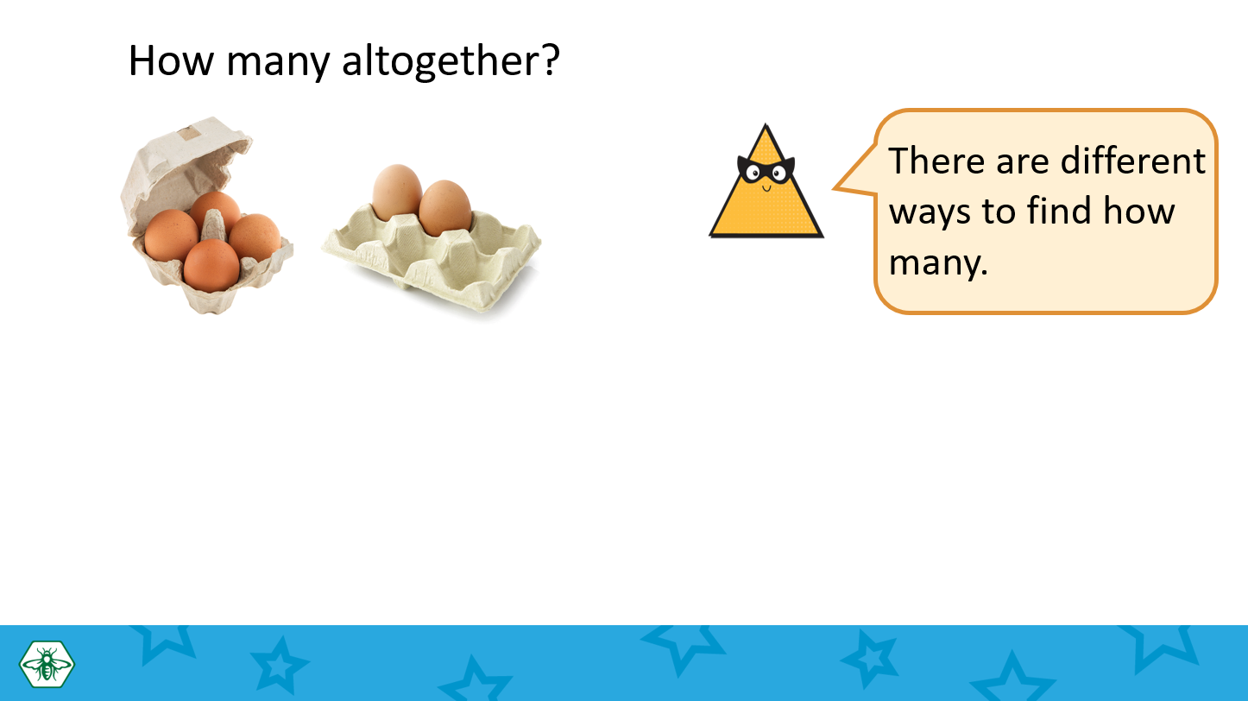
In this lesson, children review what they have covered over the course of the week. They also use ten frames and/or number tracks to solve simple addition word problems. Use this opportunity to reinforce previous learning, focussing on understanding the word problem and what information in the question is useful and why.

As an additional activity, children are asked to create and write their own addition stories and represent them on a 10 frame.

Key questions/Maths talk
- Have you solved a similar question?
- Where could you start?
- Can anyone tell me how they found their answer?
- What was helpful to you in solving this problem?

Differentiation
- Support struggling learners by providing concrete materials. Encourage them to count on from the larger number.
- Challenge advanced learners by giving them word problems with three addends (e.g. 4 + 3 + 2).

Hands-on activities/Games
- Creating a word problem: Show children and addition story. You can tweak this to be easier or harder, depending on your classroom needs. Ask children to draw or write a word problem that matches the addition story.
- Dice: Children play in pairs. They each roll a dice once, then add the two numbers that were rolled. Ask them to create a word problem with those numbers.

