Number: Numeration and Counting
7. Number 5

This unit introduces the number 5. Pupils begin by using their maths eyes to identify places where they have seen the number 5 before, in its different representations. They then move on to reading and writing it, and eventually to counting out sets of 5 and subitising sets of 5. Finally, the unit explores the different components of 5, putting down the building blocks for simple addition within 5 and partitioning.

Unit Information
Learning Outcome(s) | Numeration and Counting: develop an awareness that the purpose of counting is to quantify.
Maths Concept(s) | - Quantities can be subitised and compared without needing to count or assign a numerical value.  - There are five principles of counting: one-one, stable order, cardinal, order irrelevance and abstraction.  - The last number in the count indicates the quantity in a set.  - There are a range of counting strategies, including grouping objects and arranging objects in various visual configurations.
Maths Language | Number, number before, number after, numbers 1–5, ‘How many?’, ‘What do you see?’, odd one out, same, different
Prior Knowledge | - number names 1–4  - reading and writing numbers 1–4  - ability to count sets 1–4  - standard dice arrangements 1–4  - counting sequence 1–4
Potential Misconceptions | - Children might confuse the numbers 2 and 5.  - Children may write ‘S’ instead of the number 5.  - Children might leave the ‘hat’ as the last part in number formation.  - Children might not separate the number names from how many items there are when counting. These children would benefit from additional revision on 1-to-1 correspondence.  - Children might mix up the order of numbers.  - Children might have issues with number reversal.

Unit Overview
 | Lesson 1 | Lesson 2 | Lesson 3 | Lesson 4 | Lesson 5
Focus of New Learning | Introduce the number 5 | Write the number 5 | Count and subitise 5 | Components of 5 | Weekly review
Slides | 7.1 | 7.2 | 7.3 | 7.4 | 7.5
Book |  | p. 18 | p. 18 |  | p. 19
Concrete Resources | Dice, cubes | Whiteboards/copybooks | Dice | Five frames, coloured counters | N/A
Digital Resources | Number pack: 5

Lesson 1: Introduce the number 5

Resources
dice (potentially up to 3 dice per pair/group), cubes

Learning experiences
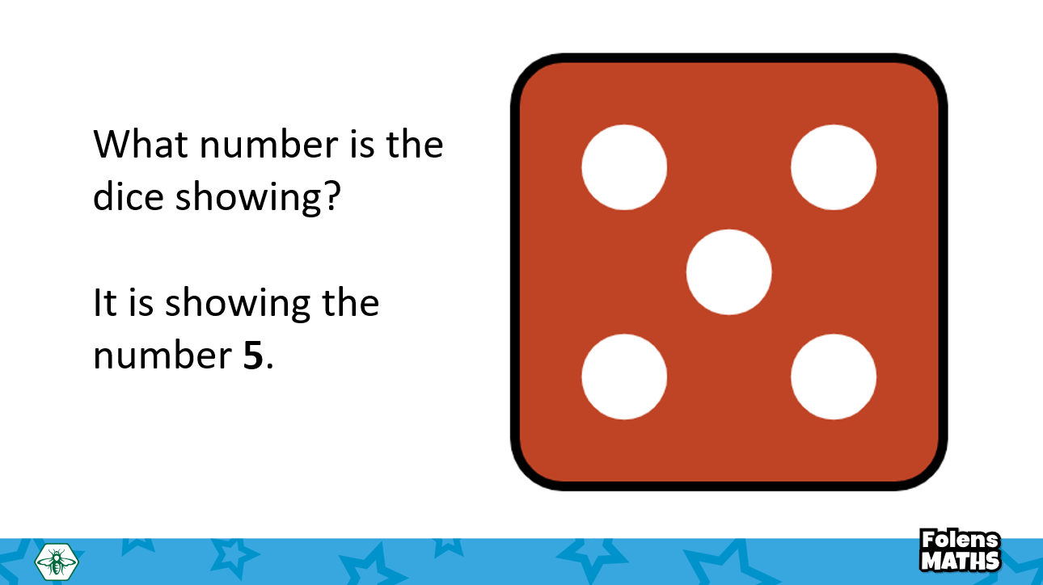
In this lesson, children recognise the quantity 5 and connect it to the number (numeral) 5. Children start by being shown different pictorial representations of 5 and are asked what all of them have in common. At this point, introduce the number 5 and ask children to read it.
Prompt pupils to use their maths eyes to identify situations where they have seen the number 5 or groups of 5.
Ask children ‘Where have you seen 5?’, ‘Can you think of other examples of 5?’ Start a discussion on the number 5, what it represents, and where we might see it in real life.

Within this lesson, it might be useful to revise the number sequence 1–4, and model counting up to 5, with an emphasis on discussing the number before and after each number.

The digital resource ‘Number pack: 5’ contains a song, poem, video, game, etc. and can be used throughout the week to support instruction.

Key questions/Maths talk
- Have you seen the number 5 before?
- Where can you see 5?
- Can you think of other ways to show 5?
- How do you know this is the number 5?

Differentiation
- Support struggling learners by showing the number 5 dice pattern on the board.
- Challenge advanced learners by asking them to use counters to show 5 in different ways (e.g. horizontally, vertically, diagonally, stacked, etc.)

Hands-on activities/Games
- Number 5 poster: Ask children to draw different representations of 5 on sticky notes or on a piece of paper. Encourage them to use fun colours, to include all of the examples discussed in the lesson, or even to come up with their own groups of 5. Use the sticky notes to make a class poster for the number 5. This activity can be repeated for each new number learned and displayed on the classroom walls for pupils to refer back to throughout the year.
- Number 5 treasure hunt: Take children on a treasure hunt for number 5. Where can they find 5? Encourage them to use their maths eyes to identify different ways the number 5 is around them. Can they spot a group of 5 objects? A door number? Encourage children to keep track of their 5 ‘loot’ and share their findings with the class.
Lesson 2: Write the number 5

Resources
whiteboards, copybook

Learning experiences
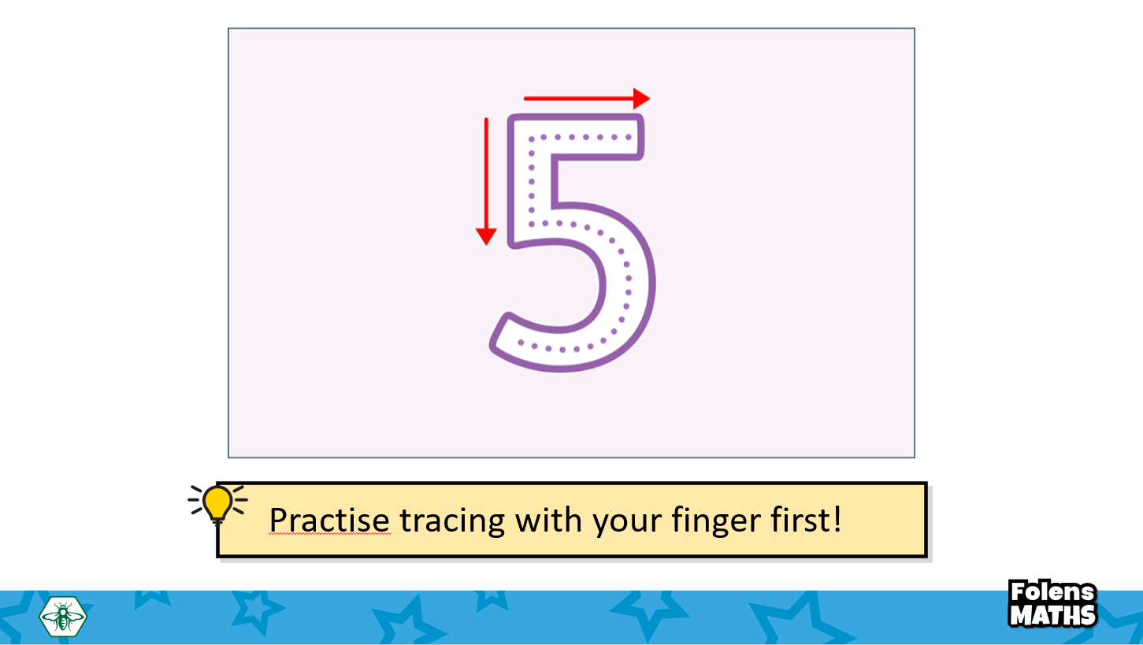
In this lesson, children will learn and practise how to write the number 5. Take your time modeling how to write 5, starting by tracing it in the air with a finger. Give the class ample opportunities to practise this. Introduce the ‘say it, write it, check it’ system: encourage children to say the number name, write it and then compare their written number to the number on the board. (This is a great opportunity to revise the writing of the numbers 1–4 as well. If your class needs it, take some time to go through each number, model tracing it, and ask children to practise writing it in the air with their finger.)

Play the song ‘Five Little Speckled Frogs’ from the number pack five activity. Ask children to trace each digit in the air with their fingers.

Key questions/Maths talk
- How can we write 5?
- Where do we start?
- What do we do next?
- What does number 5 look like?
- How can we recognise number 5?

Differentiation
- Support struggling learners by providing visual representations of 5, or with additional number formation practice. The ‘Rainbow numbers’ activity below provides some nice opportunities for this.
- Challenge advanced learners by asking them to draw sets of 5.

Hands-on activities/Games
- Rainbow numbers: Ask children to write the number 5 multiple times, using a different crayon each time.
Lesson 3: Count and subitise 5

Resources
dice

Learning experiences
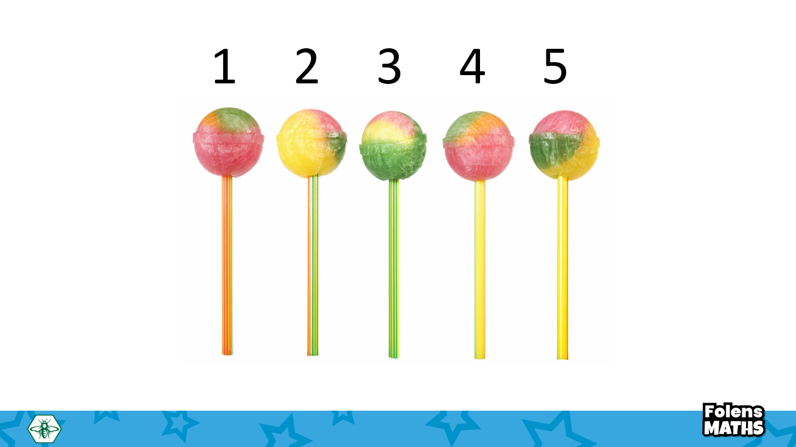
This lesson focuses on counting and identifying (subitising) sets of five. This lesson also reinforces recognition of five arrangements, starting with the standard dice arrangement, and building to other common ones.
In the PowerPoint, pupils are shown sets of five items, in different pictorial arrangements. Model counting the items in each set to find out that they are made up of five items. Reiterate the fact that the last number we count is the total number of items in the set. Encourage children to point to each item as they count. ‘Point and move’ could be explored for those children who are struggling with counting one-to-one. Pupils can apply this learning to identify the odd one out (the only set that doesn’t have five items).

Once this skill is established, tell children that they might have developed a superpower: they might be able to see five without counting. Start by showing them the standard dice arrangement for five. Ask them how they know how many the dice is showing. Encourage pupils to test their superpower with the slide activity.

Key questions/Maths talk
- What do you notice about these sets?
- How many are in each set?
- How do you know your answer is right?
- How can you check your answer?
- Can you find the odd one out? Why is it the odd one out?
- How many is that; can you tell without counting?
- Which set has 5 items?

Differentiation
- Support struggling learners by providing them with cubes or ten frames if available, and by allowing them time to think and see the sets for longer.
- Challenge advanced learners by encouraging them to think about the components of five. What ways can we make five? When subitising, change the dot patterns so they are not uniform to a dice.

Hands-on activities/Games
- Find 5: Children play in pairs with counters. They take turns at making two sets: one set of 5 counters and one set of 1–4 counters. Their partner needs to say which one is 5. Every time one of them guesses correctly, they get one point. The child who gets to 5 points first wins.
- Towers: Children play in pairs with tower blocks. They take turns making towers of 1, 2, 3, 4 and 5 blocks. They then hide one of the towers. Their partner needs to say which number tower was hidden.
Lesson 4: Components of 5

Resources
Five frames, coloured counters

Learning experiences
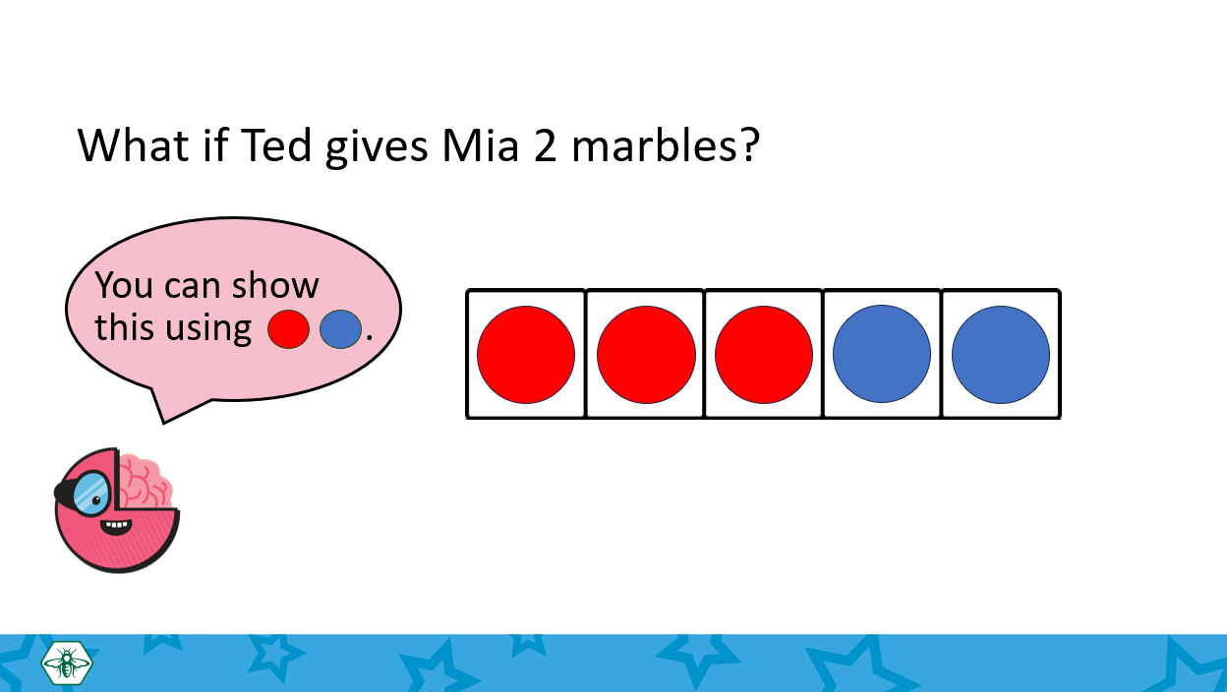
In this lesson, children continue to develop the understanding that all numbers are made up of smaller numbers. Start by showing a word problem, e.g. ‘Ted has 5 marbles and wants to share them with a friend. How could he do this?’ Encourage children to think about all the ways in which the marbles could be shared. Model solving the problem, starting with 4 and 1 make 5. Hand out 5 frames and sets of counters of different colours, and model showing 4 and 1 make 5 with counters.
Ask children to use the counters to show different solutions to the problem. Encourage children to record their answers on their whiteboards/copies. While children may have not encountered the number 0 yet, this lesson could also be an opportunity to introduce the story of five.

Key questions/Maths talk
- What numbers make 5?
- Can you think of other ways to make 5?
- How do you know you are right?
- How can you check your answer?
- How many ways of making 5 can you find?

Differentiation
- Support struggling learners by giving them five counters and a magic cloth to physically hide some counters on a number frame. Help them realise that five is the number we are focusing on here. Explore counting the counters many times before asking how many more we need to make five. Reinforce their cardinal number sense before encouraging them to explore ways of figuring out what amount is missing if we hide some components of the set. You can also repeat this using fingers or cubes.
- Challenge advanced learners by encouraging them to explore different ways to fill the five frame, for example by using counters of three different colours instead of two. You can also challenge them to identify 5 and 0 as additional components of 5.

Hands-on activities/Games
- Using number cards: Children play in pairs. Provide them with number cards 1–5, shuffled. Children take turns picking two cards. If the total makes 5, they have to shout ‘Five!’ and get a point. The first one who gets 5 points, wins.
- The changing towers: Children play in pairs, taking turns to build a tower made out of 5 blocks. One child closes their eyes, and the other takes away some of the blocks. The partner has to guess how many blocks were taken away.
- The missing bears: Show children a scene with five bears. Tell them that all of the bears are in the garden playing. Take away some of the bears, telling children that those bears are going inside. How many bears are left in the garden? Repeat this to explore all components of five. You can use a different context for this activity, depending on which soft toys or objects are available.
Lesson 5: Weekly revision

Learning experiences
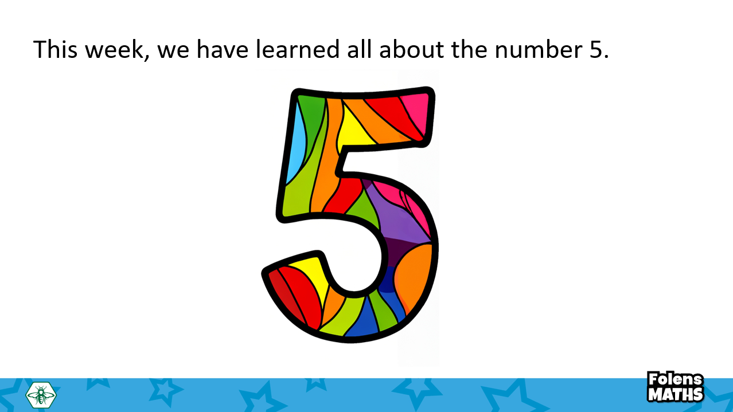
This lesson is a summary of previous learning during this week. It is a chance to focus on the aspects you feel your class might be struggling with the most – you can use this as extra practice for number formation, counting sets or subsisting, depending on your pupils’ needs.
This lesson also links to the Student Book page, where pupils use learning from the week to draw a party for five.

Key questions/Maths talk
- How many items are there altogether?
- How did you know?
- How can you check if there are 5?
- Can you recognise a set of 5 without counting?

Differentiation
- Support struggling learners by providing prompts about what they might see at a party. Ask children ‘What might you see 5 of? Let’s count!’
- Challenge advanced learners by asking them to think about the book activity in terms of the components of 5: ‘If I have 3 balloons, how many more do I need to make 5?’

Hands-on activities/Games
- The feely bag: Join some multilink cubes, making sure to include blocks of 1-5 cubes, and put them in a feely bag. Ask pupils to feel one of the blocks and try to guess how many cubes it is made out of. Then, ask pupils to take the block out of the bag and check if they were right.
- Double-sided counters: Hand out a set of 5 double-sided counters to each child or pair of children. Children throw the counters on the table, then count how many are red and how many are yellow. Did anyone get a set of only yellow or only red counters?
- How many?: Provide each child with a five frame and five counters or number cubes. Stomp your feet twice and ask children to show that number on the five frame using counters. Repeat with different numbers to five, asking children to come to the front of the class and represent the numbers to five using actions or sounds for the class to show on five frames.

