Number: Fractions

15. Halves

This unit explores halves of shapes, sets and numbers through practical, problem-solving activities.

Unit Information

Learning  Outcome(s) | Through appropriately playful and engaging learning experiences, children should be able to recognise and name fractions according to their part-whole relationships.
Mathematical Concept(s) | - Each equal share of a set has the same value.
Mathematical Language | half / halves, share, split, same, different, equal / equally, part, whole, shape, set, group, even
Prior  Knowledge | - Understanding of part-whole relationships  - Basic counting skills, up to at least 20  - Recognition of simple 2D shapes: square, rectangle, triangle, circle  - Concept of sharing  - Concept of equality: same / different
Potential  Misconceptions | - A half is any one of two parts. [The two parts must be equal.]  - One half is always a single piece. [A half may contain many pieces e.g. one half of 10 marbles is 5 marbles.]

Unit Overview

 | Lesson 1 | Lesson 2 | Lesson 3 | Lesson 4 | Lesson 5
Focus of New Learning | Split shapes into 2 equal parts. | Make a whole with 2 equal parts. | Share sets of objects into 2 equal groups. | Understand that 1 half of a set is 1 of 2 equal groups of a set. | Consolidate learning.
Slides | 15.1 | 15.2 | 15.3 | 15.4
Book | p. 90 | p. 91 | p. 92 | p. 93 | pp. 94–95
Concrete  Resources | square sticky notes or other squares of paper  Extension:  geoboard  elastic bands | small triangles from a tangram set or similar  Extension:  squares from a tangram set | interlocking cubes or similar to represent each set | interlocking cubes or similar to represent each set | interlocking cubes or similar to represent each set

Additional Digital Resources

- 15. Halves: Video  - 15. Halves: Game | - 15. Halves: Desmond’s Cakes  - 15. Halves: Half  - 15. Halves: Half Problems  - 15. Halves: Sweet Jar

Lesson 1: Split shapes into 2 equal parts.
Teaching Slides 15.1 | Student Book p. 90

Learning Experiences and Anticipated Student Responses

Sharing Food:
- The slides begin with a discussion about sharing food equally. Alternatively, real food could be used.
- The examples are designed to tease out potential misconceptions such as ‘anything split in two is split in half’, and ‘there is only one way to split an object in half’.

Folding Squares:
- Emphasise the language of half and 2 equal parts, focusing on both parts being the same.
- Challenge children to find multiple ways to fold the square in half. There are four possibilities:
Anticipated Student Responses
The first and final two are rotations of each other, but it is not important for children to recognise this.

Part A:
- Children can use the paper folding they have just completed to support this activity.
- Use the drawing tools to share examples on the board; either to get children started, or to allow children to share what they have done once they have completed the activity.
- There are eight simple possibilities, each based on the four folds of a square above:
Anticipated Student Responses
 | 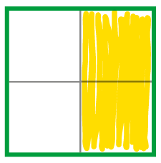 |  | 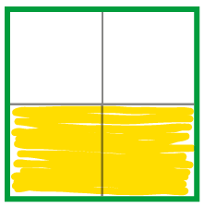 |  | 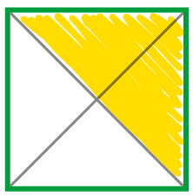
- There are further possibilities in which the halves are not side by side, which some children may discover:
Anticipated Student Responses
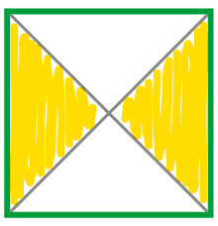
- Draw attention to the fact that in each square, the same amount must be coloured as uncoloured. Attention could also be drawn to the fact there are four parts altogether and two of them are coloured, this will provide a foundation for upcoming lessons about splitting sets in half.

Part B and C:
- Part B requires children to think about how many parts the shapes are split into and whether they are split equally or not. Pay particular attention to the triangle as this often causes confusion.
Anticipated Student Responses
circle on the top row | triangle on the second row | pink outlined rectangle on the second row
- This could be extended by discussing how the shapes that are not split in half, could be split in half.
- In response to the maths talk question, look for a response based on ‘two parts that are the same size’.

Extension Activity:
- The extension provides a hands-on way to further explore splitting shapes in half.
- A link to a virtual geoboard is included on the slide.
Anticipated Student Responses
Children can create any shapes and split them in half, ensuring that the two parts are the same size.
Lesson 2: Make a whole with 2 equal parts.
Teaching Slides 15.2 | Student Book p. 91

Learning Experiences and Anticipated Student Responses

Virtual Shape Exploration:
- Begin by exploring some virtual manipulatives to match two halves of a shape together. In both examples, the halves are the same shape, but orientated differently. The shapes can be moved and rotated.

Part A:
- Children will require two small triangle pieces from a tangram set to complete this activity. Alternatively, virtual versions from Mathigon can be used: https://mathigon.org/polypad#tangram. These are included on the slides.
- Encourage children to find interesting shapes. One whole side of a triangle does not need to align exactly with one whole side of the other, so long as they are partially touching. The example on p. 91 demonstrates this.
- Invite children to the board to show the shapes they have made. The triangles on the slides can be copied and manipulated to create multiple different versions. This can also be changed to the same colour to make it easier for children to see the whole shape.
- There are many different shapes children could make. Below are some examples:
Anticipated Student Responses
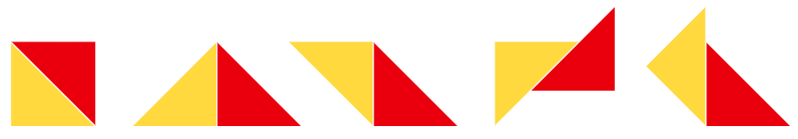
- The maths talk question is designed to get children discussing and comparing shapes, and seeing other shapes they could have made.
- The slides then offer some consolidation of the concept that one whole is made of two equal parts.

Part B:
- Children may already have found some of these shapes in Part A. Encourage them to use their triangles to test each one. This can also be done virtually with the manipulatives on the slides.
- All three shapes can be made from the triangles:
Anticipated Student Responses
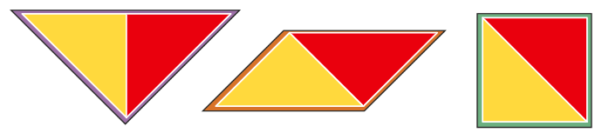

Extension Activity:
- The extension offers some further exploration of the same idea, using squares instead of triangles.
- The square from tangram sets can be used. Alternatively, as above, there are virtual versions on Mathigon: https://mathigon.org/polypad#tangram.
- Squares offer less varied options, but any shape in which the square forms half of it is acceptable:
Anticipated Student Responses

Lesson 3: Share sets of objects into 2 equal groups.
Teaching Slides 15.3 | Student Book p. 92

Learning Experiences and Anticipated Student Responses

Sharing Marbles:
- The slides begin with a problem about sharing a set of marbles equally. The marbles are interactive so can be moved around and used to show how they could be shared.
- In response to the maths talk question, look for answers based on each having the same amount.
- Marbles can also be deleted, if a smaller quantity would be a preferable starting point, or duplicated to create bigger sets for challenge and further exploration.

Part A:
- If children need extra support, encourage them to use concrete resources of their choice (cubes, counters, etc.) to make the sets and then split them in half.
- Use the drawing tools to demonstrate colouring or ringing half of each set if required.
Anticipated Student Responses
Set 1: two groups of 3 | Set 2: two groups of 4 | Set 3: two groups of 7
- In response to the maths talk question, look for answers based on each person getting the same amount.

Part B:
- This is similar to the previous task, but introduces bar models.
- Again, if children need extra support, encourage them to use concrete resources of their choice (cubes, counters, etc.) to make the sets and then split them in half.
- Use the drawing tools or move the marbles directly into the bar models to demonstrate sharing them.
Anticipated Student Responses
Set 1: two groups of 6 | Set 2: two groups of 8 | Set 3: two groups of 10
- Once children have worked on the task, discuss how they completed it, using the slides to demonstrate as required. For example, some may have used concrete materials to make the sets, split them in half and then drew what they saw. Others may have drawn a circle in each section of the bar model in turn, crossing out the marbles as they went. Some may have been comfortable working with half of a given number so they may have counted each set, worked out what half of it was, and drew that amount in each section of the bar model.
- As with the problem at the beginning of the lesson, the marbles can be deleted or duplicated to create different sets.
- In response to the maths talk question, children should identify both the number of marbles in each half, and the fact that the number in each half is the same.

Extension Activity:
- The extension requires some experimenting to find examples and counter examples.
- Encourage children to use cubes to test examples.
Anticipated Student Responses
Children will need to find one example that is true (e.g. 4) and one that is not (e.g. 5) to conclude that the statement is sometimes true.
- Children may discover that an even set can be shared into two equal groups, but an odd set cannot. However, they may not yet have enough experience with even and odd numbers to reach this conclusion.
Lesson 4: Understand that 1 half of a set is 1 of 2 equal groups of a set.
Teaching Slides 15.4 | Student Book p. 93

Learning Experiences and Anticipated Student Responses

Sharing into Groups:
- This lesson begins by reinforcing the concept and language of sharing a set equally into 2 groups, before moving on to more abstract work with numbers.

Part A:
- This focuses on finding halves of numbers. It requires children to choose 3 even numbers so a recap of even numbers may be required. A top tip is included on the slides for this purpose.
- Providing choice here facilitates differentiation. Encourage children who need extra support to choose smaller numbers, and those who are able for a greater challenge to choose bigger numbers. This also provides an opportunity for those who are able to work beyond 20.
Anticipated Student Responses
one half of 4 = 2 | The answers to the other three will depend on the numbers children choose.
one half of 8 = 4
one half of 12 = 6
- Early finishers can be encouraged to keep going with different numbers.

Part B:
- Some simple word problems are provided here.
- Encourage children to use cubes or other manipulatives to model the problems. Demonstrate this on the board using the interactive manipulatives.
- Children may wish to work in pairs on this activity.
Anticipated Student Responses
- 2 | - 18

Part C:
- This provides a more cognitively challenging word problem.
- Children may wish to work in pairs or small groups for this activity.
- Encourage children to work on the question systematically. For example, beginning with the smallest possible number of books Emma and James could have altogether.
Anticipated Student Responses
5 each (10 books in total) | 6 each (12 books in total) | 7 each (14 books in total)
- The parameters in this question can easily be altered for differentiation. For example, the total number of books could be reduced to a smaller range with smaller numbers (e.g. more than 3 but fewer than 7) or increased to larger range with larger numbers (e.g. more than 8 but fewer than 20).
- In response to the maths talk question, look for answers based on having found all possible totals between 8 and 15 and finding half of each, where a half can be found.

Extension Activity:
- The extension is similar to the extension activity in the previous lesson as it requires experimenting to find examples and counter examples.
- Encourage children to use cubes to test examples.
Anticipated Student Responses
Children will need to find one example that is not true in order to prove that the statement is false (e.g. half of 6 = 3).

Lesson 5: Consolidate learning.
Student Book pp. 94–95

Learning Experiences and Anticipated Student Responses

Part A, p. 94:
Anticipated Student Responses
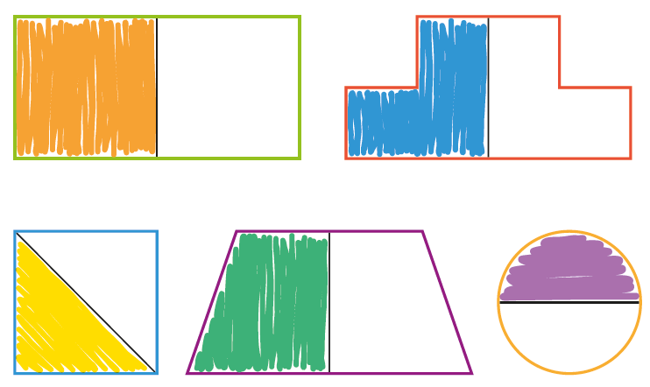

Part B, p. 94:
- As per Part A on p. 90, there are four simple possibilities:
Anticipated Student Responses
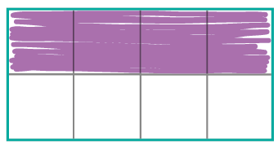 | 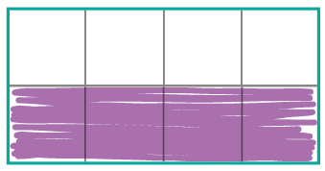 | 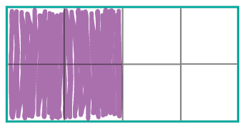 | 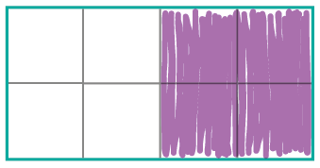
- There are further possibilities in which the halves are not side by side, for example:
Anticipated Student Responses
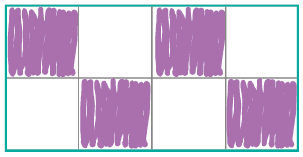 | 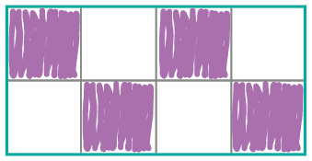 | 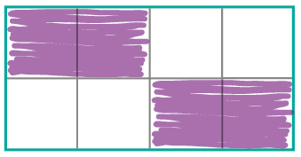 | 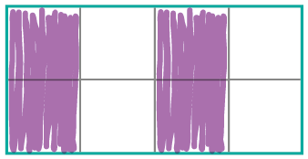

Part A, p. 95:
Anticipated Student Responses
1 half of 4 = 2 | 1 half of 6 = 3
1 half of 10 = 5 | 1 half of 12 = 6
1 half of 14 = 7 | 1 half of 20 = 10

Part B, p. 95:
- Encourage children to ue cubes or other manipulatives to make each set and then split it in half.
Anticipated Student Responses
- 1 half of 2 = 1 | - 1 half of 8 = 4
- 1 half of 16 = 8 | - 1 half of 18 = 9
- 1 half of 22 = 11 | - 1 half of 24 = 12

