Shape and Space: Shape
3. 2D Shapes

This unit introduces children to 2D shapes. Children notice circles, triangles, squares and rectangles around them and begin to describe their properties. Children may use informal language such as ‘pointy ’ or ‘sharp ’ to describe what they notice. When using physical representations of 2-D shapes, ensure that they are as thin as possible to support children’s understanding about them being flat.

Unit Information
Learning Outcome(s) | Shape: explore and recognise properties of 3-D and 2-D shapes.
Maths Concept(s) | - 3-D and 2-D shapes can be classified and sorted by their appearance and by simple properties.  - 2-D shapes are flat. They have two dimensions, length and width.  - Shapes can be combined to make other shapes and/or structures.
Maths Language | Sides, Straight, Corners, Round, Same, Different, Circle, Triangle, Rectangle, Square
Prior Knowledge | - Recognition of shapes based on visual characteristics and their resemblance to familiar objects (e.g., recognizing a circle because it looks like a wheel)  - Children should be able to sort objects based on different attributes, which is a foundational skill for categorizing shapes. They might sort objects by size, color, or use, but not necessarily by shape
Potential Misconceptions | - Some children might recognize shapes based on a single characteristic or attribute rather than considering all properties. For instance, they might call any item with a circular outline a "ball" regardless of its 2D/3D status or think any four-sided shape is a "square" without considering the lengths of sides or angles  - Young children often believe that a shape must be in a particular orientation to qualify as that shape. For example, a square turned on its corner might not be recognized as a square, or they may think a very large or very small triangle is not a triangle because of its size  - Some children may mistakenly identify objects that resemble circles, rectangles and triangles (‘almost’ shapes) as actual 2D geometric shapes. For example, they may believe that a pizza is a proper circle.

Overview
 | Lesson 1 | Lesson 2 | Lesson 3 |  | Lesson 4 | Lesson 5
Focus of New Learning | Recognise and sort circles and triangles | Recognise and sort circles, triangles, rectangles and squares | Explore variations and non-examples of 2D shapes |  | Combine 2D shapes | Weekly review
Slides | 3.1 | 3.2 | 3.3 |  | 3.4 | 3.5
Pupil Book |  | p.10 |  |  | p.11
Concrete Resources | 2D shapes (circles, triangles, squares, rectangles), feely bag, craft matchsticks, sensory materials (sand, rice, shaving cream)
Digital Resources | 3. 2D Shapes: Game  3. 2D Shapes: Printable 1  3. Planet Maths: Circles and Squares (Draw)  3. Planet Maths: Circles and Squares (Identify) |  |  | 3. Planet Maths: Circles and Squares (Draw)  3. Planet Maths: Circles and Squares (Identify)  3. Planet Maths: Colour the Shapes

Lesson 1: Recognize and sort circles and triangles

Resources
2D shapes (circle and triangle), feely bag, sensory materials (sand, rice, shaving cream)

Learning experiences
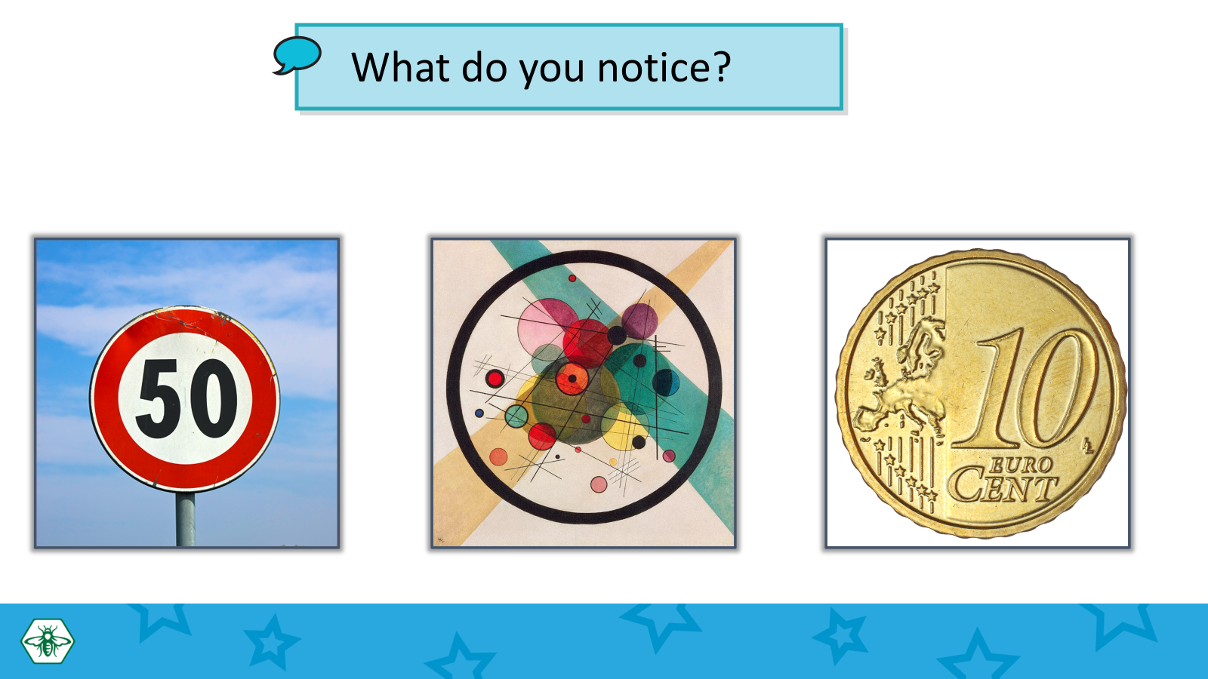
In this lesson, children start by noticing that circles and triangles are all around them. They are then presented with a series of slides containing circles and triangles in different colours, sizes and orientations. Pupils will need to explore and discuss what is the same and what is different about each set of shapes. The main point is to notice that a shape’s name is not affected by its colour, size or orientation. It also provides an opportunity to discuss the properties of triangles and circles including curved/round and straight sides.
Children learn that triangles are flat shapes with three straight sides and three corners, and that circles are flat shapes which are perfectly round.

Key questions/Maths talk
- Where do you see circles / triangles?
- What circles / triangles are in your house / classroom / outside?
- What do you notice about these shapes? (This shape is a…)
- What is the same and what is different? (This shape is the same / different because…)
- How do you know they are the same / different? (This shape has sides / corners)
- How many sides / corners does this shape have? (This shape has…sides / corners)
- Are the sides straight or curved?

Differentiation
- Support struggling learners by helping them to sort triangles and circles in different colours and sizes, discussing the characteristics as you go. Use clear, simple language and repeat the activity with increasing independence.
- Challenge advanced learners by having them sort triangles and circles not just by type, but also by size and color. Encourage them to explain the criteria they used for sorting them.

Hands-on activities and station teaching
- Shape hunt: Go on a shape hunt around school. Prompt children to notice circles and triangles on the surface of everyday objects (e.g. clock, bicycle wheel, triangular flag)
- Shape sorting: Show children a selection of physical circular and triangular shapes. What do they notice about the shapes? Can they sort them into two groups? What is the same and what is different about the shapes in each group
- Feely bag: Have a feely bag with a selection of circular and triangular shapes inside. Show children either a circle or a triangle. Without peeking inside the bag, ask children to find a shape that is the same as yours. Before they select a shape, ask them to explain how they know that it is the same as yours.
- Shape drawing: Invite children to draw circles and triangles in the air /on a partner’s hand / on a whiteboard so that they get practice drawing circles and triangles before being introduced to rectangles and squares in the next lesson.
- Sensory shape exploration: Children use their fingers to draw circles/triangles in sensory materials (sand, rice, shaving cream) after picking a shape card. This tactile experience is beneficial for kinaesthetic learners and helps solidify the memory of shape names and properties. *

*Suitable for station teaching

Lesson 2: Recognize and sort circles, triangles, rectangles and squares

Resources
2D shapes, feely bag, sensory materials (sand, rice, shaving cream), craft matchsticks

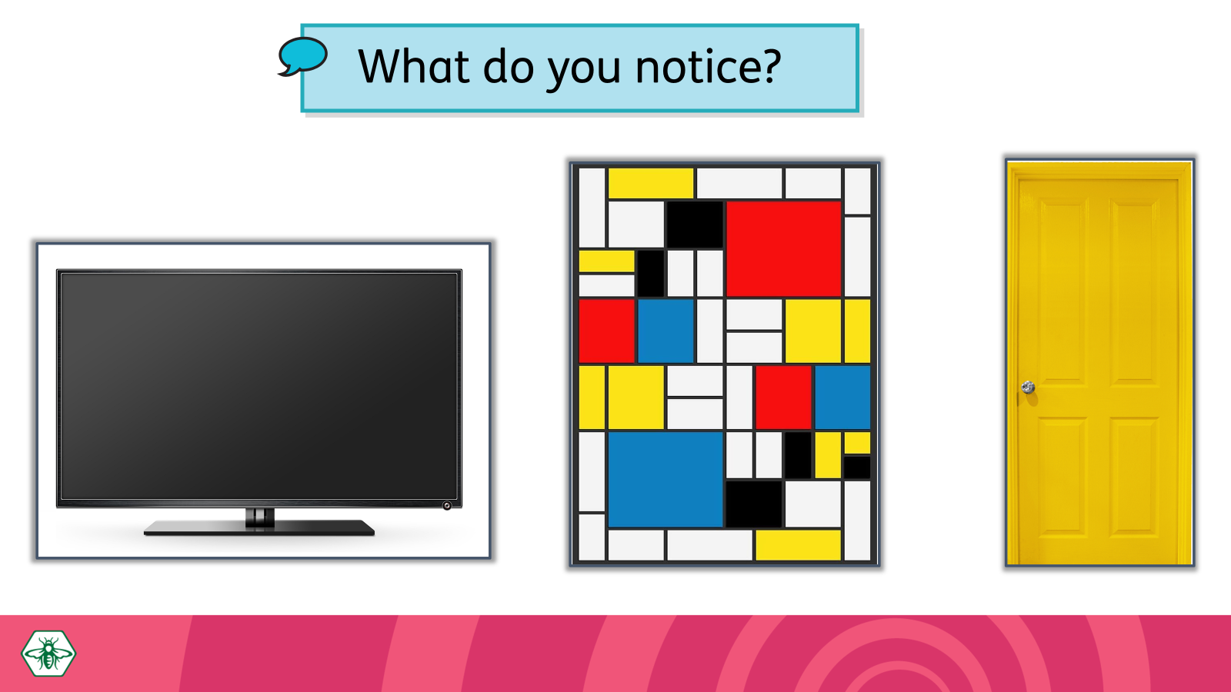
Learning experiences
Building on the previous lesson, children are introduced to rectangles and squares. They recognise that rectangles and squares are all around them and begin to understand that both shapes have 4 straight sides and 4 corners. They also recognise that squares are a special kind of rectangle, where each of the 4 sides are equal in length. Building on the previous lesson, they are presented with a series of slides containing 2D shapes in different colours, sizes and orientations reinforcing the idea that a shape’s name is not affected by its colour, size or orientation.
Finally, they can play the digital activity (3. 2D shape sorting) to sort all four shapes.

Key questions/Maths talk
- Where do you see circles / triangles?
- What circles / triangles are in your house / classroom / outside?
- What do you notice about these shapes? (This shape is a…)
- What is the same and what is different? (This shape is the same / different because…)
- How do you know they are the same / different? (This shape has sides/corners.)
- What is the difference between a square and a rectangle. How are the sides of a square and a rectangle different to each other? What is special about all the sides of a square?
Differentiation
- Support struggling learners by helping them to sort triangles, circles, rectangles and squares in different colours and sizes, discussing the characteristics as you go. Use clear, simple language.
- Challenge advanced learners by having them sort shapes not just by type, but also by size and color. Encourage them to explain the criteria they used for sorting them.

Hands-on activities and station teaching
- Shape hunt: Go on a shape hunt around school. Prompt children to notice rectangles and squares on the surface of everyday objects (e.g. door, desk, book, whiteboard)
- Shape sorting: Show children a selection of 2D shapes. What do they notice about the shapes? Can they sort them into groups? How many squares are there? How many pairs of shapes are there?
- Feely bag: Have a feely bag with a selection of 2D shapes inside. Show children a circle, triangle, rectangle or square. Without peeking inside the bag, ask children to find a shape that is the same as yours. Before they select a shape, ask them to explain how they know that it is the same as yours.
- Sensory shape exploration: Children use their fingers to draw rectangles/squares in sensory materials (sand, rice, shaving cream) after picking a shape card. *
- Shape matching: Print and cut out the cards with 2D shapes on them (See: 2D Shapes: Printable 1) . Children sort them into pairs and then place them face down on the table. They turn over the cards two at a time, and try to find matching pairs. *
- Shape builder: Use craft matchsticks to build triangles, squares and rectangles. Ask children to predict how many sticks they will need to make each shape. What is the smallest square they can make? What is the largest? What is the smallest number of sticks needed to build a rectangle? *
- Geoboard: Children use an online geoboard to create triangles, squares and rectangles. *
- Shape reader: Read shape books such as Bear in a Square by Stella Blackstone. Encourage children to identify the different shapes on each of the pages paying particular attention to pages with circles, triangles, rectangles and squares. Prompt children to talk about the properties of each shape. *

*Suitable for station teaching

Lesson 3: Explore variations and non-examples of 2D shapes

Resources
2D shapes

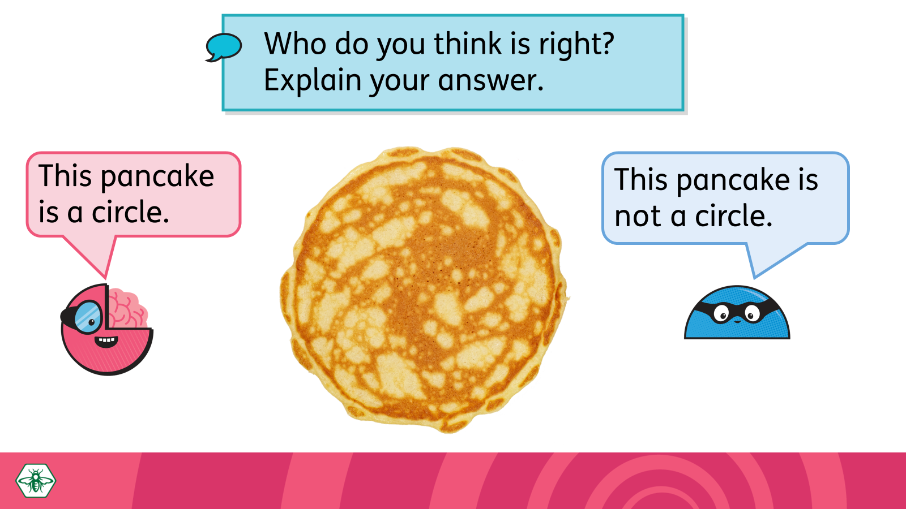
Learning experiences
This lesson is a chance to talk about ‘almost’ 2D shapes (e.g. a pancake is ‘almost’ a circle) that children will encounter in their environment as well as 2D shapes that have some but not all of the properties of circles, triangles or rectangles. Discussing the properties of shapes and ‘almost’ shapes deepens children’s understanding of shapes and their properties.

Start by explaining that shapes are all around us, and we can see many shapes every day. However, not all things that look like shapes are "perfect shapes”. For example, while a cream cracker has a square-like appearance it is not a proper square because it has round corners and is not completely flat. Use the first few teaching slides to talk about why the displayed items (pancake/playing card/sandwich) are not proper 2D shapes (circle/rectangle/triangle). When discussing non-examples of shapes, you can acknowledge what the child knows while pushing for greater precision—'Yes, a pizza slice can be a triangular shape but the crust is curved so it’s not a triangle. A triangle has three straight sides.’

The next set of slides feature 2D shapes that share some properties with either a circle, triangle, or rectangle but are not proper circles/triangles/rectangles. Look out for curvy rounded corners, curvy shapes that are not circles, and shapes whose corners don’t quite meet. Discuss each shapes properties with the children so they deepen their understanding of what defines a shape.

Key questions/Maths talk
- What shapes can you see? (I can see a…)
- How do you know this shape is a square/rectangle/triangle/circle? (I know because…)
- How do you know this shape is not a square/rectangle/triangle/circle? (I know because…)
- How is this shape different from a square/rectangle/triangle/circle? (It has / does not have…)

Differentiation
- Support struggling learners comparing different shapes and drawing out the properties of the shapes before comparing them to ‘almost shapes.’(E.g. show a circle and ask children ‘Is it a triangle? No. Why not? Because a triangle has 3 straight sides and 3 corners. Then show a pizza slice and ask ‘Does this have 3 straight sides and 3 corners?’ No. So, it is not a triangle.
- Challenge advanced learners by providing a mix of various objects and cutouts, and challenge students to sort them into groups: perfect shapes, almost perfect shapes, and not shapes. Discuss why items belong in each category, encouraging critical thinking about the properties of each.

Hands-on activities and station teaching
- Shape sort: Provide children with cutouts of triangles, circles, rectangles and squares along with ‘almost’ shapes and have them sort the proper shapes from the ‘almost shapes’.
- Shape hunt: Invite children to look in the classroom for ‘almost shapes’ and describe why the object is not a proper circle/triangle/rectangle. E.g. The whiteboard is almost a rectangle but it doesn’t have sharp corners.
- Shape drawing: In pairs, children take turns to draw an ‘almost’ shape for a partner and the partner has to say what shape it almost is and what makes it not quite that shape.

Lesson 4: Combine 2D shapes

Resources
2D shapes

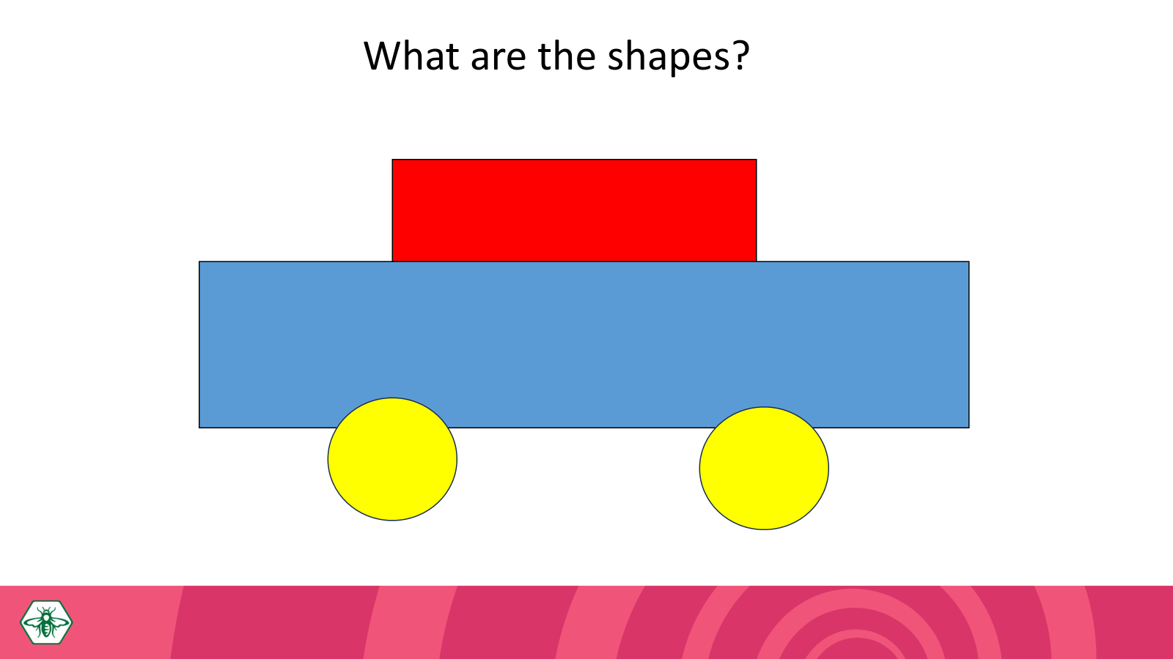
Learning experiences
In this lesson, children combine 2D shapes to make new shapes. For example, two rectangles can be put together to make a larger rectangle or square. Conversely, larger shapes and shape pictures can be comprised of smaller shapes.

Use the slides to model that a shape can have other shapes within it, just as numbers can be made up of other numbers. Throughout the lesson, remind children that these shapes are flat.

Key questions/Maths talk
- What shapes do you see in this picture? (I see a…)
- What do you notice about the shape/shapes? (This shape is a…)
- Which shape could these two/three shapes make? (The shapes make a…)

Differentiation
- Support struggling learners by having them work with one or two shape or simplified pictures.
- Challenge advanced learners by asking them to create specified complex shapes or objects using a set number of different shapes. This requires more critical thinking and planning. Alternatively, encourage them to create a picture or a story using the shapes. This integrates art and literacy into the math lesson, pushing them to use their creativity and knowledge of shapes in new ways.

Hands-on activities and station teaching
- Shape puzzles: Using a pre-outlined templates and cut-out shapes, children choose a shape template and try to fill the outline with the appropriate shapes. This helps them see how different shapes can fit together to form a new shape.*
- Shape creation: Invite children to glue different shapes on to construction paper to create their own pictures / designs. Encourage creativity, asking them to think about what objects they can represent with shapes (like a sun with triangles for rays)*
- Shape cover: Children use different shapes to cover the surface of their books. Which shapes did they use / not use and why?*

*Suitable for station teaching

Lesson 5: Weekly review

Resources
2D shapes

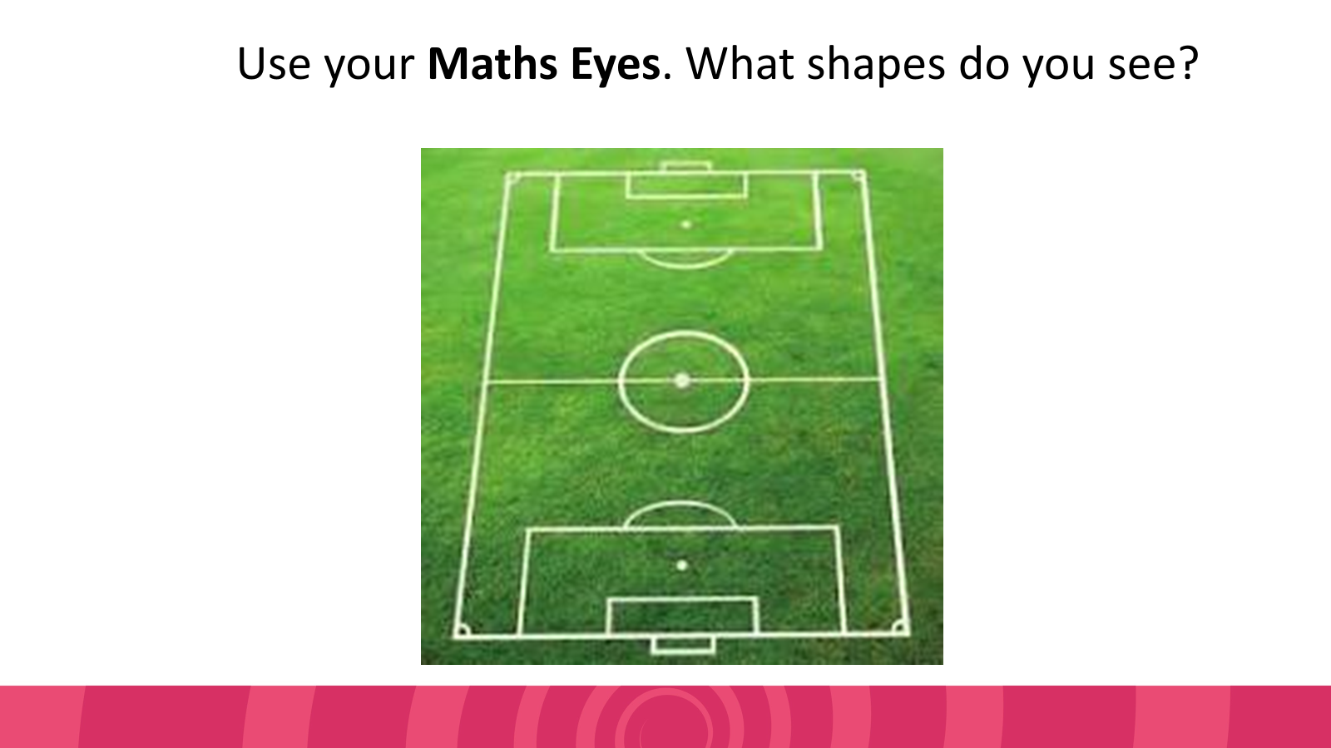
Learning experiences
In this lesson, children review what they have covered over the course of the week. It is a chance to focus on the aspects you feel your class might be struggling with. It is also an opportunity to play some of the Planet Maths digital games to revise and consolidate children’s understanding.

The final slides also prompt children to use their Maths Eyes and recognise shapes in the real world.

Key questions/Maths talk
- What shapes do you see in this picture? (I see a…)
- What do you notice about the shape/shapes? (This shape has…)
- How do you know this shape is a square/rectangle/triangle/circle? (I know because…)
- How is this shape different from a square/rectangle/triangle/circle? (It has / does not have…)

Differentiation
- Support struggling learners by helping them to sort triangles, circles, rectangles and squares in different colours and sizes, discussing the characteristics as you go. Use clear, simple language and repeat the activity with increasing independence.
- Challenge advanced learners by having them sort shapes based on their properties rather than their names. (E.g. ‘Put shapes with three straight sides and three corners here.’)

Hands-on activities and station teaching
- Shape sorting: Provide various pre-cut shapes (circles, triangles, rectangles, squares) in different sizes, colours and orientations. On large sheets of poster paper, draw several large shapes (one shape per sheet). These will serve as sorting mats. You can also label each mat with the name of the shape to encourage word recognition. Invite the children to sort the shapes by placing them on the corresponding place mat. As they sort, ask questions to encourage their thinking such as ‘Why did you put that shape there?, How do you know this is a triangle? Can you find a shape with four sides?’
- Create your own shape monster: Provide various pre-cut shapes (circles, triangles, rectangles, squares) in different sizes and colours. Encourage children to create their own ‘shape monsters’ by gluing these shapes onto a large piece of paper. After crafting, have them describe their monster by naming the shapes and properties used (e.g. 'My monster has three triangle teeth and two square eyes.’) You can differentiate this activity by having struggling learners create more simple shape monsters, while advanced learners can create more complicated designs. You can also ask them to describe the properties of the shapes used in their creations.
- Shape hunt: Invite children to identify shapes around them. Ask them to draw 3 things that are circles / triangles / rectangles / squares on a worksheet or the whiteboard. Encourage them to look out for ‘almost’ shapes.

